**University of Macau**

**Faculty of Science and Technology**

  
**AdSmart – An E-Commerce Platform**

**for Advertisement Services using**

**Responsive Web Technologies**

*by*

**Alex, Lam Man Chio, student No: M-B8-5505-1**

**User Manuals**

## Content

Use case 1: Register an AdSmart Customer account 3

Use case 2: Login AdSmart customer account 7

Use case 3: Register AdSmart Business Partner Account 10

Use case 4: Login AdSmart Business Partner Account 15

Use case 5: Reset AdSmart Account Password 18

Use case 6: Update AdSmart Customer Profile 23

Use case 7: Update AdSmart Business Partner Profile 30

User case 8: Search Product and Add Product to Shopping Cart 37

User case 9: Create Advertisement request 45

User case 10: Explore Advertisement and Send a Contract to Customer 49

User case 11: Discuss to Business Partners and Make a Deal 70

User case 12: Create Product 100

## User case 1: Register an AdSmart Customer account

This section provides walk through of the following user interfaces:

1. Front Page (Figure 1.1)
2. Signup Page (Figure 1.2)
3. AdSmart customer Signup page (Figure 1.3)
4. The example of AdSmart customer Signup page (Figure 1.4)
5. Completed AdSmart customer registration (Figure 1.5)

When the user visits AdSmart for the first time, he/she will go to AdSmart Front page (figure 1.1), and then he/she needs to click “Account” button in the top navigation bar, which will then redirect him/her to the AdSmart signup page (figure 1.2).

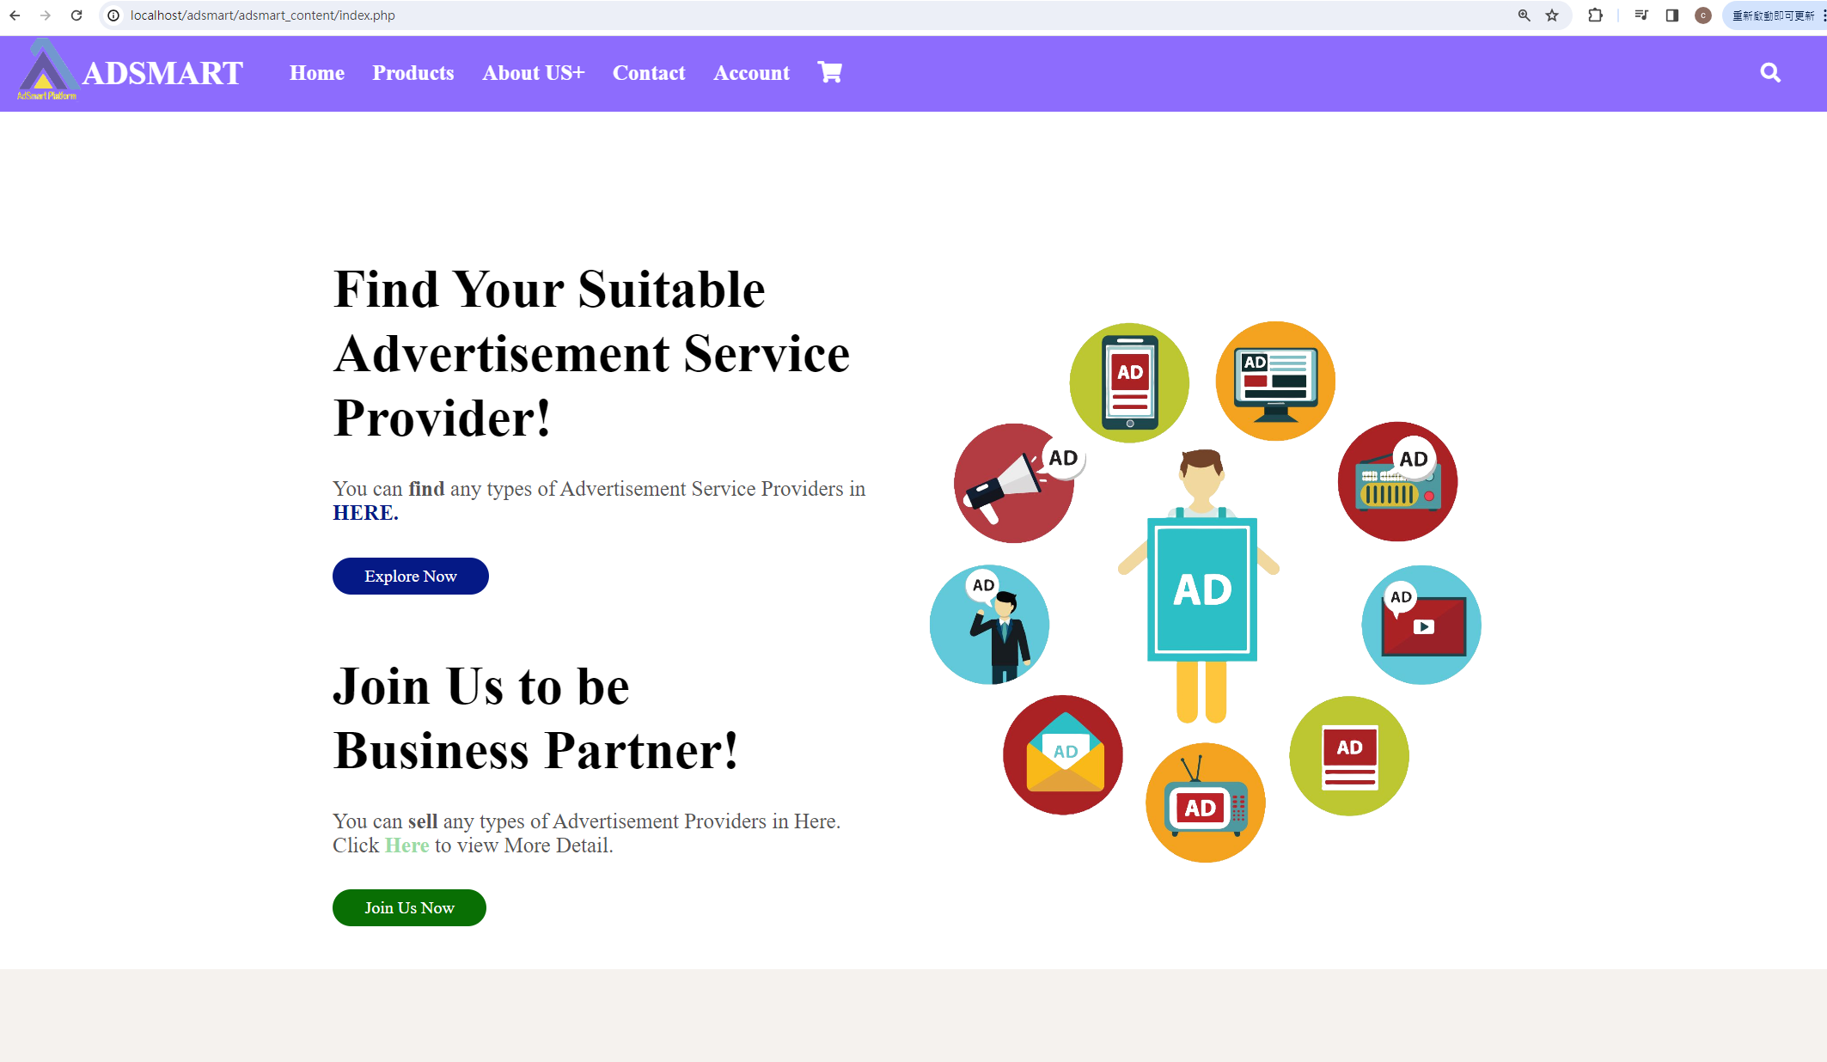

Figure 5.7 Front Page

As figure 1.2, AdSmart offers two user types for registration. The user does not have an AdSmart customer account, so that he/she needs to register a AdSmart customer account.

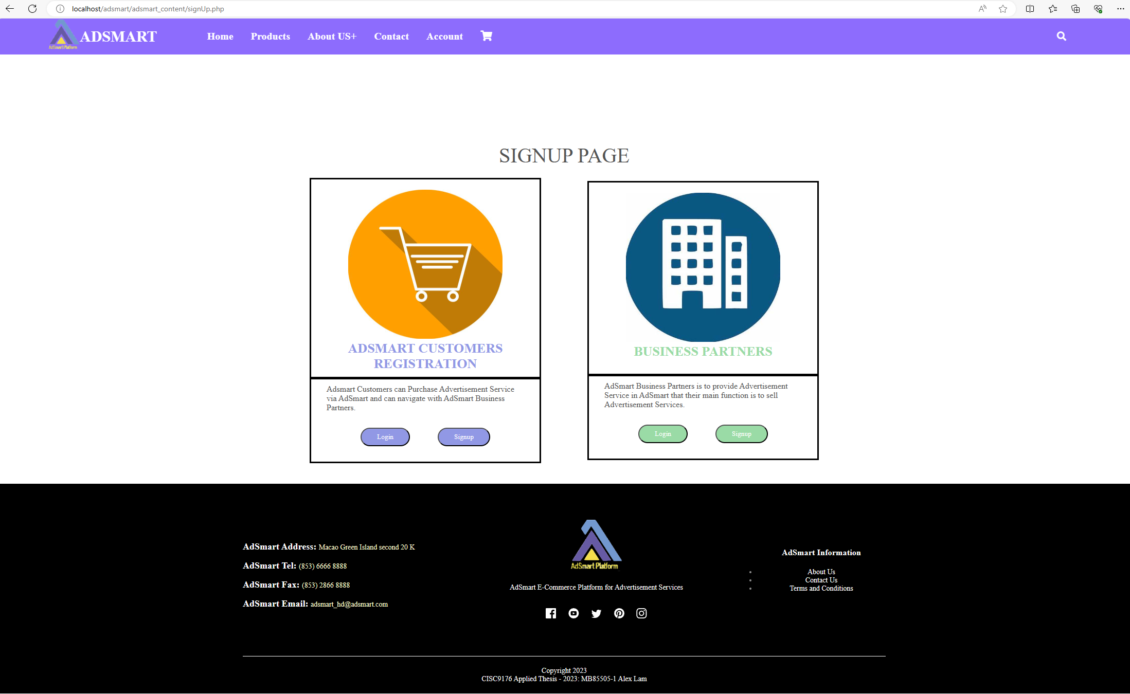

Figure 1.2 Signup Page

As figure 1.3 indicates, the AdSmart customer registration page requires the user to enter their personal information, account information and preferences for products and services. and AdSmart separates four sessions:

1) Applicant’s Basic Personal Information: First name (required), Last name (required), Email address (required), Contact number (required) and country (required).

2) AdSmart Customer Account Information: User ID (required), Password (required) and Password confirm (required). If the applicant is a company representative that he/she needs to provide the information of company in this session and the information of company should be included the following information: Company name, Company’s country, applicant’s department name, Staff number, applicant’s title and work mobile number.

3) Looking for Advertisement Service (optional): The information is captured from AdSmart's database. Such as Broadcast advertisement, display advertisement, events advertisement and etc. and AdSmart provides explanations for each term.

4) Looking for Advertisement Product (optional): The information is captured from AdSmart's database. Such as Clothes product, Poster, Print material and sticker, and AdSmart provides explanations for each term.



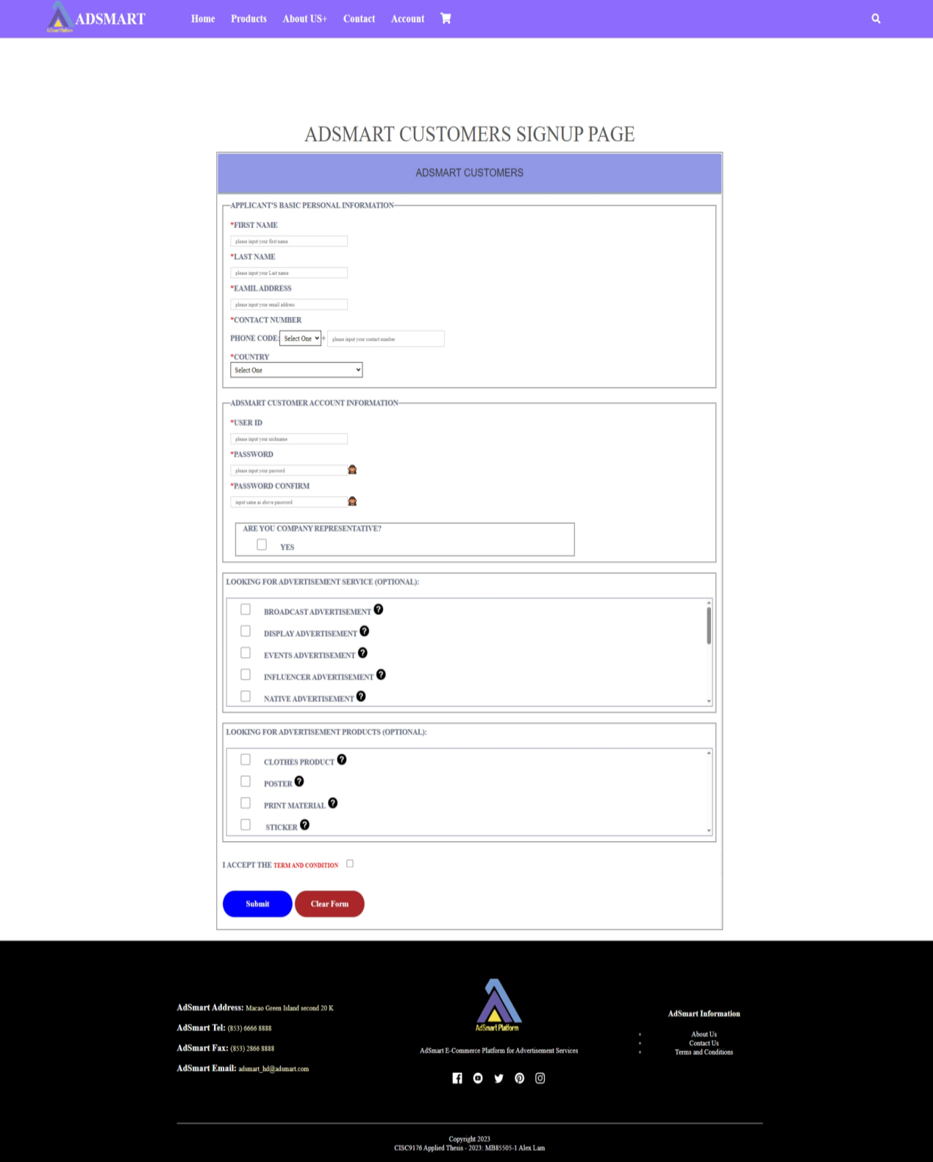

Figure 1.3 Signup as AdSmart customer

In figure 1.4, an example is provided where a user has entered all the required information for registration. Note that there are some conditions of each criterion, such as user id and email address must be unique and password cannot include some special characters.



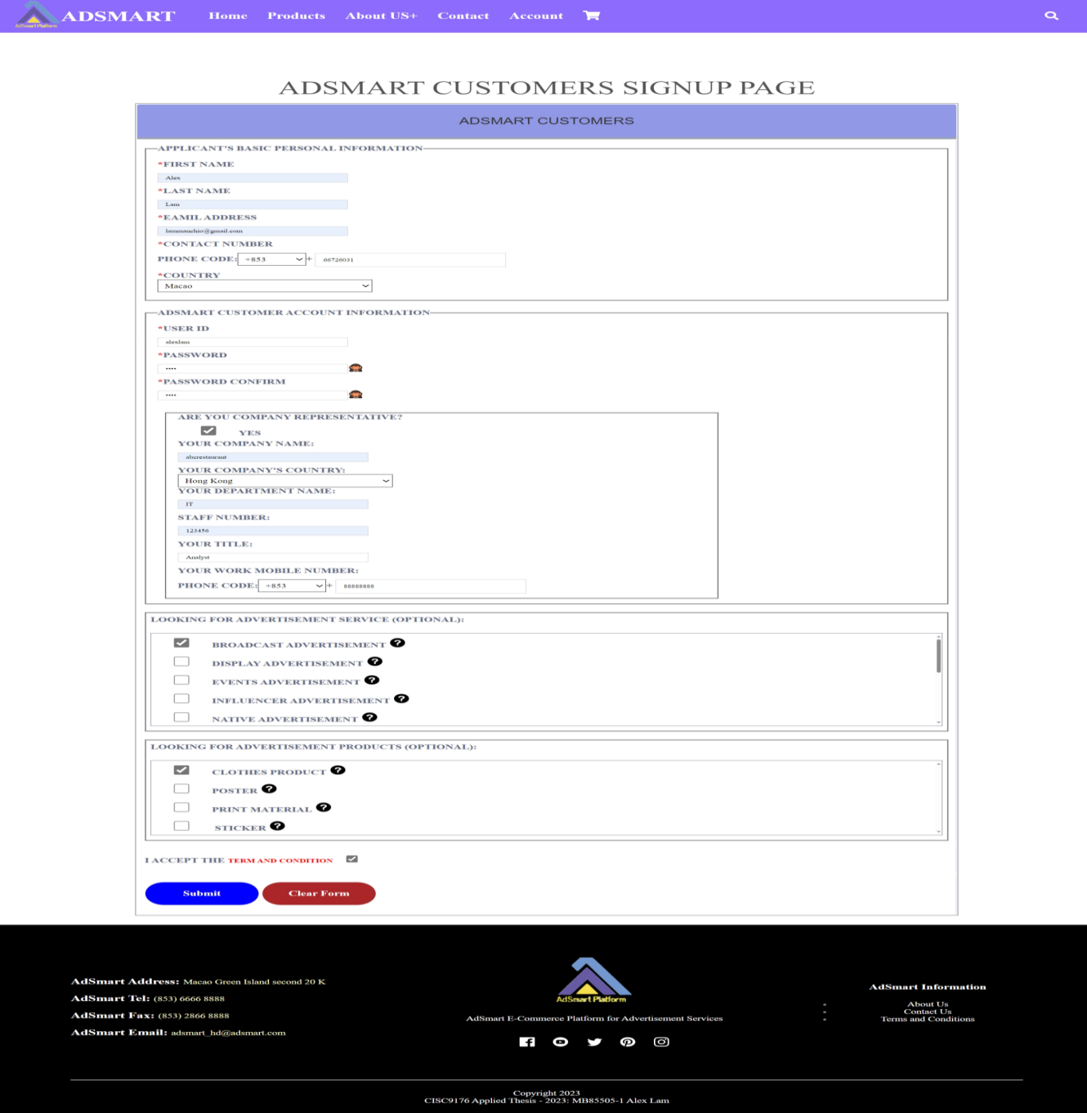

Figure 1.4 The example of AdSmart customer signup page

When the user finished the AdSmart customer registration, he/she can see the successful message “Your AdSmart customer account has been created Successfully!!!” (figure 1.5) and the AdSmart customer can click on the login page link to proceed with the login process.

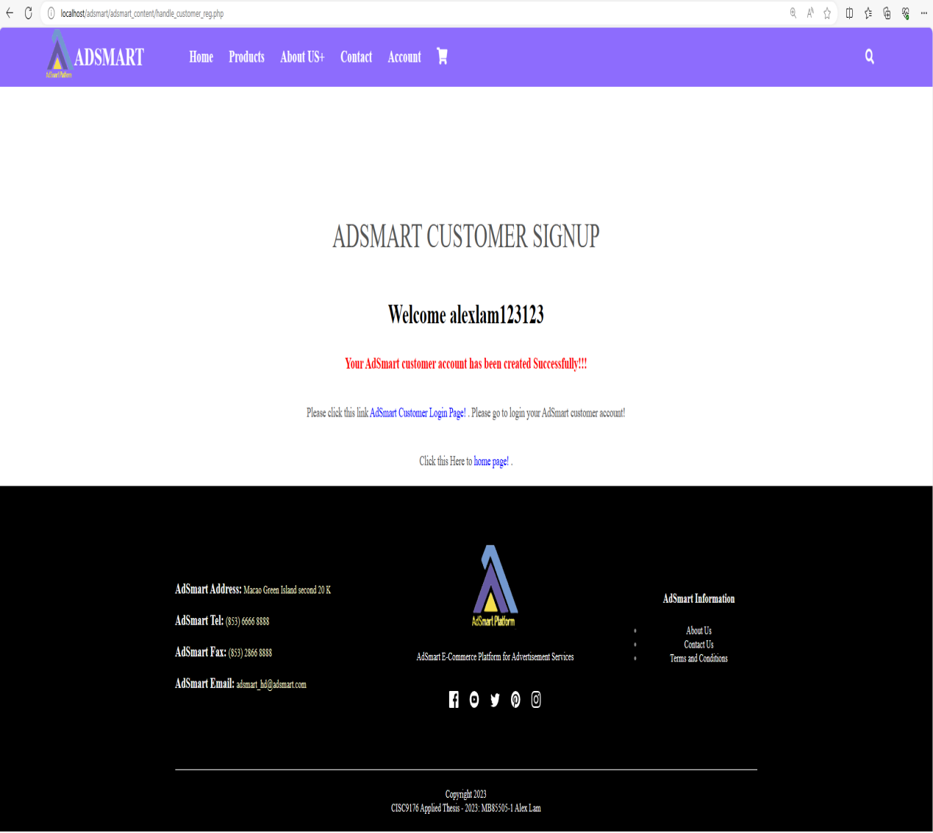

Figure 1.5 Completed AdSmart customer registration

## Use case 2: Login AdSmart customer account

This section provides walk through of the following user interfaces:

1. Signup Page (Figure 1.6)
2. AdSmart customer login Page (Figure 1.7)
3. The example of AdSmart customer login Page (figure 1.8)
4. Completed AdSmart customer login (Figure 1.9)

As figure 1.6, after the AdSmart customer has finished the AdSmart customer registration process, he/she needs to go to signup page to login AdSmart account. Subsequently, the customer must click the login button located under the AdSmart customer registration box.



Figure 1.6 Singup page

As figure 1.7, it is the AdSmart customer login page, the users need to enter their user id and password to login the AdSmart customer account.

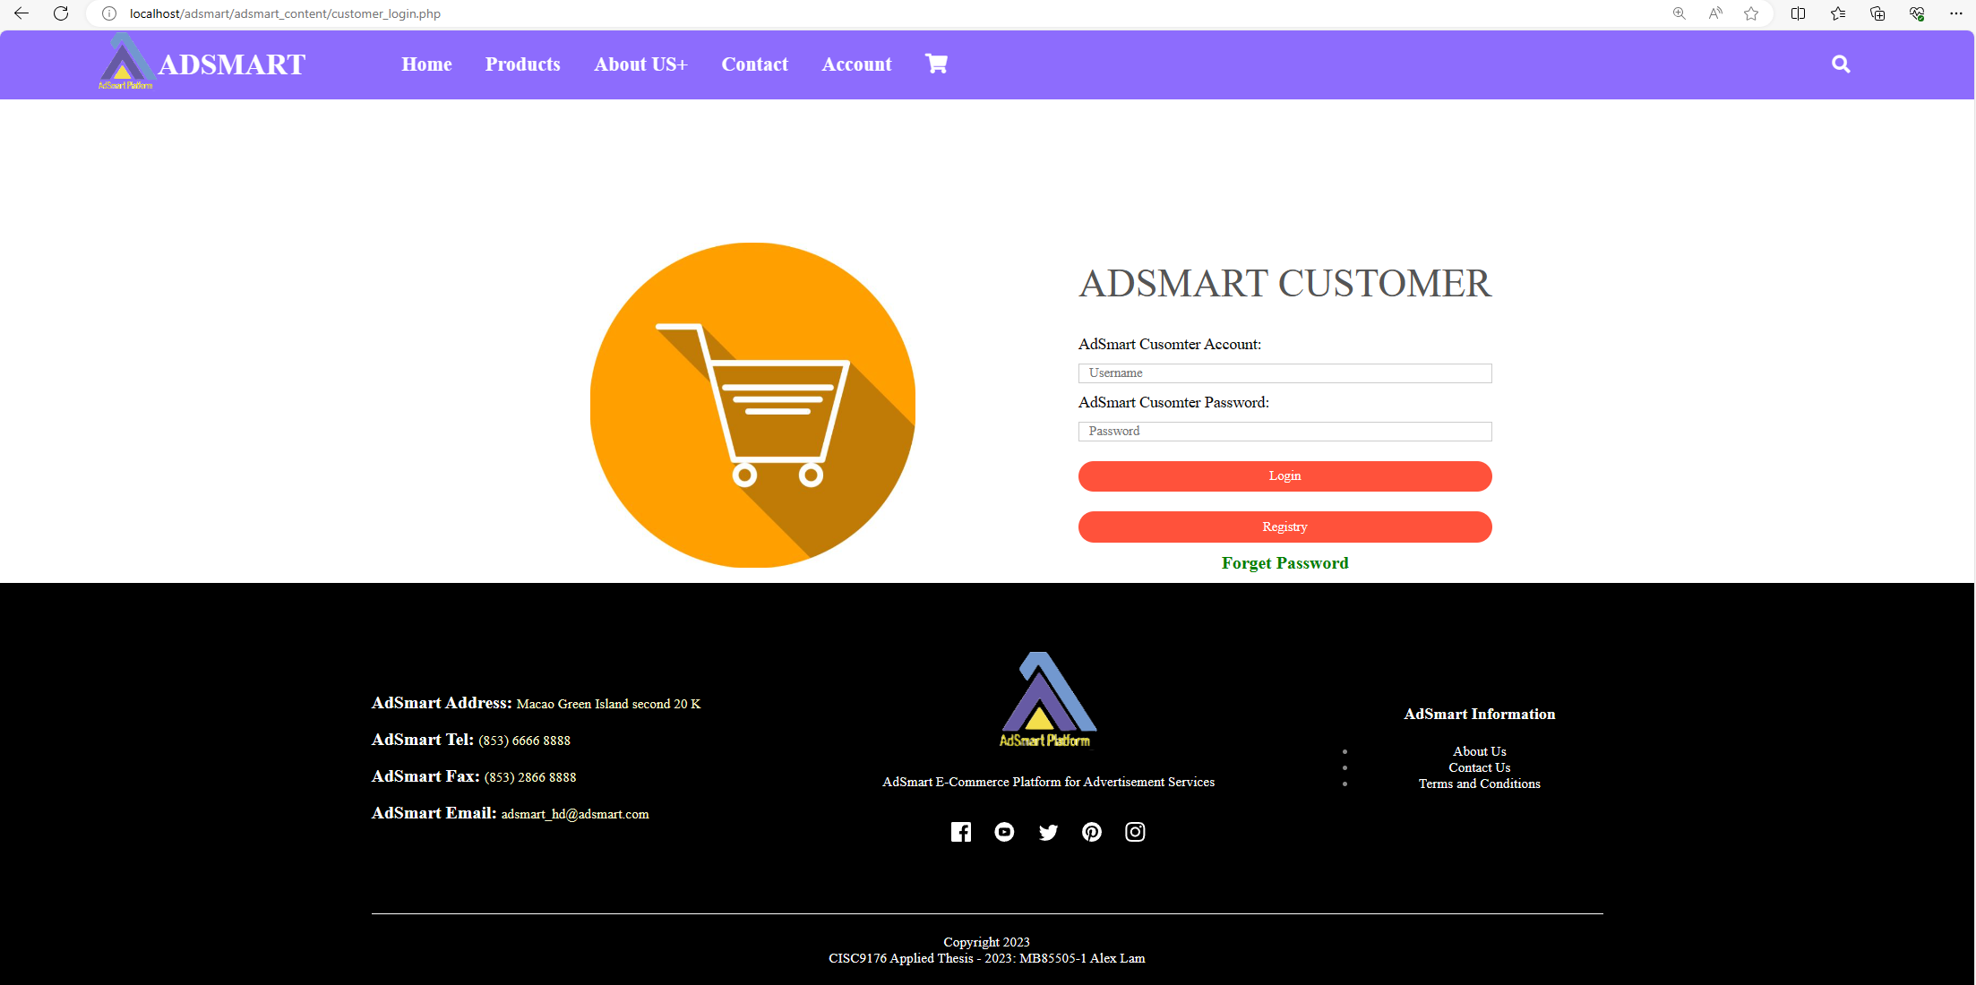

Figure 1.7 AdSmart customer login

As figure 1.8, is the example to show when the user has entered his/her user id and password, and then click the “Login” button.

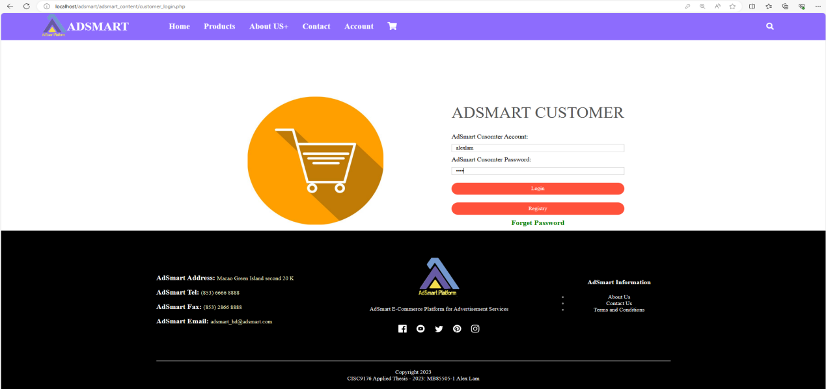

Figure 1.8 The example of AdSmart customer login

When the AdSmart’s customer login successfully that they will see the successfully message “Login Successfully!!!” and will see the greeting words “Welcome !!” + user id name (figure 1.9). Additionally, the user will be able to view the default user icon located in the top right corner of the page.

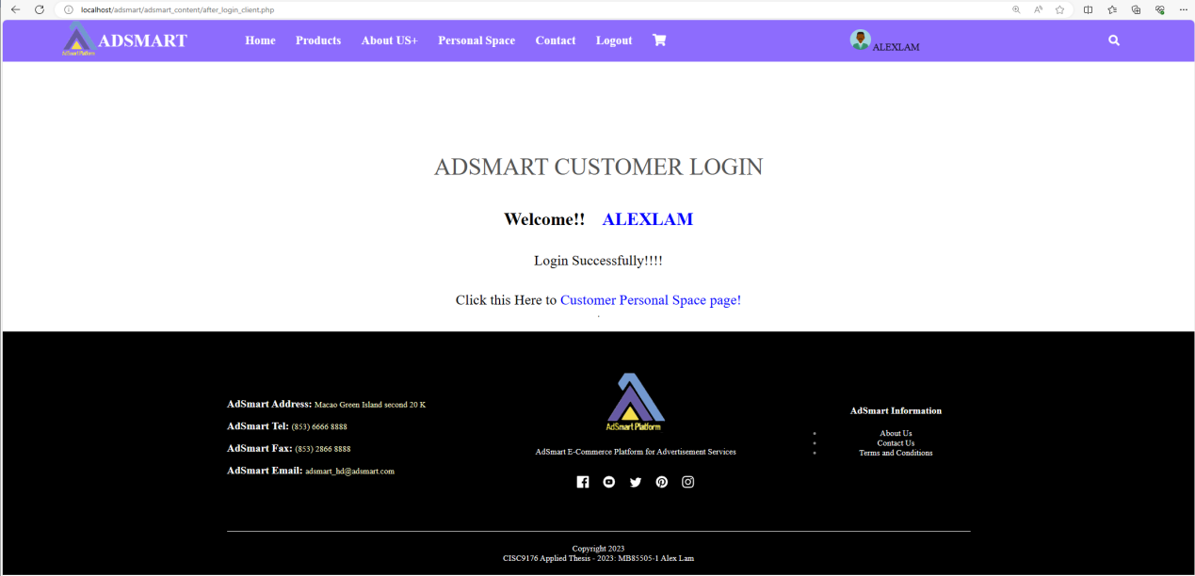

Figure 1.9 Completed AdSmart customer login

**Use case 3: Register AdSmart Business Partner Account**

This section provides walk through of the following user interfaces:

1. Front Page (Figure 1.10)
2. Signup Page (Figure 1.11)
3. Signup as AdSmart business partner (Figure 1.12)
4. The example of AdSmart business partner registration (Figure 1.13)
5. Completed AdSmart business partner registration (Figure 1.14)

In this demonstration, I assume one print advertisement service company that it wants to sell their product and service on AdSmart platform.

When the company representative browses AdSmart front page (figure 1.10) that it needs to click “Account” button in the top navigation bar, and then the company representative will come to AdSmart signup page (figure 1.11).



Figure 1.10 Front page

As figure 1.11, AdSmart offers two user types for registration. In this demonstration, I assume the company that does not have AdSmart business partner account, so that it needs to register a new AdSmart business partner account. The company representative needs to click “signup” button under the “Business Partner” box. When the company representative clicked the “signup” button, the representative would be directed to the AdSmart business partner signup page.



Figure 1.11 Signup page

As figure 1.12 indicates, the applicants are required to input their company information, account information and preferences for products and services in the AdSmart business partner registration page, and then AdSmart separates four sessions:

1) Applicants basic company’s information: Company name (required), Company name in Chinese (optional), Company registration number (required), Company description (required), Company Image (required), Contact number (required), Company registration country (required), Company registration address (required) and Company email address.

2) Applicant’s account information: User ID (required), Password (required) and Password confirm (required).

3) What kinds of advertisement services the company can provide (optional): these information is captured from AdSmart's database. Such as Broadcast advertisement, display advertisement, events advertisement and etc. and AdSmart provides explanations for each term.

4) What kinds of advertisement products the company can provide (optional): these information is captured from AdSmart's database. Such as Clothes product, Poster, Print material and sticker, and AdSmart provides explanations for each term.



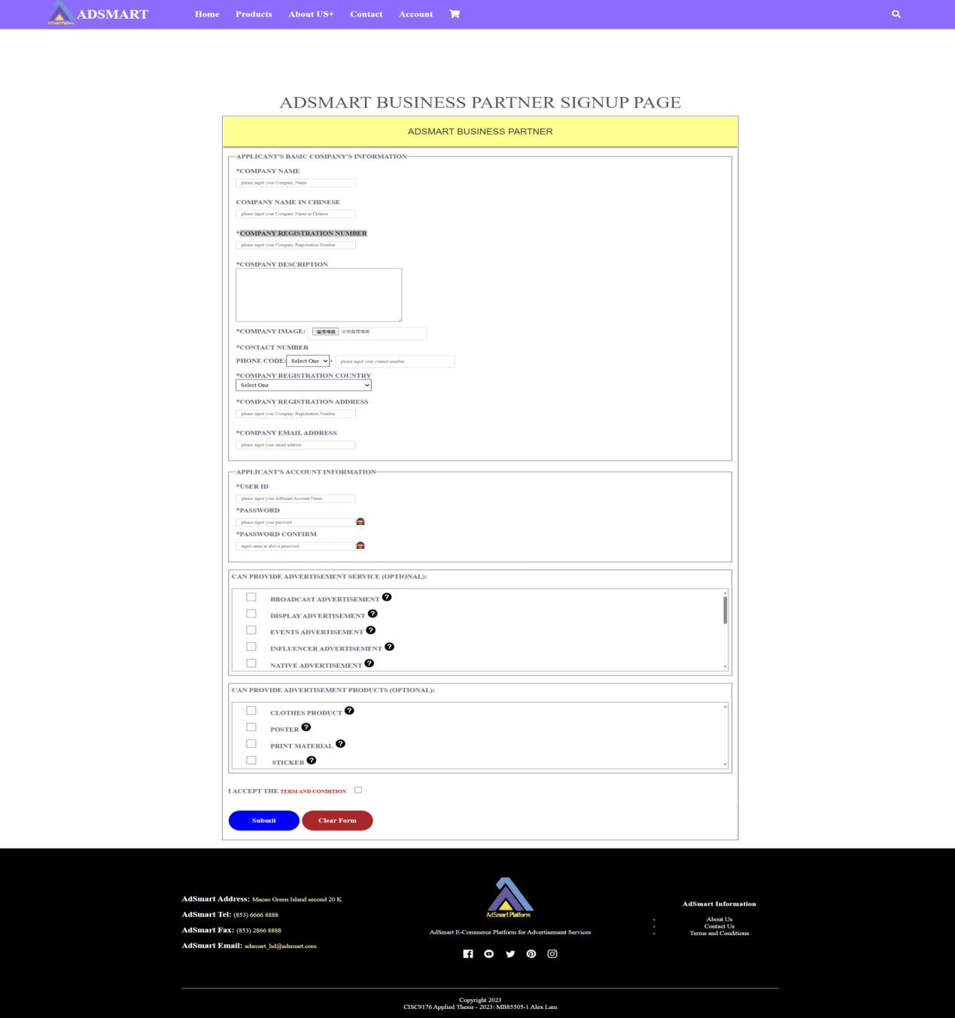

Figure 1.12 Signup as AdSmart business partner

As figure 1.13 is an example of a user has entered all required information for registration. Note that there are some conditions of each criterion, such as user id and email address must be unique and password cannot include some special characters.



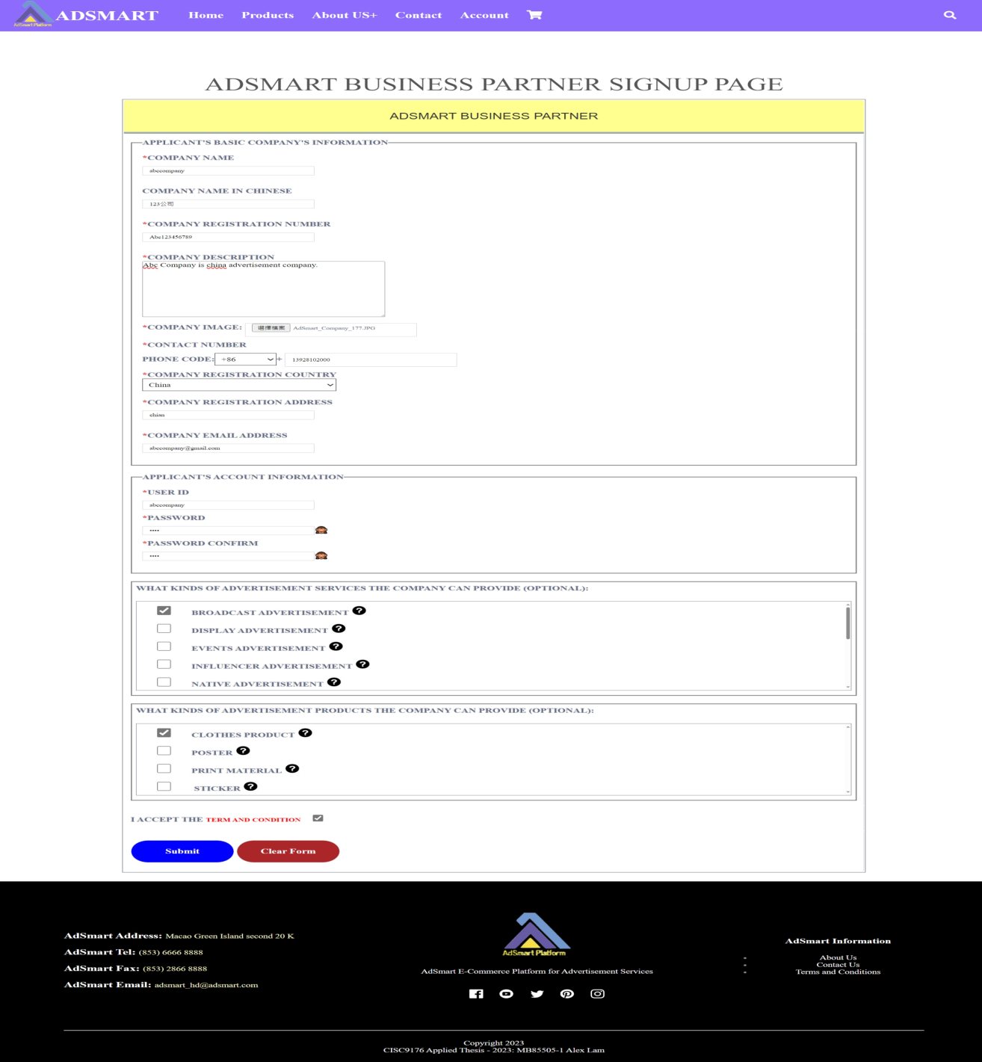

Figure 1.13 The example of AdSmart business partner registration

When the applicant finished the AdSmart business partner registration, he/she can see the successful message “Your AdSmart Business Partner account has been applied Successfully!!!” and will see this message “AdSmart will process your apply as soon as possible. Please check your email after three working days.” (figure 1.14). This indicates that the AdSmart Business Partner account needs to undergo AdSmart validation and cannot be used after the registration completion. The applicant must await approval from AdSmart before being able to utilize the account.

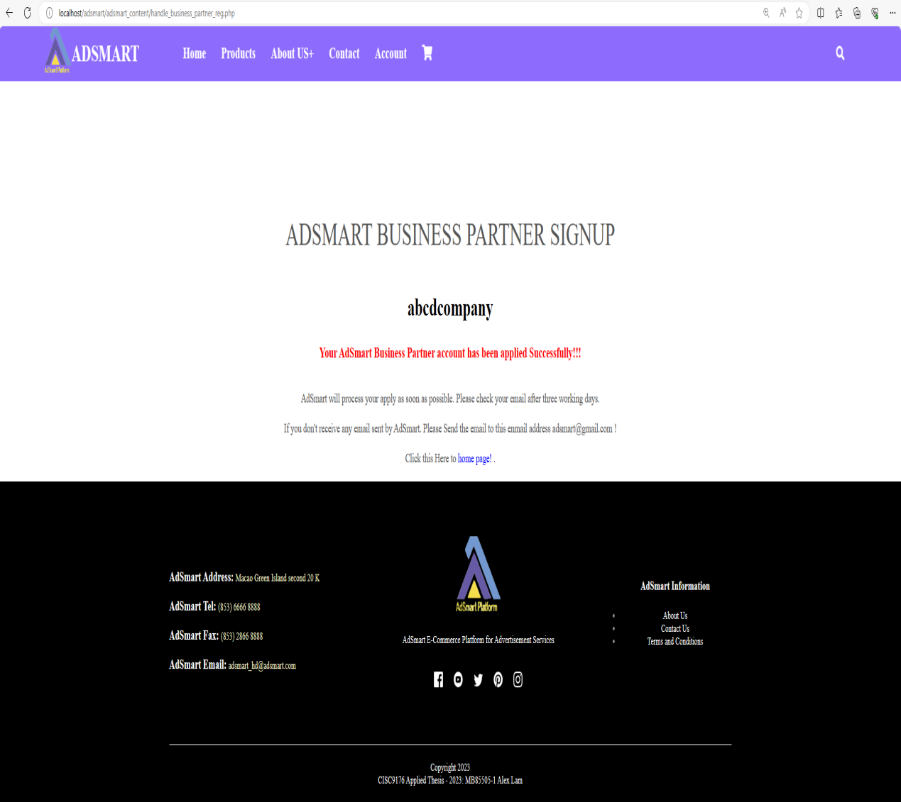

Figure 1.14 Completed AdSmart business partner registration

**Use case 4: Login AdSmart Business Partner Account**

This section provides walk through of the following user interfaces:

1. Signup Page (Figure 1.15)
2. AdSmart business partner login Page (Figure 1.16)
3. The example of AdSmart business partner login Page (Figure 1.17)
4. Completed AdSmart customer login (Figure 1.18)

As figure 1.15, after an AdSmart business partner has finished the registration process, he/she needs to go to signup page to login their AdSmart account. Subsequently, the business partner must click the login button located under the AdSmart business partner box to proceed with the login process.



Figure 1.15 Signup page

As figure 1.16, the AdSmart customer login page allows the user to enter their user id and password to login the AdSmart customer account.

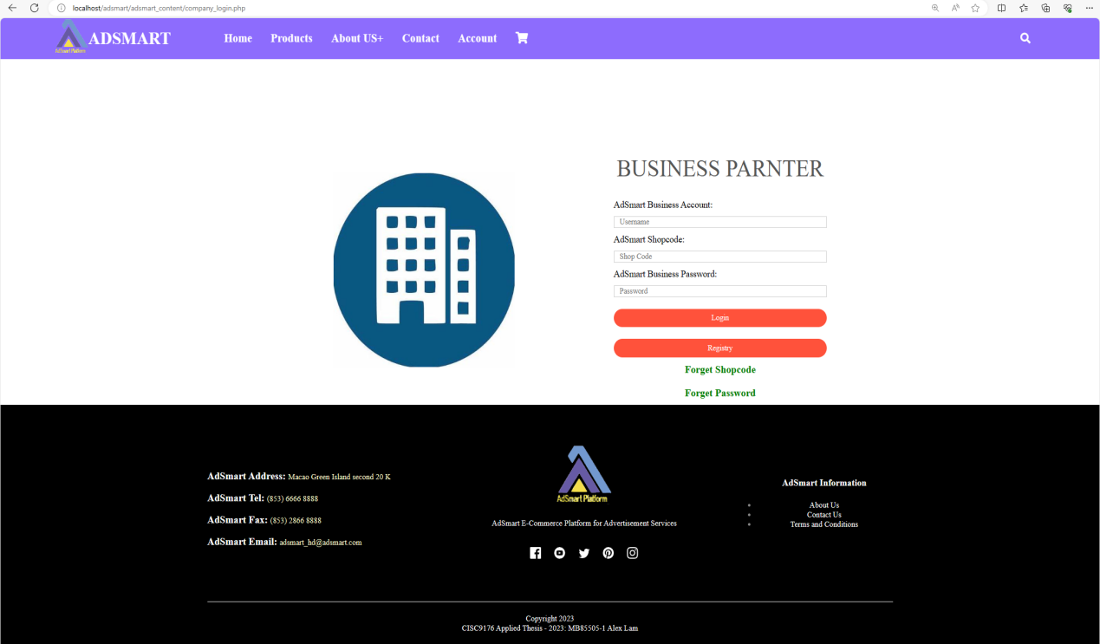

Figure 1.16 AdSmart business partner login page

As figure 1.17, The example demonstrates when the user enters their shop code, user ID, and password, and then clicks the "Login" button.

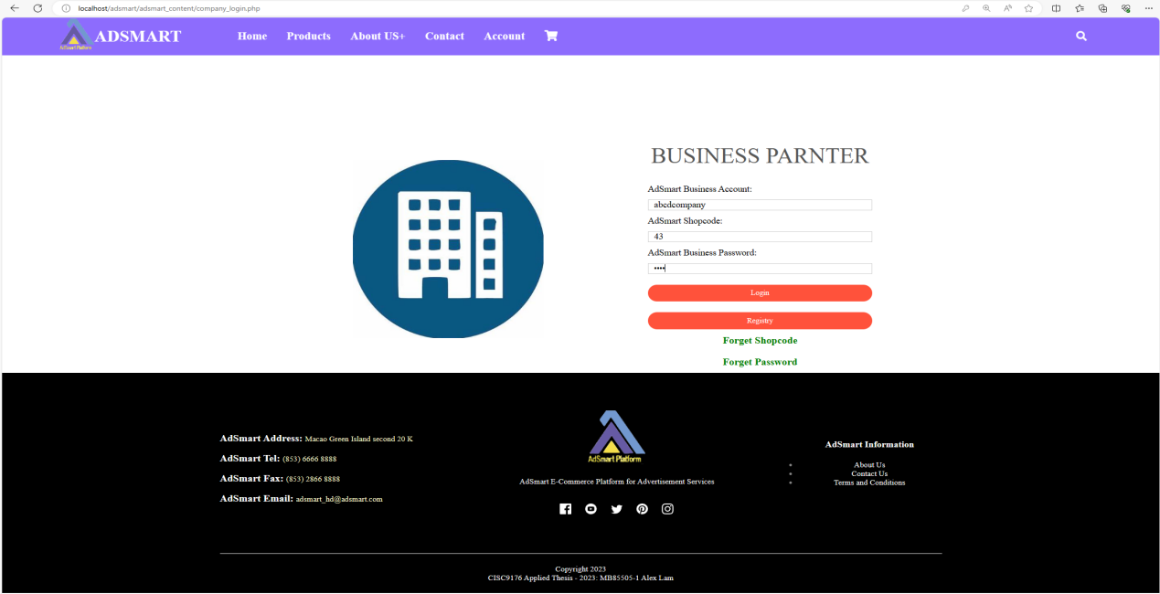

Figure 1.17 The example of AdSmart business partner login Page

When the AdSmart’s business partner logins successfully that he/she will see the successfully message “Login Successfully!!!” and will see the greeting words “Welcome !!” + user id name (figure 1.18) and they can see their company icon in the top right corner of the page.

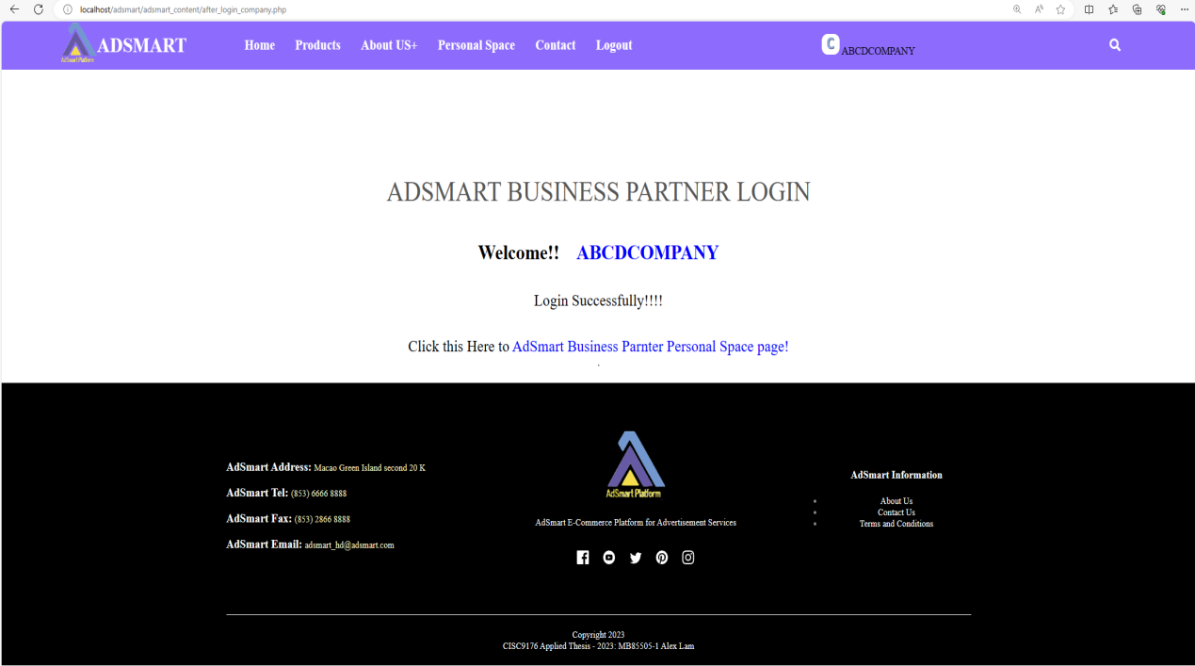

Figure 1.18 AdSmart business partner login successful message

**Use case 5: Reset AdSmart Account Password**

This section provides walk through of the following user interfaces:

1. Signup Page (Figure 1.19)
2. AdSmart customer login Page (Figure 1.20)
3. AdSmart customer reset password Page (Figure 1.21)
4. The example of AdSmart customer reset password page (Figure 1.22)
5. Sent a reset email to customer’s email (Figure 1.23)
6. Check AdSmart customer’s email (Figure 1.24)
7. AdSmart customer create new password page (Figure 1.25)
8. The example of AdSmart customer create new password page (Figure 1.26)
9. Reset password successful (Figure 1.27)

This demonstration shows AdSmart customers how to reset their password in case they forget the initial password. Initially, the AdSmart customer needs to click the "login" button to navigate to the AdSmart customer login page (figure 1.19).



Figure 1.19 Signup page

As figure 1.20, if AdSmart user cannot recall their account password, they should click the "Forget Password" button on the AdSmart customer login page.



Figure 1.20 AdSmart customer login Page

As figure 1.21, the AdSmart customer reset password page will allow the user to enter their email address, which must be registered in the AdSmart database.

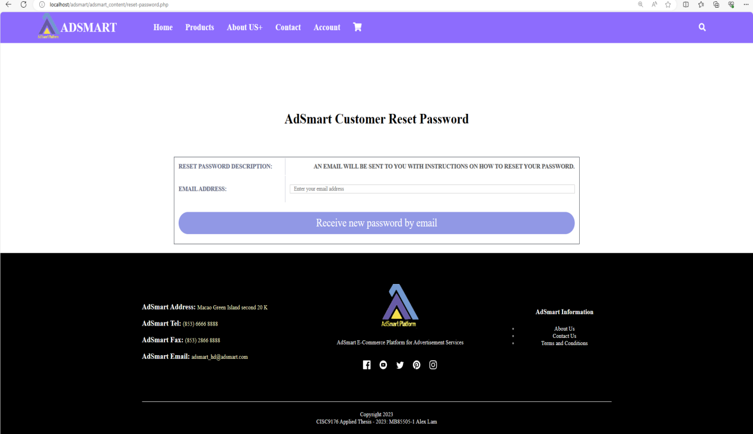

Figure 1.21 AdSmart customer reset password page

As figure 1.22, is the example to show when the user has entered the email address.

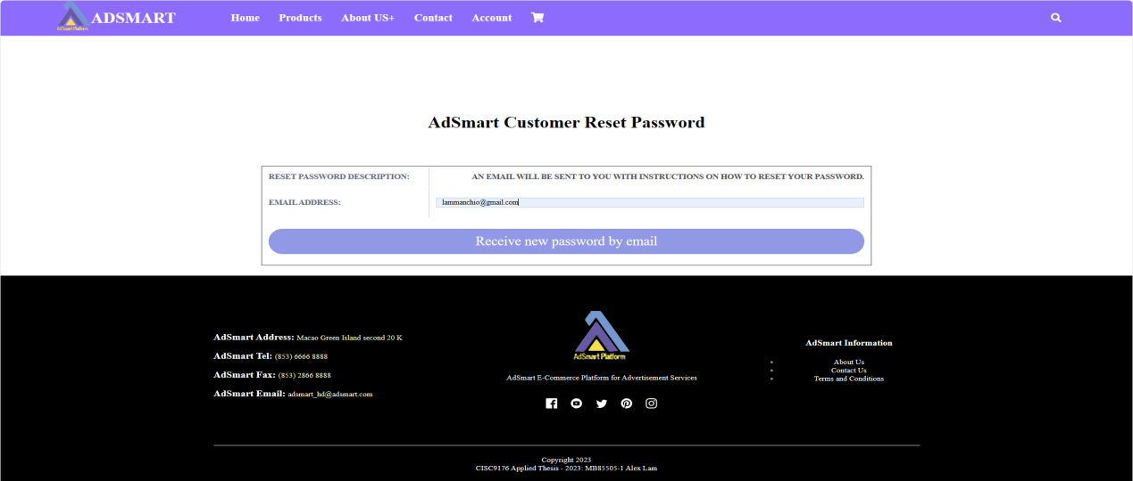

Figure 1.22 The example of AdSmart customer reset password page

As figure 1.23 is to show when the user has clicked the “Receive New password by email” button, then the user can see the “Please check your email to reset password” message.

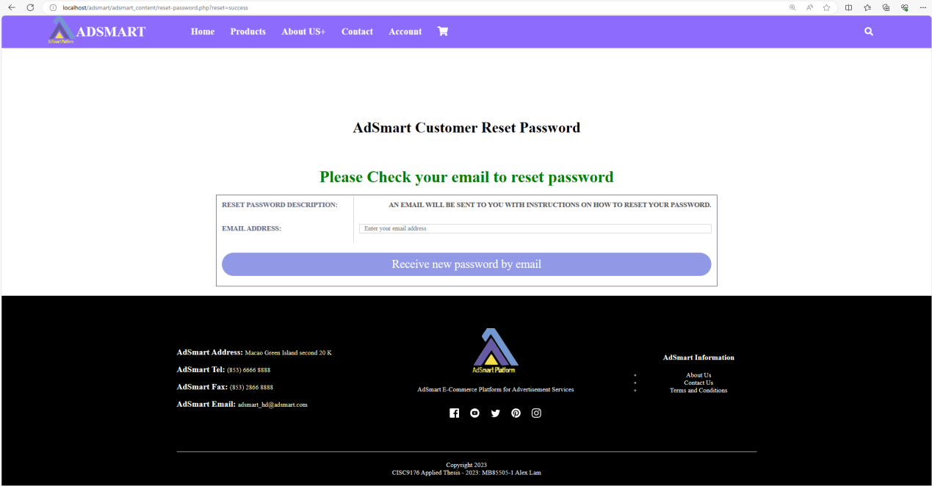

Figure 1.23 Sent a reset email to customer’s email

As figure 1.24, it is the user’s google email and the user can receive the email that sent by AdSmart. The subject of email is “Reset your password for AdSmart” and the content should have password reset link that the user clicks the link to reset his/her password.

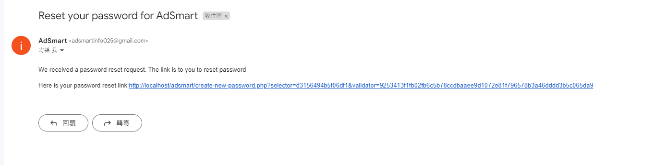

Figure 1.24 Check AdSmart customer’s email

As figure 1.25, after the user clicks the reset password link, he/she will be directed to AdSmart Customer Create New Password page. On this page, AdSmart user is required to enter a new password and confirm password.

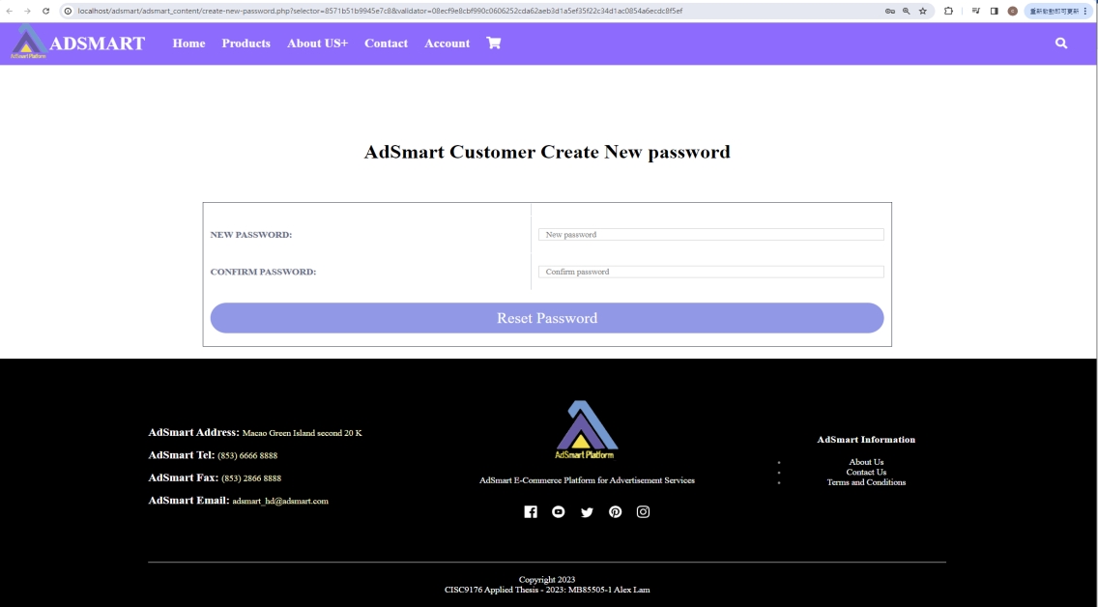

Figure 1.25 AdSmart customer create new password page

As figure 1.26, is the example to show when the user has entered a new password and confirm password.

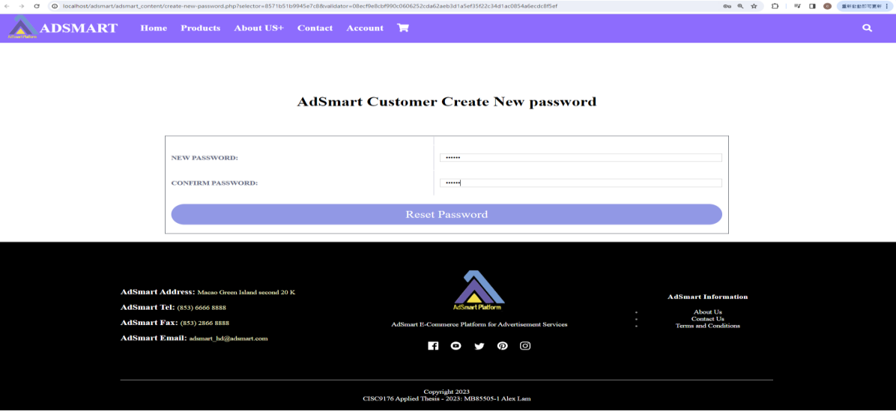

Figure 1.26 The example of AdSmart customer create new password page

When the AdSmart customer successfully resets the password, he/she will see the successful message on the AdSmart customer login page (figure 1.27). Subsequently, the AdSmart customer can utilize the new password to proceed with the login process.

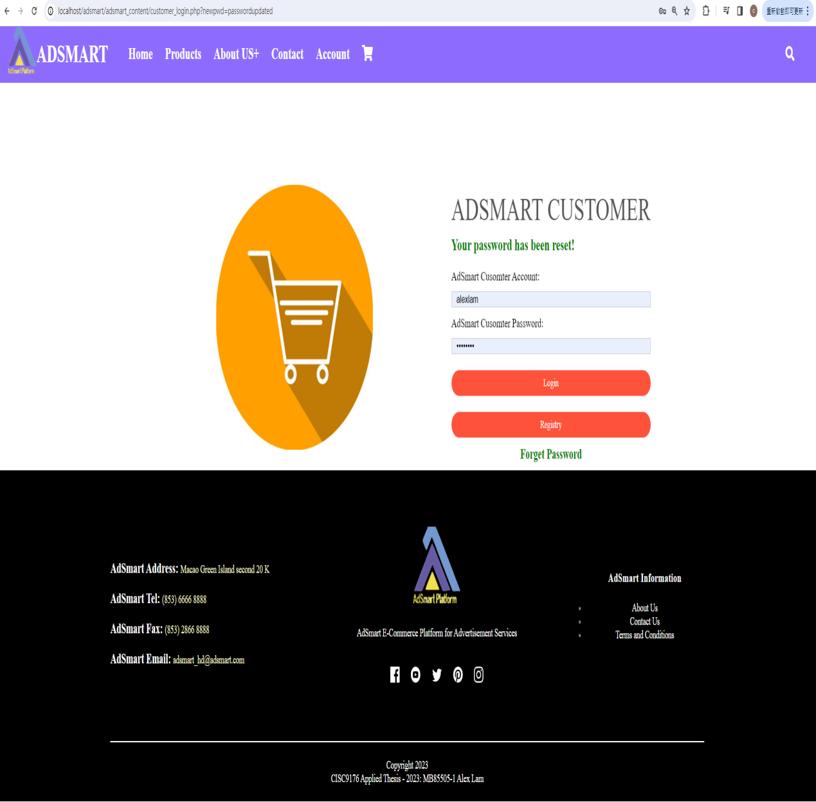

Figure 1.27 Reset password successful

**Use case 6: Update AdSmart Customer Profile**

This section provides walk through of the following user interfaces:

1. Signup Page (Figure 1.28)
2. AdSmart customer login Page (Figure 1.29)
3. AdSmart customer personal space home page (Figure 1.30)
4. AdSmart customer profile page (Figure 1.31)
5. Update AdSmart customer profile page (Figure 1.32)
6. Update AdSmart customer profile successfully (Figure 1.33)
7. Change AdSmart customer password page (Figure 1.34)
8. Change AdSmart customer password successfully (Figure 1.35)

In this demonstration, we will illustrate how AdSmart customers can navigate to their AdSmart customer profile page and update their profile, including changing their password.

AdSmart customers must login their AdSmart customer account. They should proceed to the Signup Page (figure 1.28) and then click the login button in the AdSmart customer registration box.

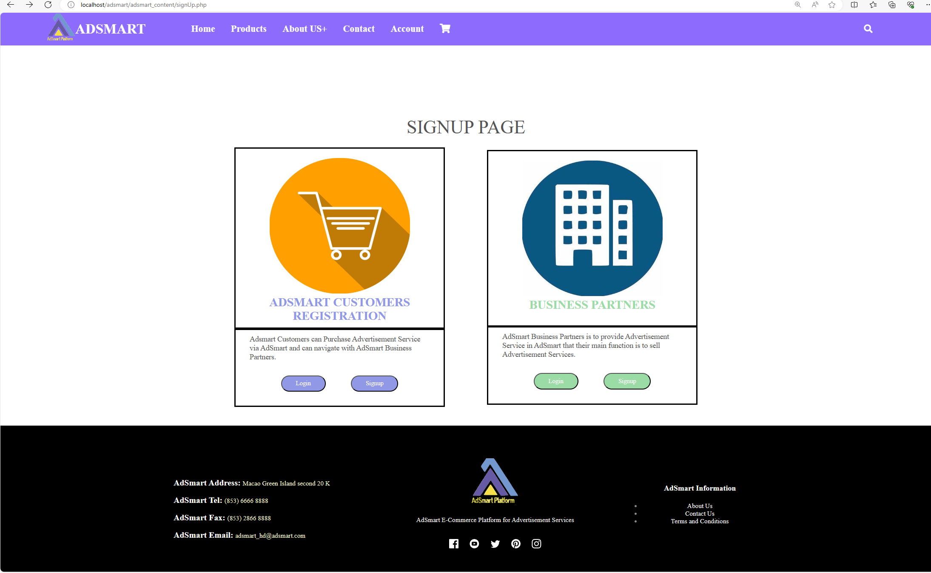

Figure 1.29 Signup page

As figure 1.29, after the AdSmart customer clicks the login button, they will be directed to the AdSmart customer login page (figure 1.30) that they need to enter their user id and password. Subsequently, they should click “login” button to login.

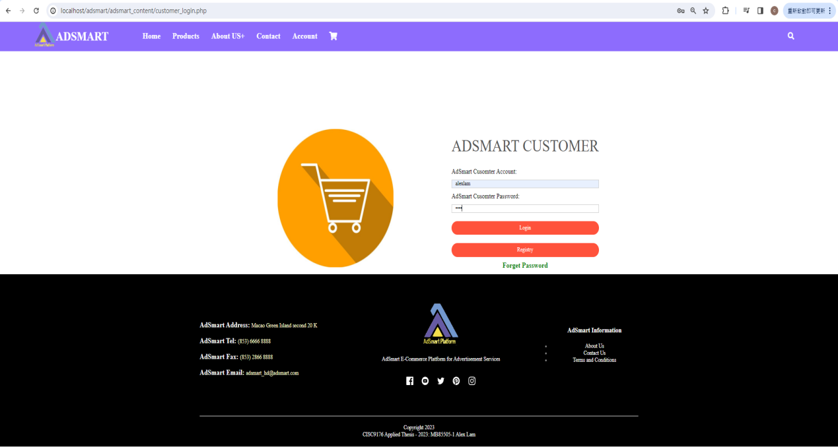

Figure 1.30 AdSmart customer login Page

After login, AdSmart customers should click the "Personal Space" button on the navigation bar. This action will direct them to the AdSmart personal space home page (as figure 1.31).

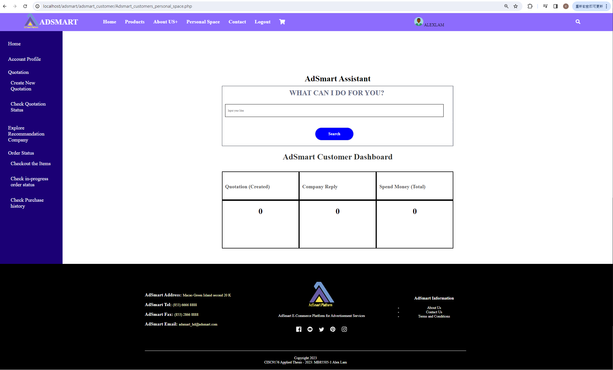

Figure 1.31 AdSmart customer personal space home page

As figure 1.32, in the AdSmart Customer Profile page, users are allowed to edit their information They can update their personal information, change their password, modify credit card information, and adjust their preferences.



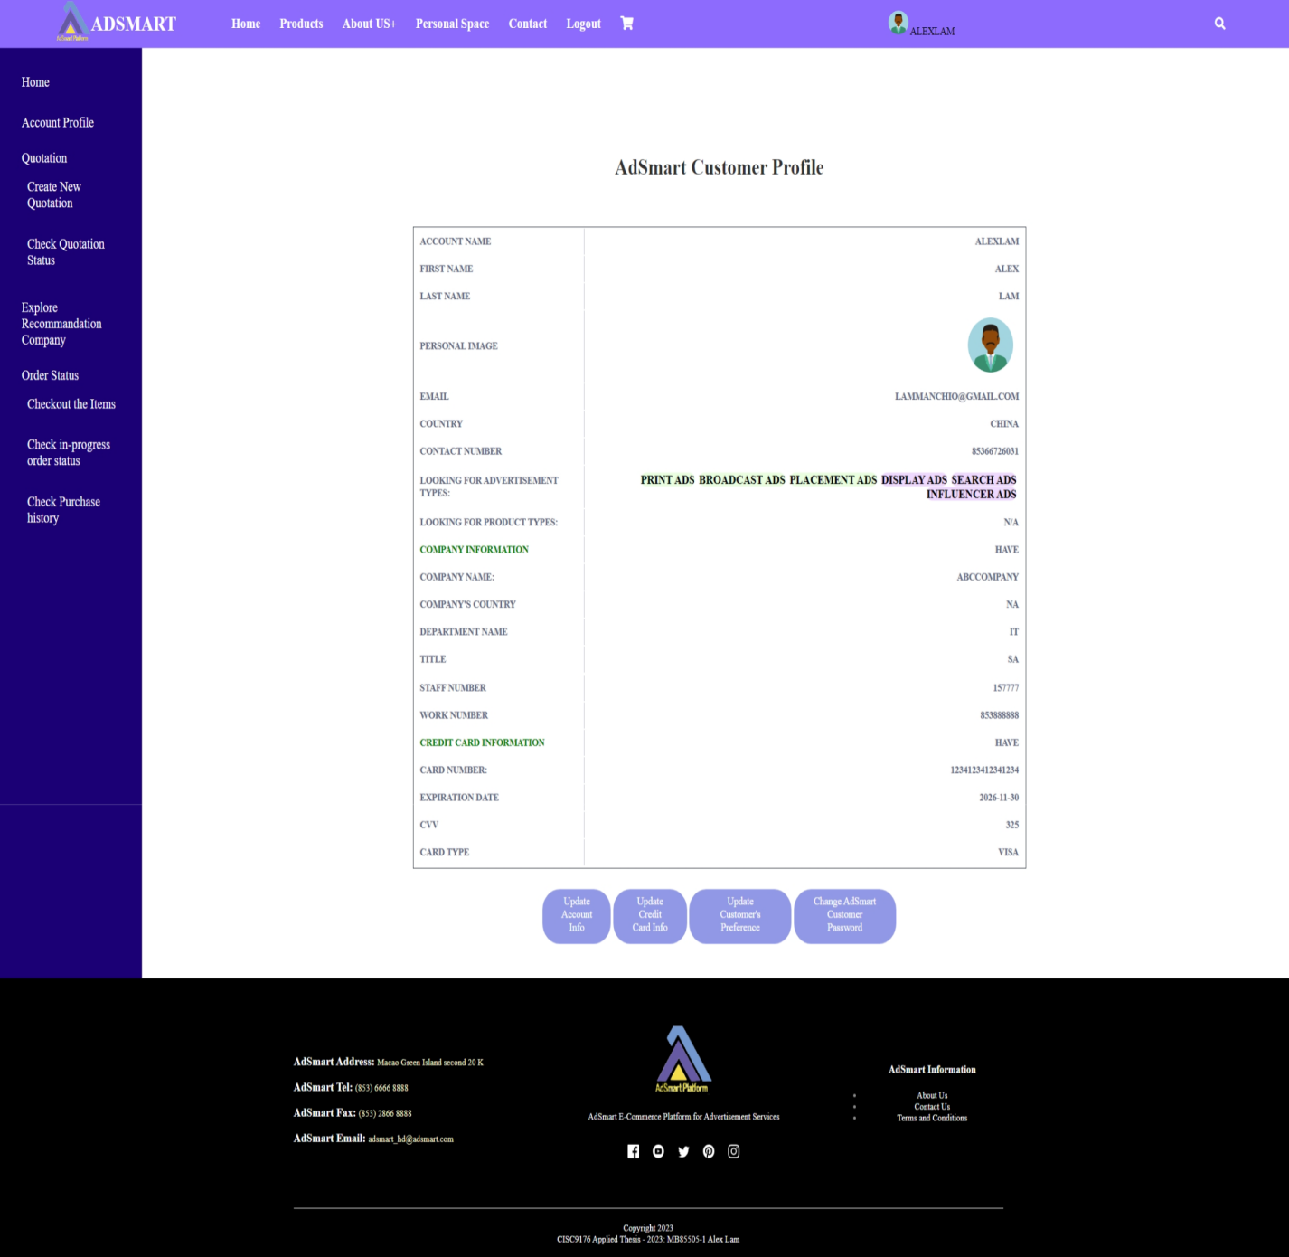

Figure 1.32 AdSmart customer profile page

As figure 1.33, in the update AdSmart customer profile page, AdSmart customers can update their personal information such as first name, last name, icon, email address, country, contact number and company information.

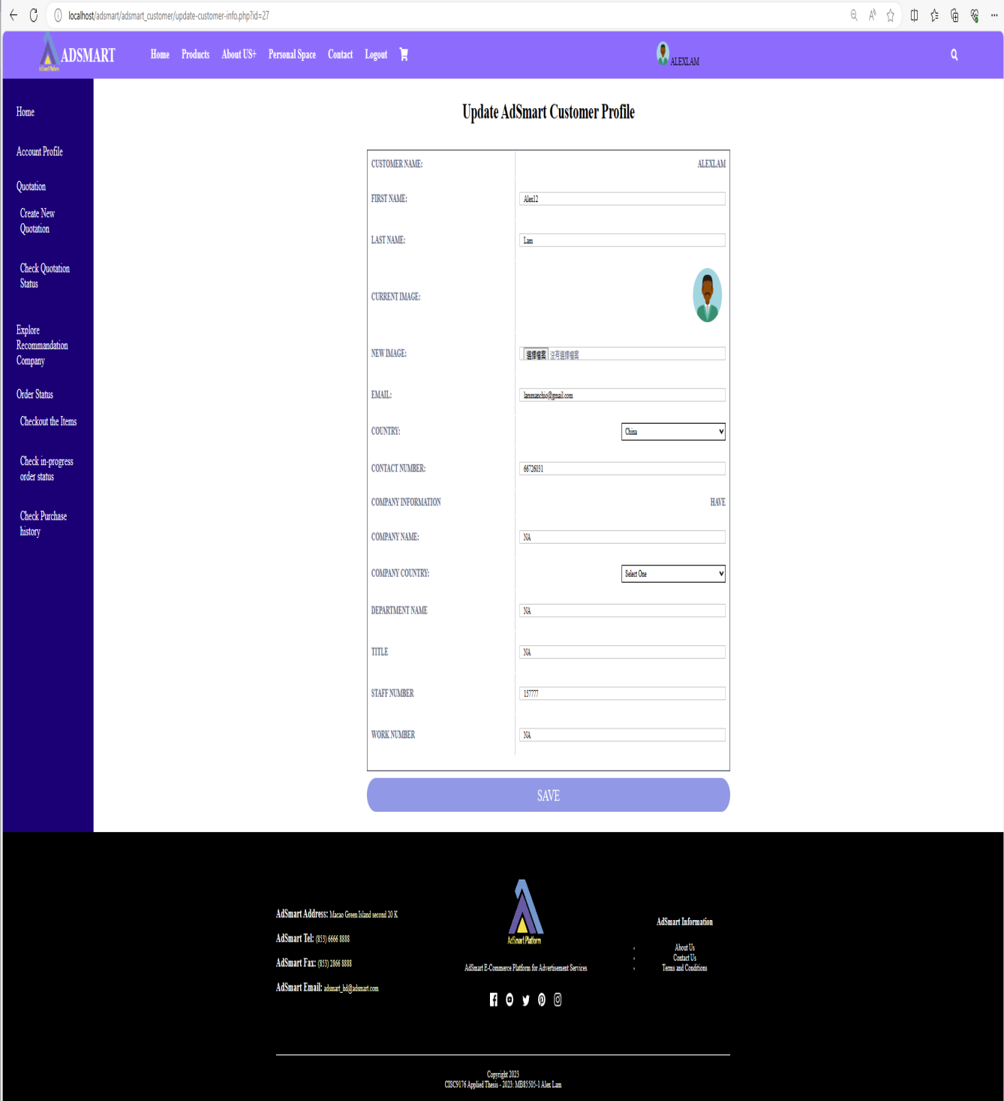

Figure 1.33 Update AdSmart customer profile page

As figure 1.34, After updated the information of customer profile, AdSmart customer will see the successful message “AdSmart customer profile updated successfully”.

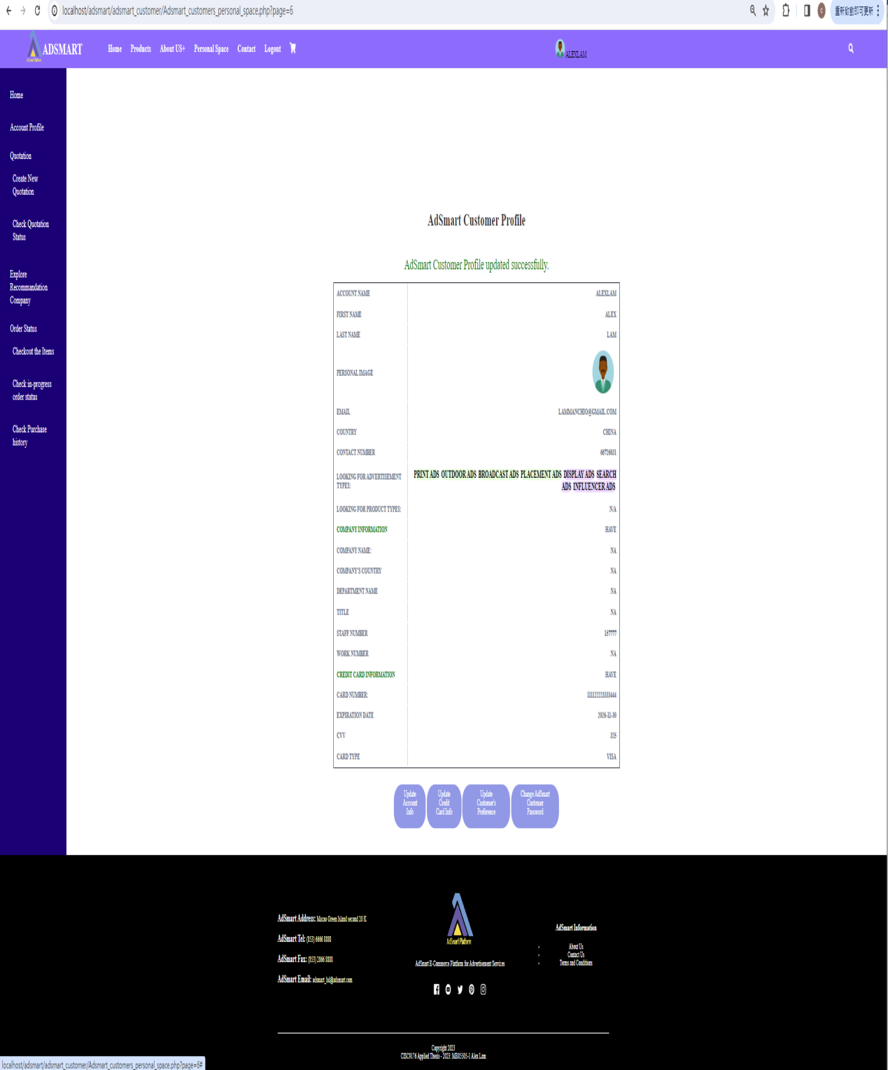

Figure 1.34 Update AdSmart customer profile successfully

As figure 1.35, in change AdSmart customer password page, AdSmart customers can change their password that they need to input the current password, new password and confirmation password.

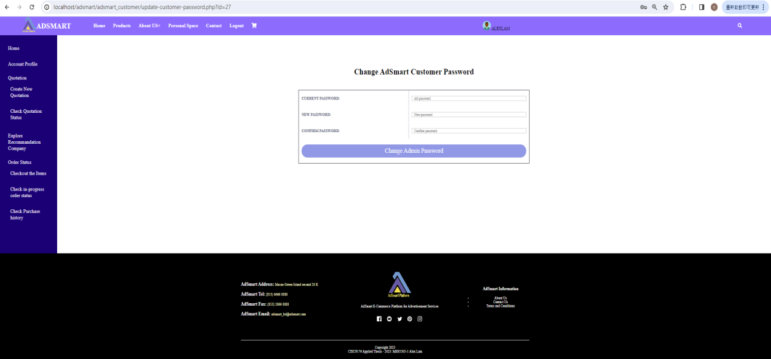

Figure 1.35 Change AdSmart customer password page

As figure 1.36, after changed AdSmart customer password, AdSmart customers can see the successful message “Password Change Successfully”.

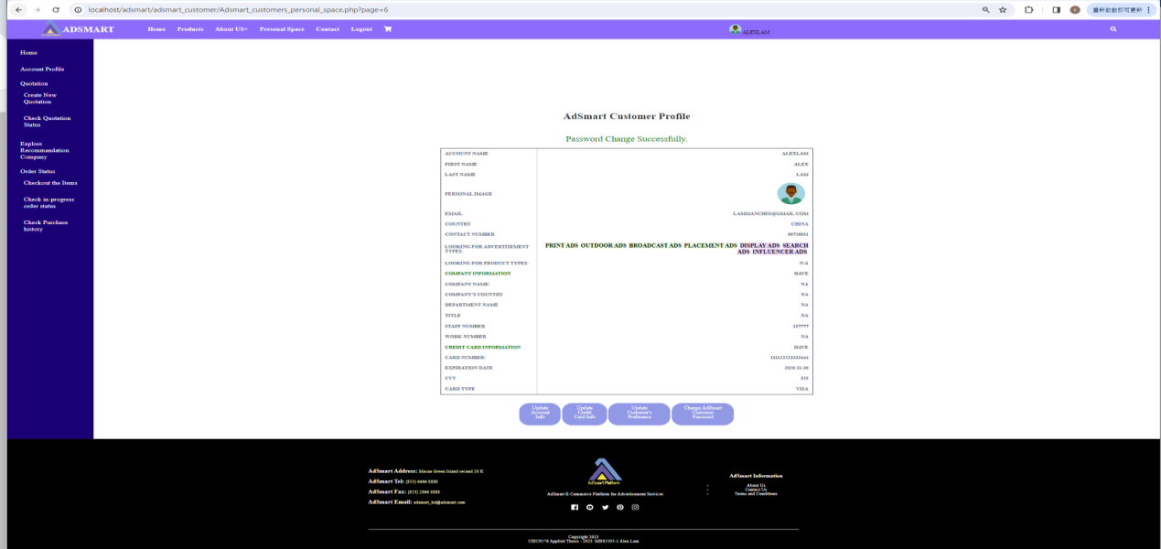

Figure 1.36 Change AdSmart customer password successfully

**Use case 7: Update AdSmart Business Partner Profile**

This section provides walk through of the following user interfaces:

1. Signup Page (Figure 1.37)
2. AdSmart business partner login Page (Figure 1.38)
3. AdSmart business partner personal space home page (Figure 1.39)
4. AdSmart business partner profile page (Figure 1.40)
5. Update AdSmart business partner profile page (Figure 1.41)
6. Update AdSmart business partner profile successfully (Figure 1.42)
7. Change AdSmart business partner password page (Figure 1.43)
8. Change AdSmart business partner password successfully (Figure 1.44)

In this demonstration, we will illustrate how AdSmart business partners can access their AdSmart business partner profile page and update their profile information, including changing their password.

AdSmart business partners need to login their AdSmart Account Password, therefore, they need to go to Signup Page (figure 1.37) and then click the login button in the AdSmart customer registration box.



Figure 1.37 Signup page

As figure 1.38, after AdSmart business partners click the login button, they will be directed to the AdSmart business partner login page. They need to enter their user id, password and shopcode. Subsequently, they should click the "login" button to proceed with the login process.

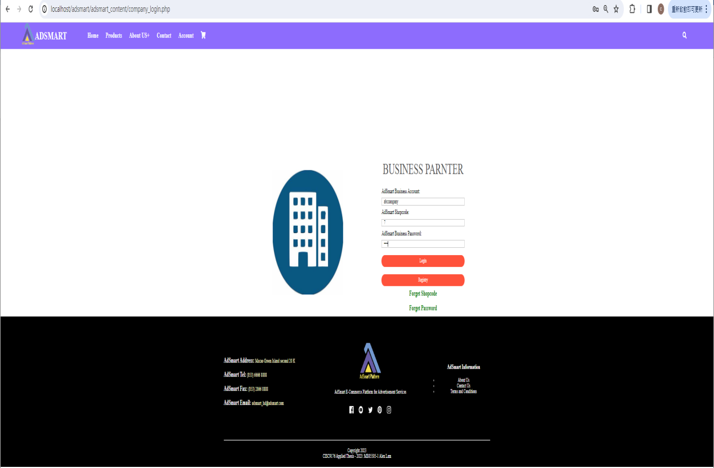

Figure 1.38 AdSmart business partner login Page

After login, AdSmart business partners should click the “Personal Space” button located on the navigation bar. This action will navigate them to the AdSmart personal space home page (as figure 1.39).

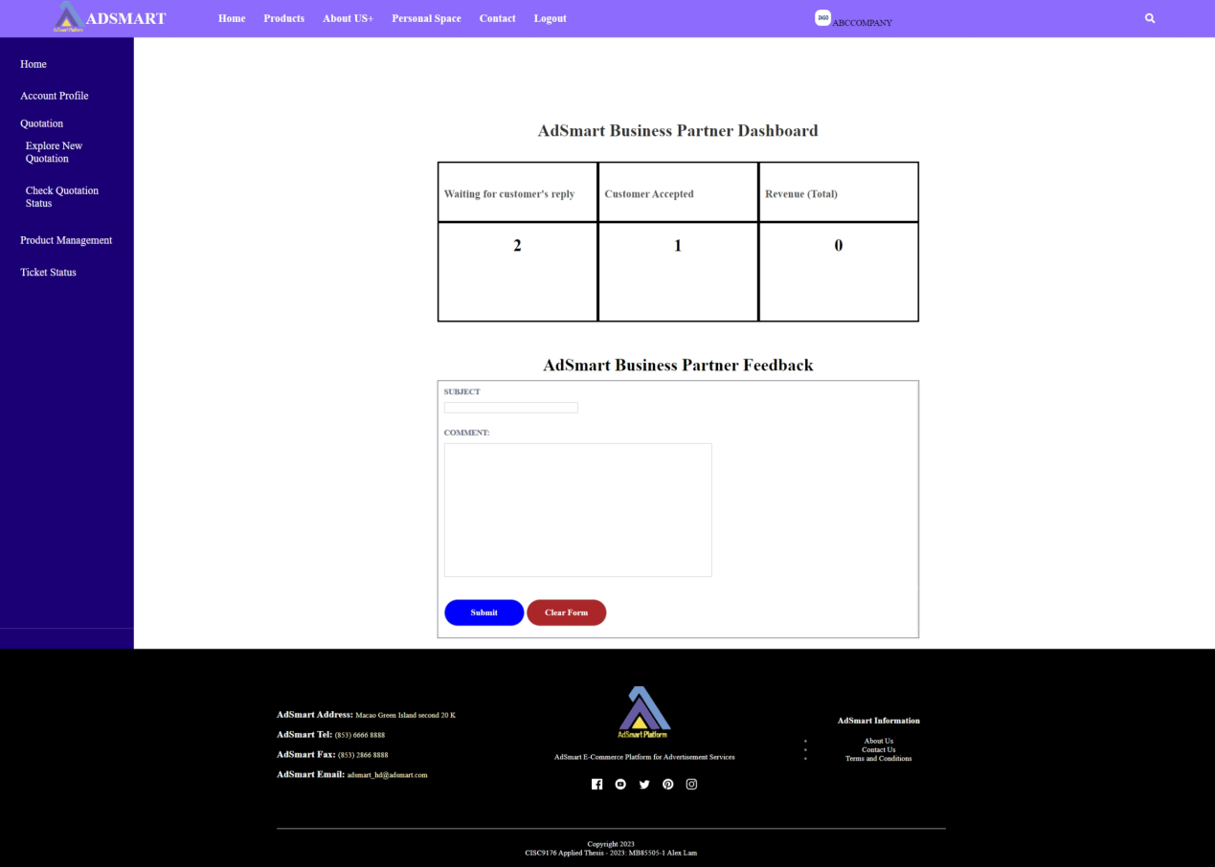

Figure 1.39 AdSmart business partner personal space page

As figure 1.40, in the AdSmart Business Partner Profile page, AdSmart business partners can edit their company information. They have the ability to update their company information, change their password, modify bank account information, and adjust their preferences.

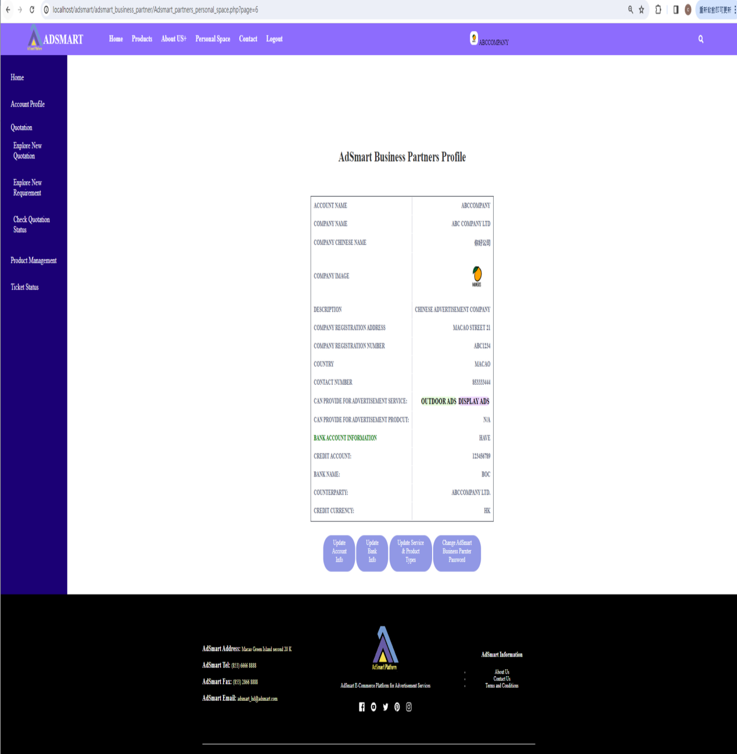

Figure 1.40 AdSmart business partner profile page

As figure 1.41, in the Update AdSmart business partner profile page, AdSmart business partners can update their company information such as company name, company Chinese name, company image, email, country, contact number, description, company registration address and company registration number.

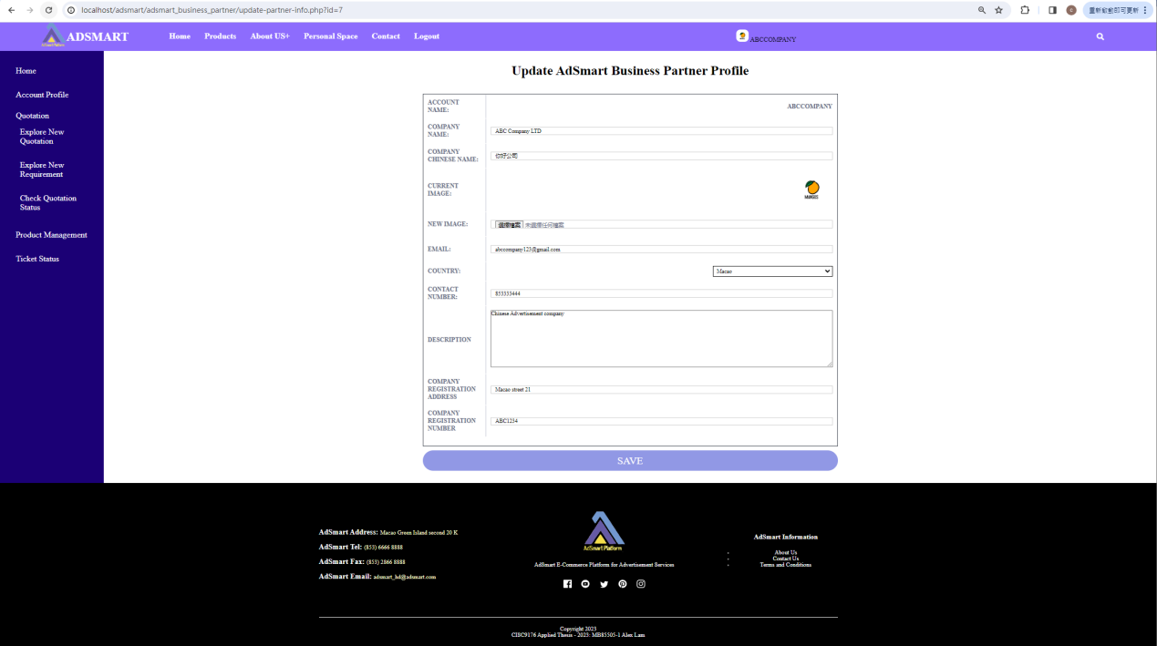

Figure 1.41 Update AdSmart business partner profile page

As figure 1.42, After updated business partner profile information, AdSmart business partners can see the successful message “AdSmart Business Partner Profile updated successfully”.

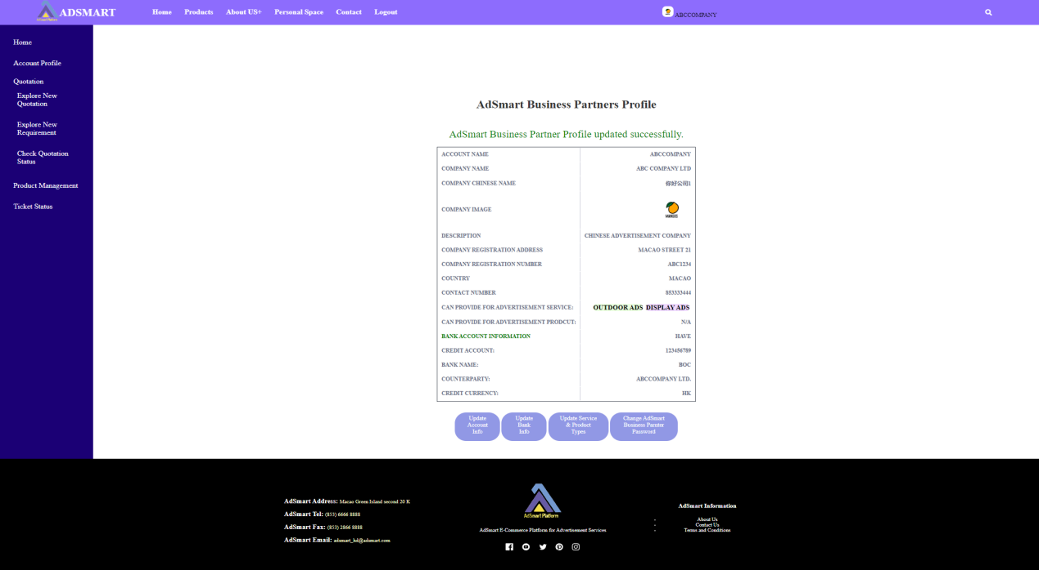

Figure 1.42 Update AdSmart business partner profile successfully

As figure 1.43, in the Change AdSmart business partner password page, AdSmart business partners can change their user’s password in this page that they need to input the current password, new password and confirmation password.

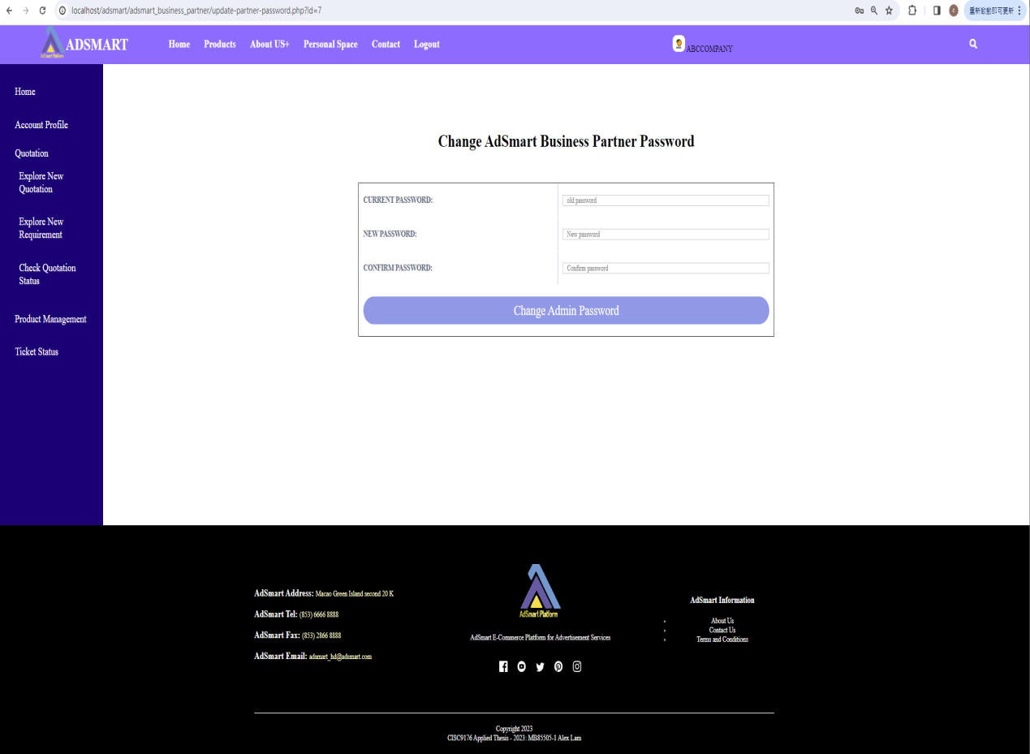

Figure 1.43 Change AdSmart business partner password page

As figure 1.44, after changed AdSmart business partner password, AdSmart business partners can see the successful message “Password Change Successfully”.

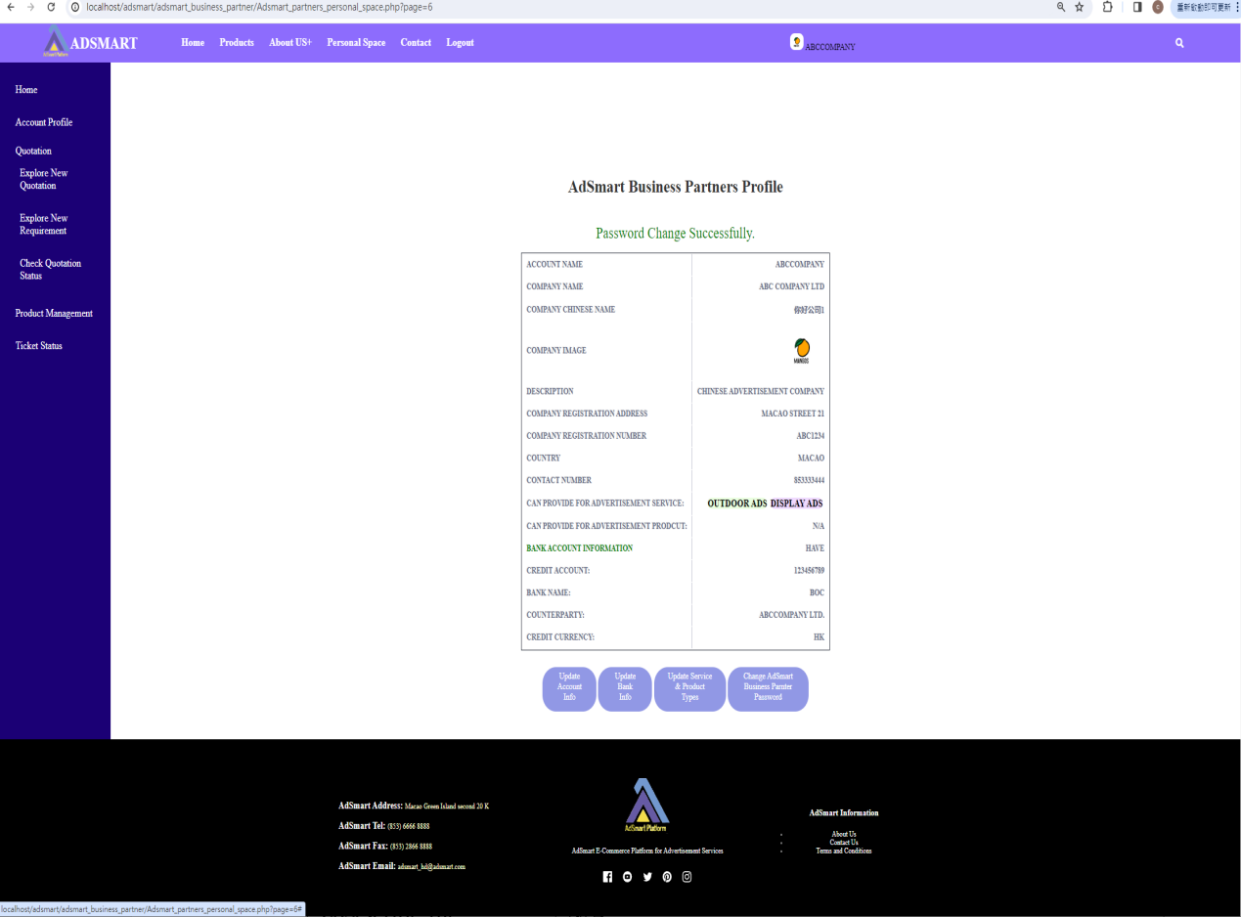

Figure 1.44 Change AdSmart business partner password successfully

**Use case 8: Search Product and Add Product to Shopping Cart**

This section provides walk through of the following user interfaces:

1. Customer Login Page (Figure 1.45)
2. Customer personal space (Figure 1.46)
3. The example of search product (Figure 1.47)
4. Search result page (Figure 1.48)
5. Explore business partner’s shop (Figure 1.49)
6. The example of add item to shopping cart (Figure 1.50)
7. Display added item successful message (Figure 1.51)
8. Check the content of Shopping cart (Figure 1.52)

As figure 1.45, AdSmart customer needs to login AdSmart, therefore, he/she needs to go to AdSmart customer login page to login.

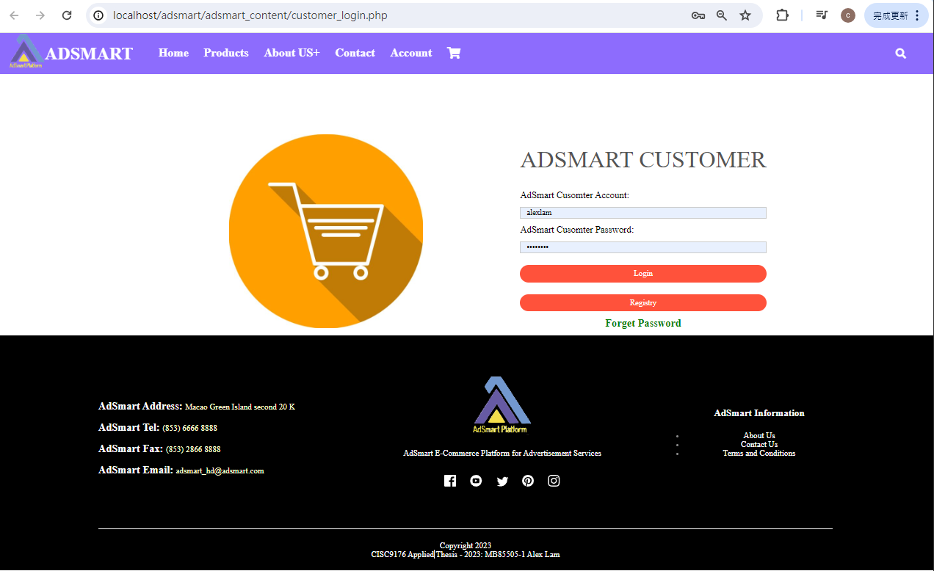

Figure 1.45 Customer Login Page

As figure 1.46, after login, AdSmart provides a search bar on the personal page that customers can use to search for products or services.

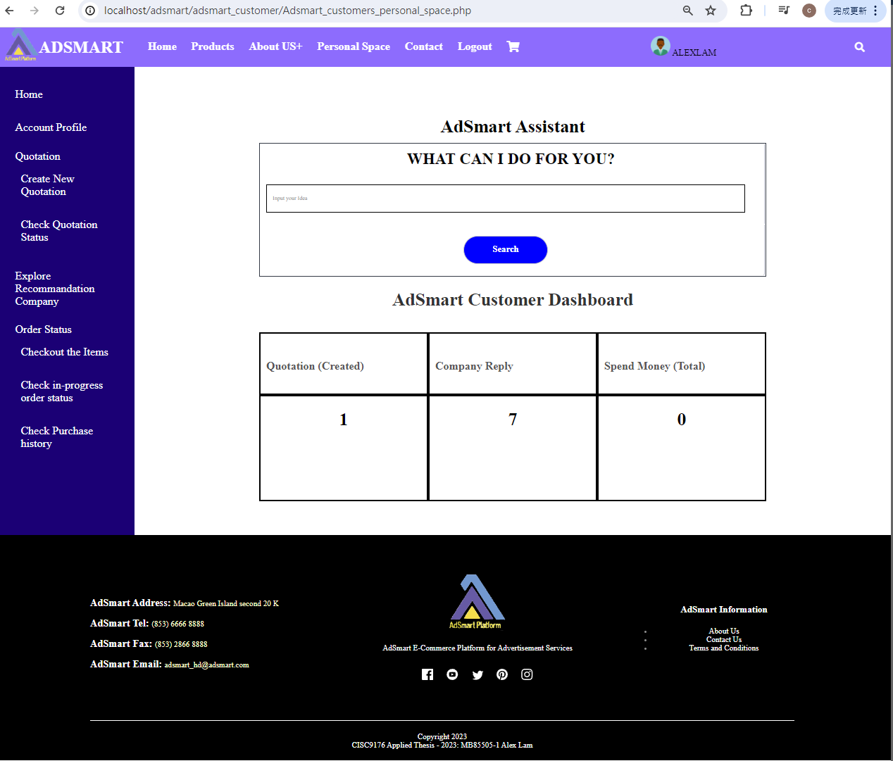

Figure 1.46 Customer personal space

As figure 1.47, this is an example where a user has entered a sentence to search for a product. Note that AdSmart allows users to input sentences to search for products or services.

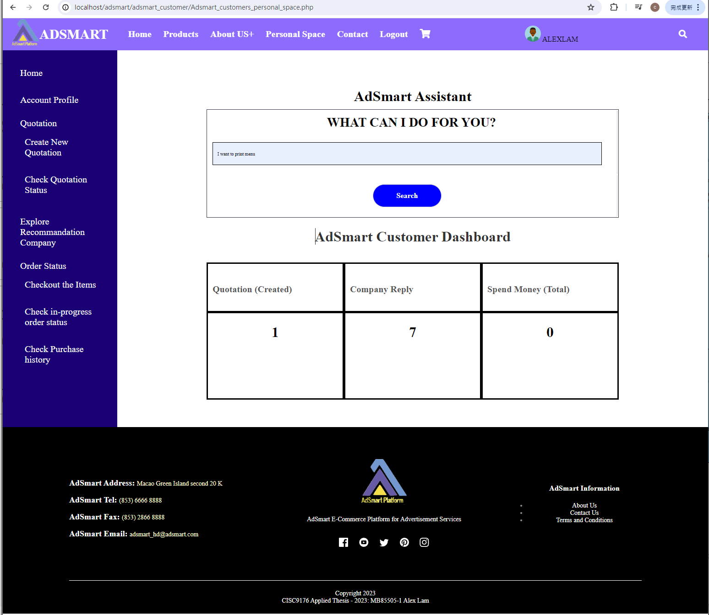

Figure 1.47 The example of search product

As figure 1.48 is the search result that customer entered the sentence "I want to print a menu" to search for the product.



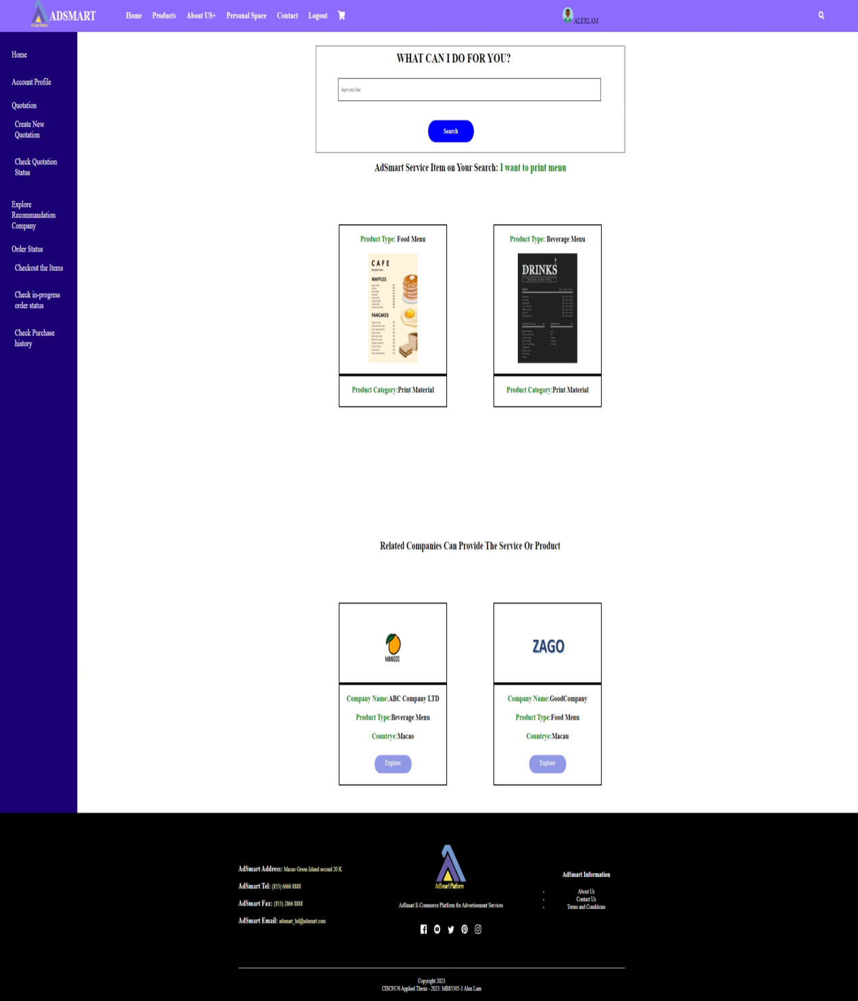

Figure 1.48 Search result page

As figure 1.49, this is the business partner's shop that the customer sees when they click the "explore" button on the search result page. AdSmart will keep a search bar in the business partner's shop to make it convenient for customers to search for products again.



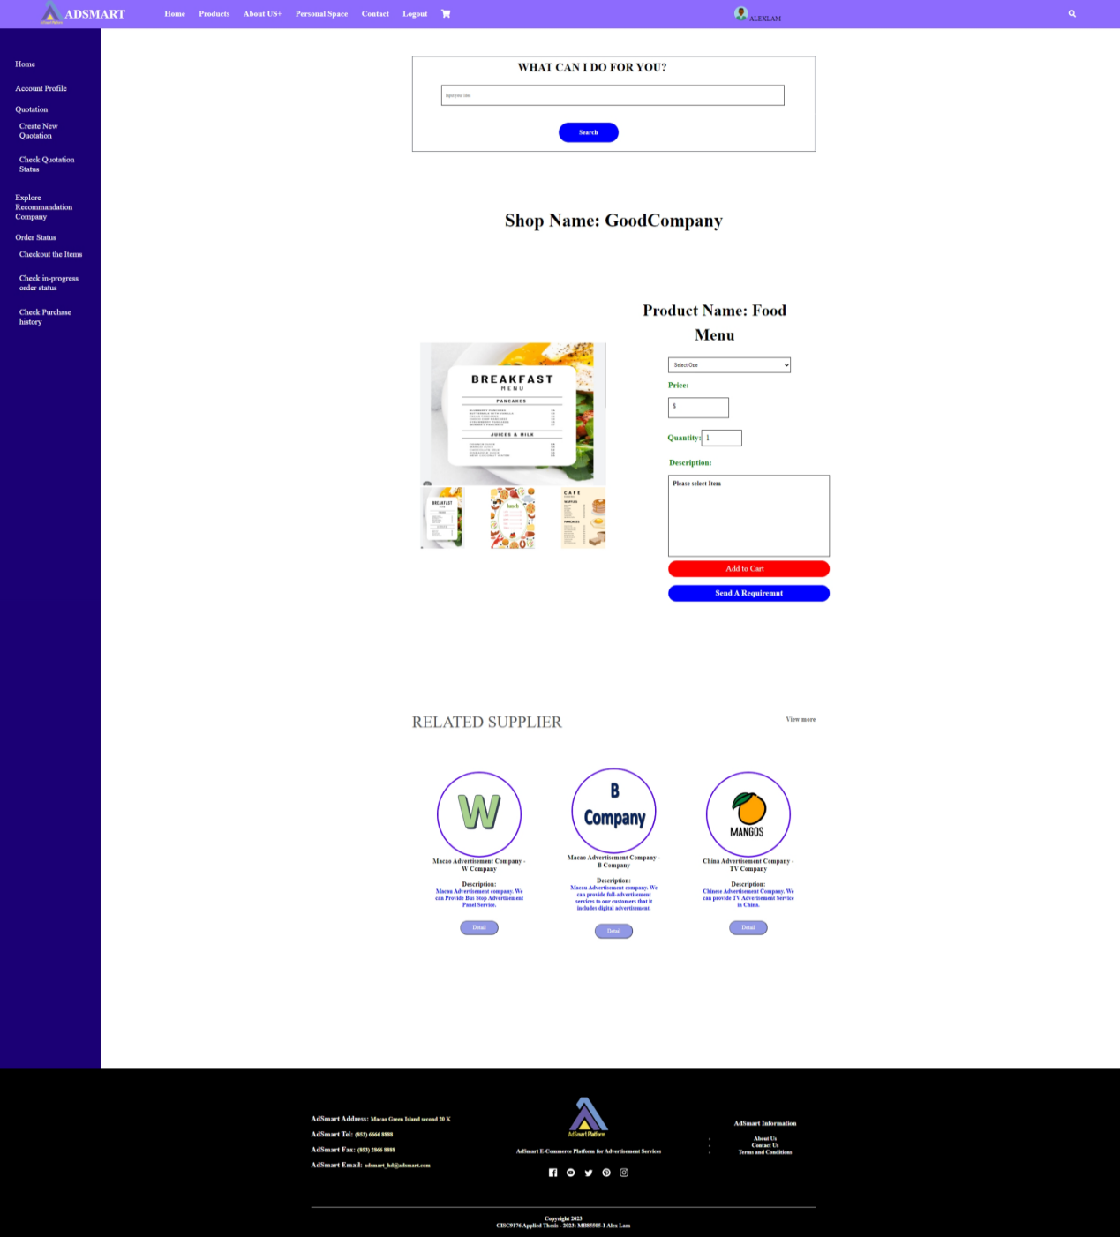

Figure 1.49 Explore business partner’s shop

As figure 1.50 is an example of customer to add the product to shopping cart. Customer needs to select product and quantity, and then clicks the “add to cart” button.



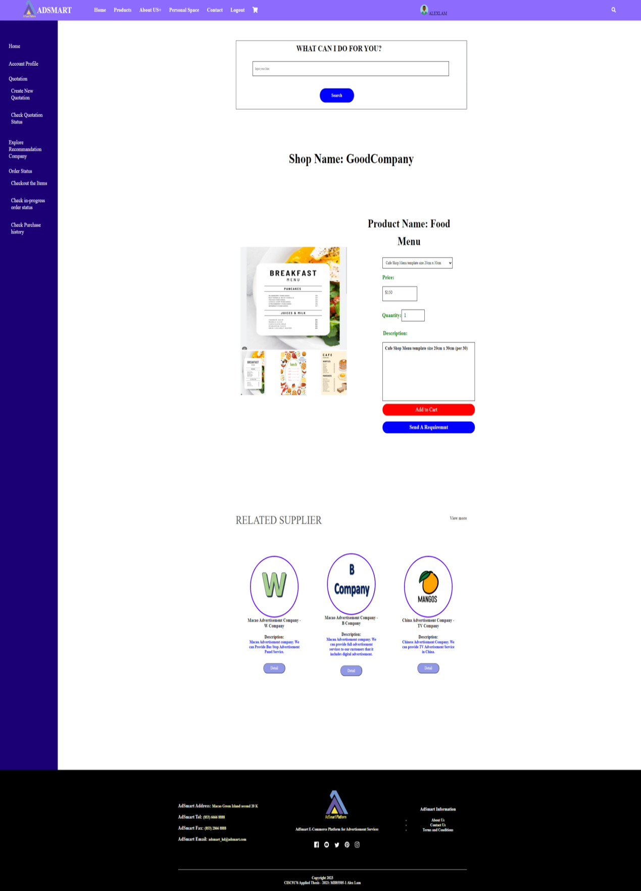

Figure 1.50 The example of add item to shopping cart

As figure 1.51, the customer can see a success message confirming that the item has been added to the shopping cart. The customer can then check the shopping cart to verify. (figure 1.52).

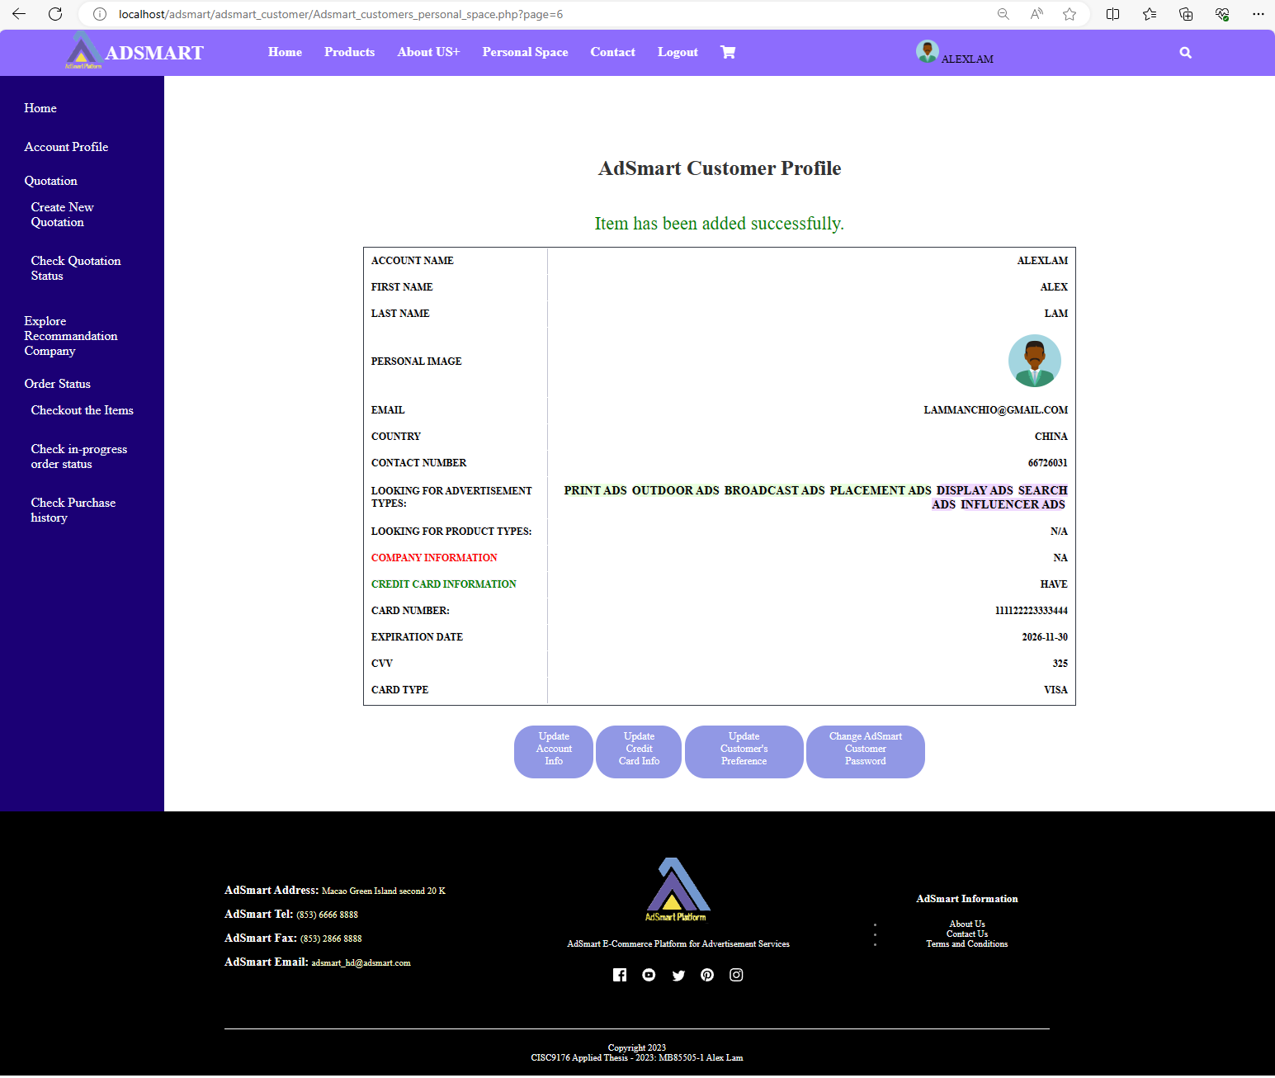

Figure 1.51 Display added item successful message

As figure 1.52, the shopping cart page displays details of the items added to the cart. Customers can view the company name, product name, product image, price, quantity, and total amount in the shopping cart page. Additionally, customers can edit the quantity and remove items on this page.

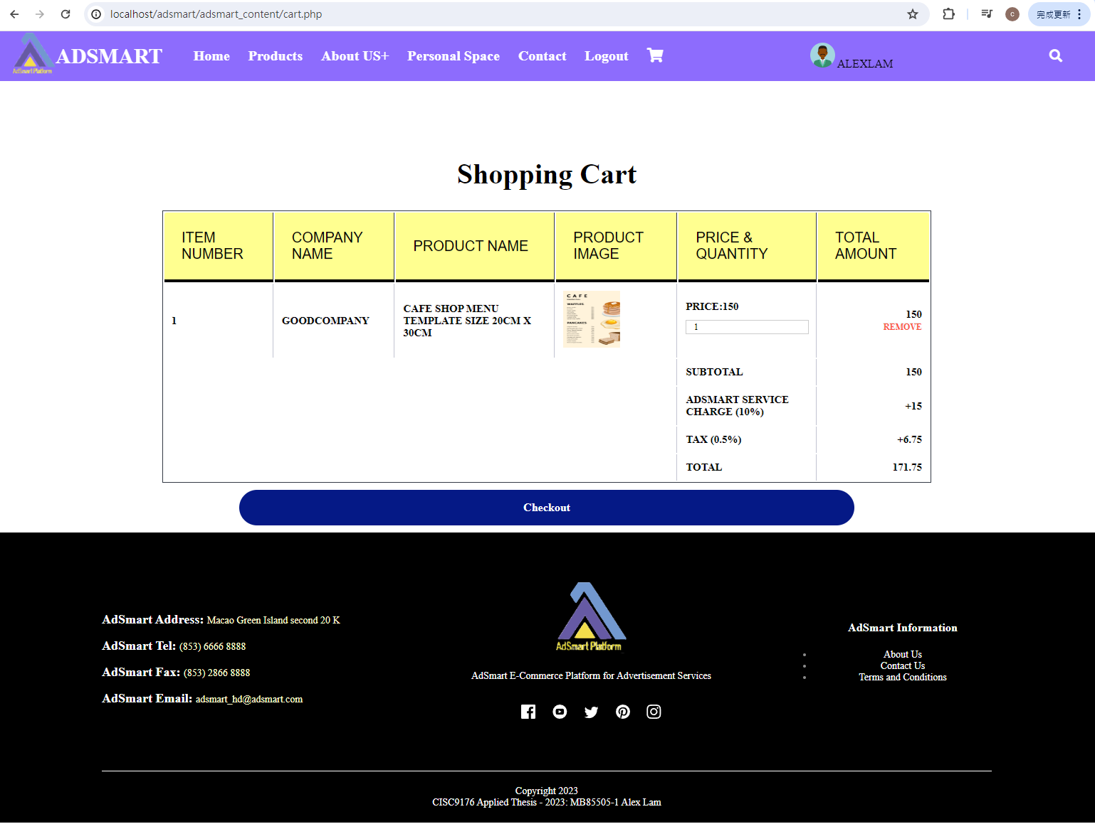

Figure 1.52 Check the content of Shopping cart

**Use case 9: Create Advertisement request**

This section provides walk through of the following user interfaces:

1. AdSmart customer Personal space page (Figure 1.53)
2. Create an advertisement request page (Figure 1.54)
3. The example of Create an advertisement request page (Figure 1.55)
4. Complete an advertisement request creation (Figure 1.56)

In this demonstration, we will show AdSmart customer how to create an advertisement request.

As figure 1.53, customer needs to click the "Create New Quotation" button in the left bar, which will take customer to “Create an Advertisement Request” page.

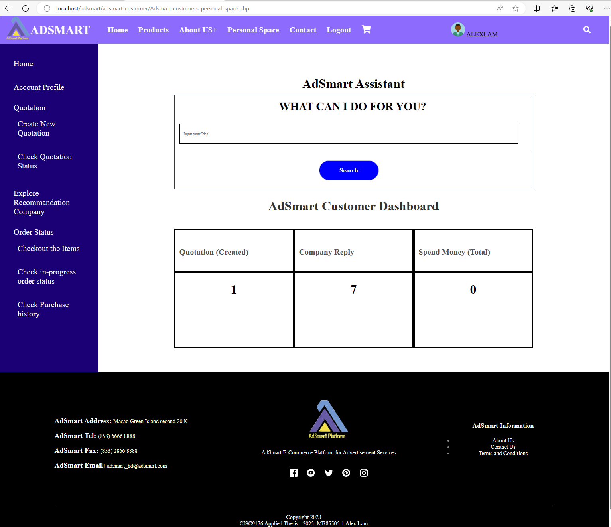

Figure 1.53 AdSmart customer Personal space page

As figure 1.54, the customer needs to input the details of the request on this page for creating the advertisement request.

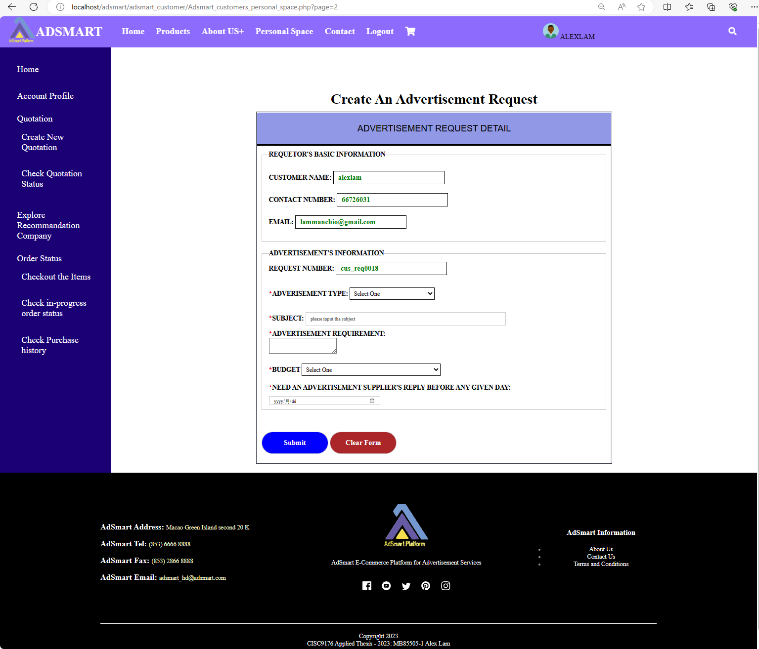

Figure 1.54 Create an advertisement request page

As figure 1.55 is an example of customer to create an advertisement request. Customer needs to input advertisement type, subject, advertisement requirement, budget and need an advertisement supplier’s reply before any given day and AdSmart will auto-generate the request number.



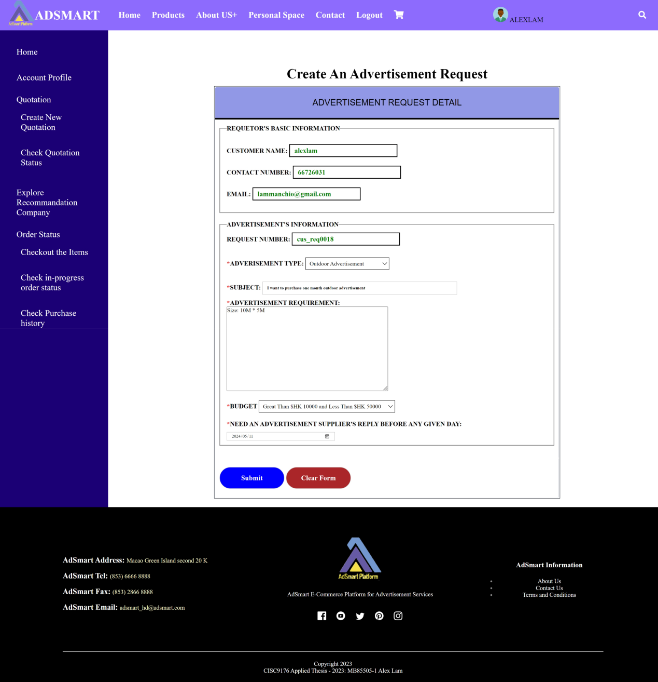

Figure 1.55 The example of Create an advertisement request page

As figure 1.56, customer can see the successful message “Advertisement request created successfully” on the “Advertisement Quotation Status” page and can see the ticket status in this page.



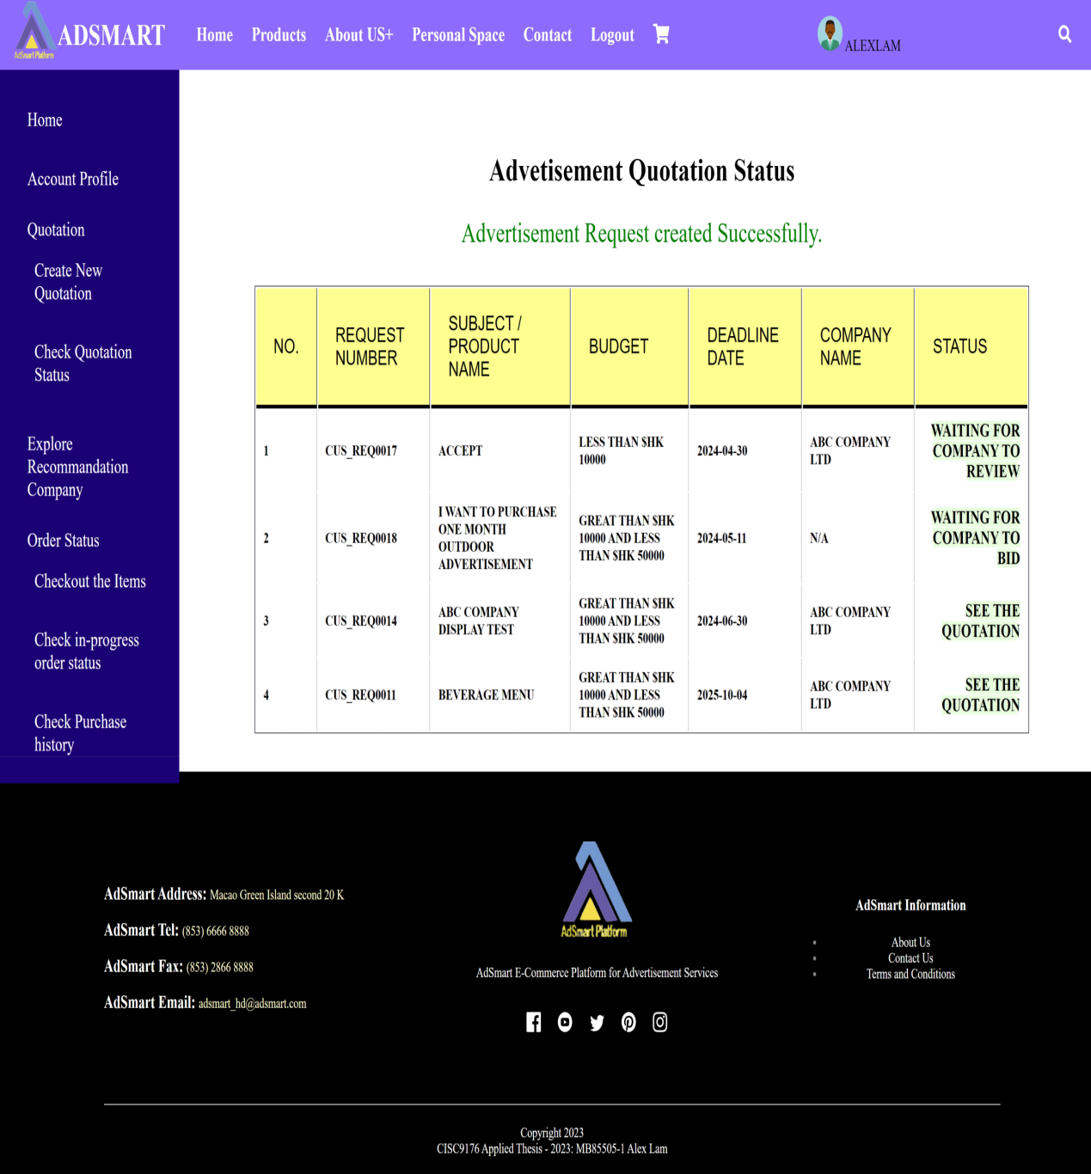

Figure 1.56 Complete an advertisement request creation

## Use case 10: Explore Advertisement and Send a Contract to Customer

This section provides walk through of the following user interfaces:

1. AdSmart business partner Personal space page (Figure 1.57)
2. Explore new advertisement request page (Figure 1.58)
3. Ticket’s detail page (Figure 1.59)
4. The example of business partner to send first quotation to customer (Figure 1.60)
5. Business partner’s advertisement quotation status page (Figure 1.61)
6. Customer’s advertisement quotation status page (Figure 1.62)
7. The detail of first quotation (Figure 1.63)
8. The example of customer accepts this offer (Figure 1.64)
9. Display the successful message about the ticket has been replied (Figure 1.65)
10. Customer Accepted and need to generate contract (Figure 1.66)
11. Generate a contract page (Figure 1.67)
12. The example for business partner to generate a contract (Figure 1.68)
13. view the quotations (Figure 1.69)
14. See the quotations (Figure 1.70)
15. Upload business partner signoff contract (Figure 1.71)
16. Upload PDF file successfully (Figure 1.72)
17. See the quotation in customer side (Figure 1.73)
18. Download the contract in customer side (Figure 1.74)
19. Download the full signoff version contract in business side (Figure 1.75)
20. Download the full signoff version contract in customer side (Figure 1.76)

In this demonstration, we will show AdSmart business partners how to explore an advertisement request and send a quotation to a customer. In this scenario, let's assume ABC Company can provide outdoor advertisements; therefore, ABC Company can view outdoor advertisement requests. If the company cannot provide outdoor advertisements, they will not see any outdoor advertisement requests.

As figure 1.57, the business partner needs to click the "Explore an Advertisement Service" button on the left bar. AdSmart will then redirect the business partner to the page where they can explore advertisement services.

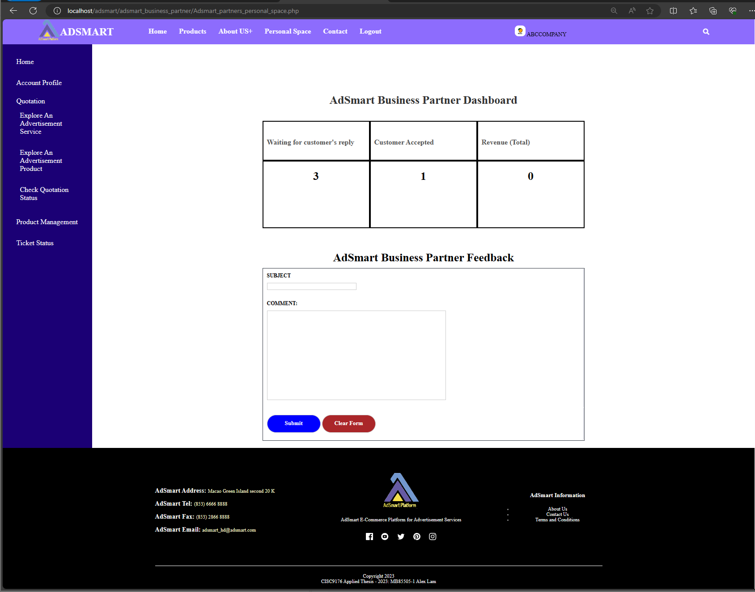

Figure 1.57 AdSmart business partner Personal space page

As figure 1.58, after the business partner clicks the "Explore an Advertisement Service" button, AdSmart will redirect the business partner to the “Explore an Advertisement Service” page. On this page, the business partner needs to click the "Explore" button to view the details of the ticket.

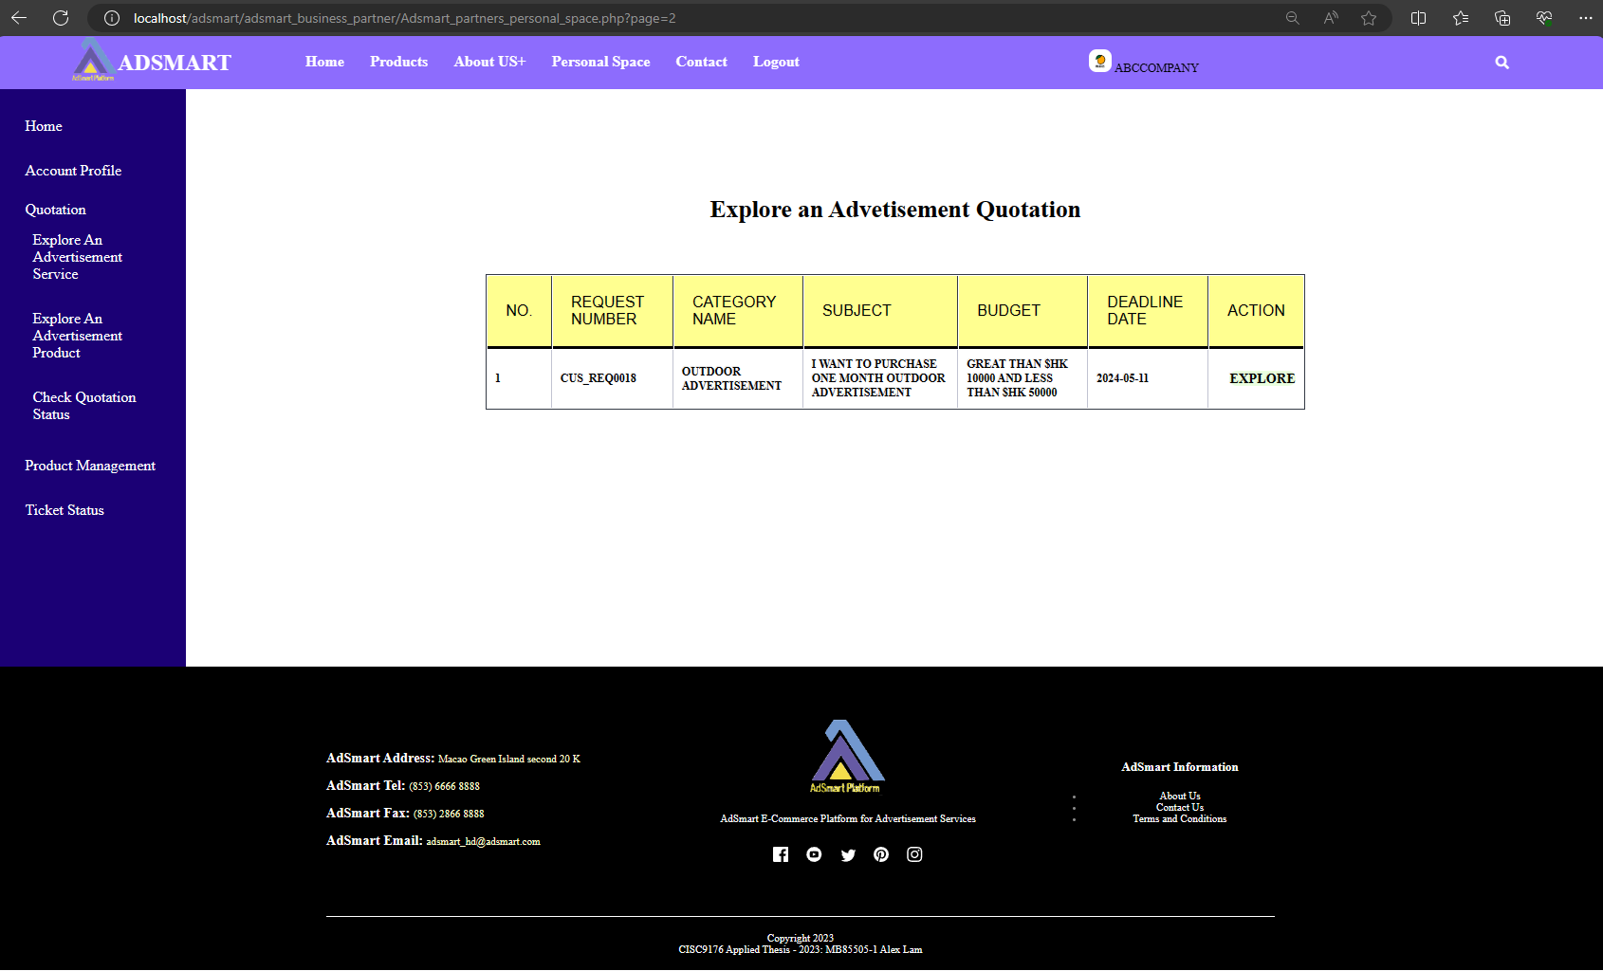

Figure 1.58 Explore new advertisement request page

As figure 1.59, this is the ticket detail page. On this page, business partner can view the ticket number, customer name, customer type, advertisement type, subject, advertisement requirement, budget and need supplier to response before that’s date. If the business partner can meet the requirement, then he/she can send the implementation plan, price and target date to the customer.

 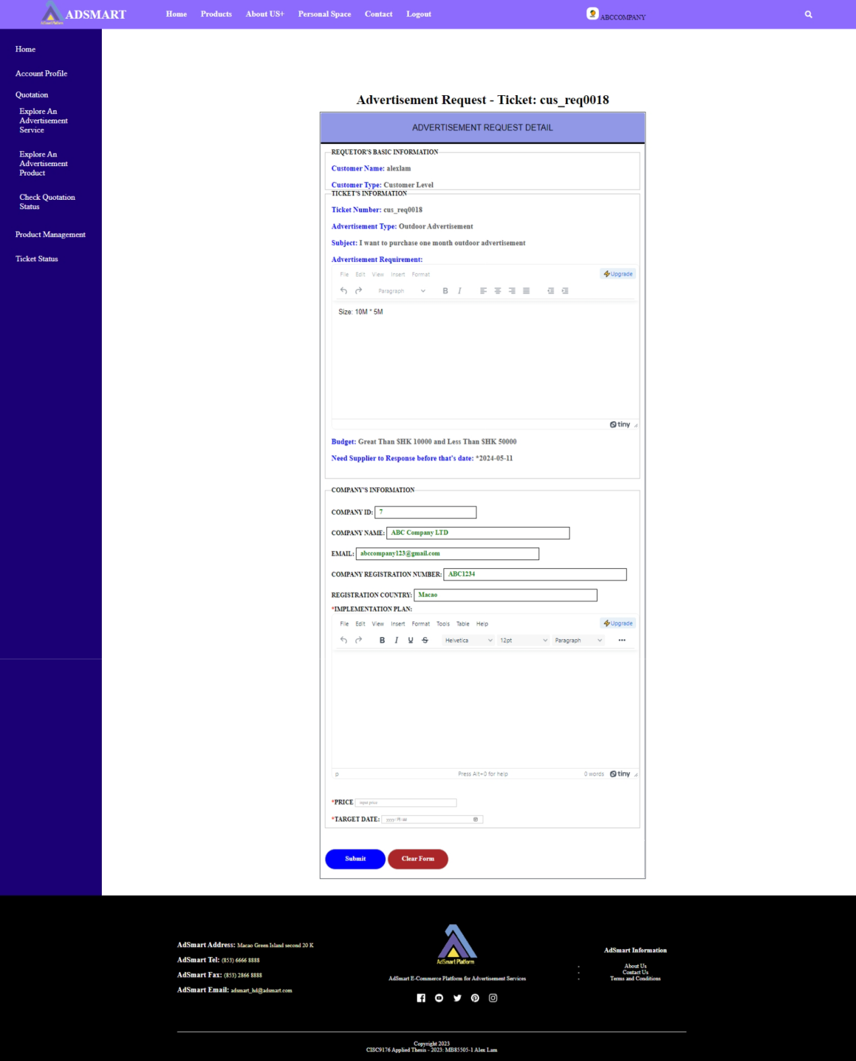

Figure 1.59 Ticket’s detail page

As figure 1.60, this is an example of the business partner sending the first quotation to the customer for review. The business partner needs to input the implementation plan, price, and target date.



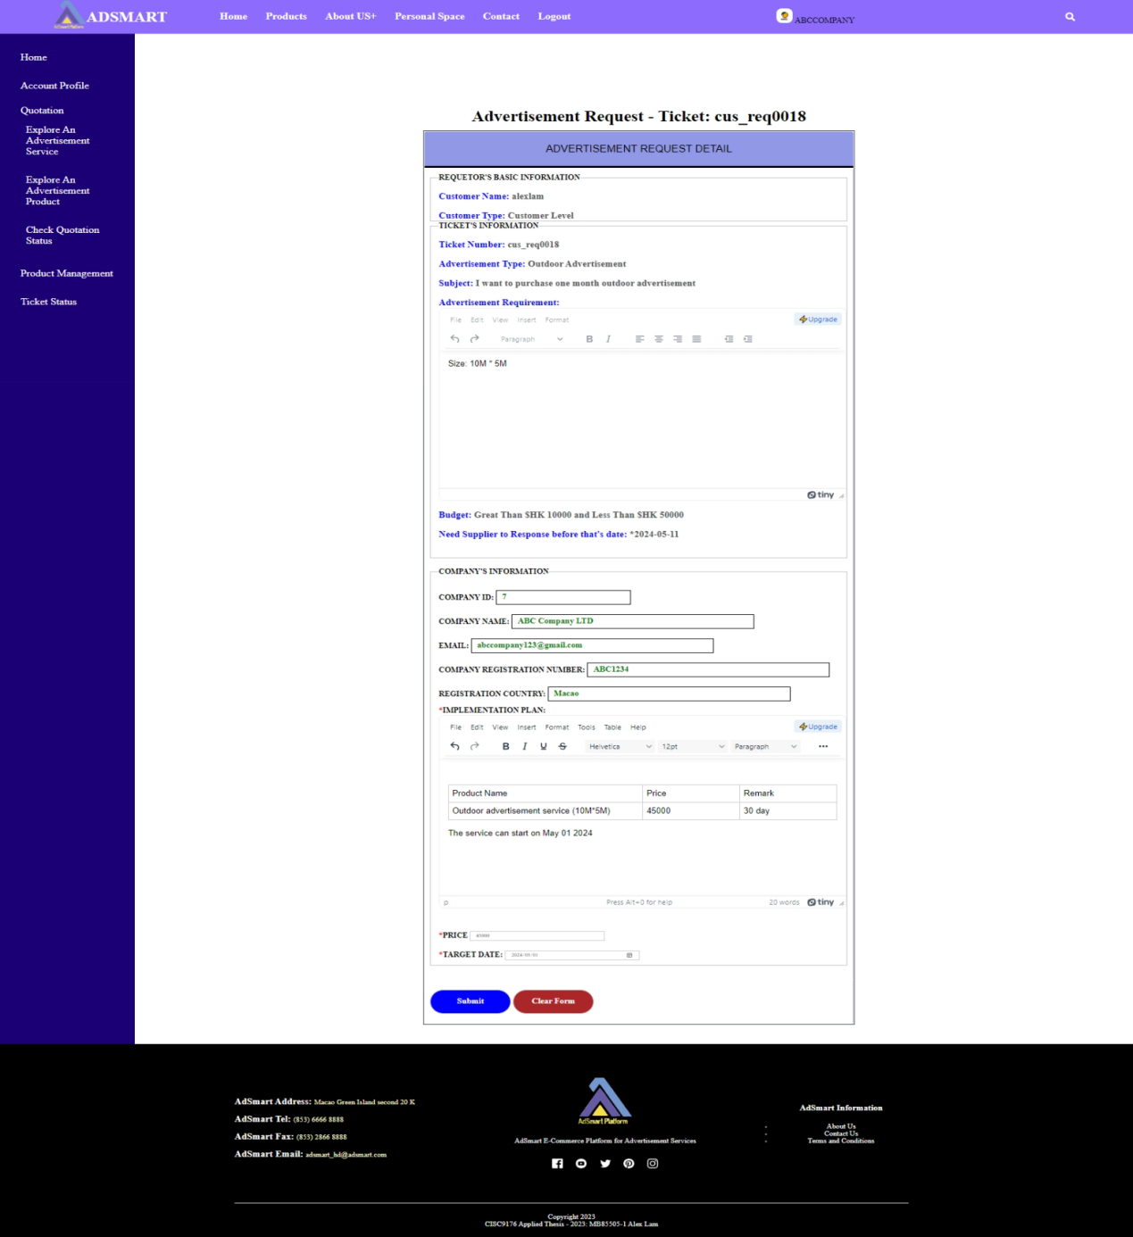

Figure 1.60 The example of business partner to send first quotation to customer

As figure 1.61, the business partner can check the ticket status after sending the first quotation to the customer. The status is shown as "Waiting for Customer Review", indicating that the ticket is currently under review by the customer.

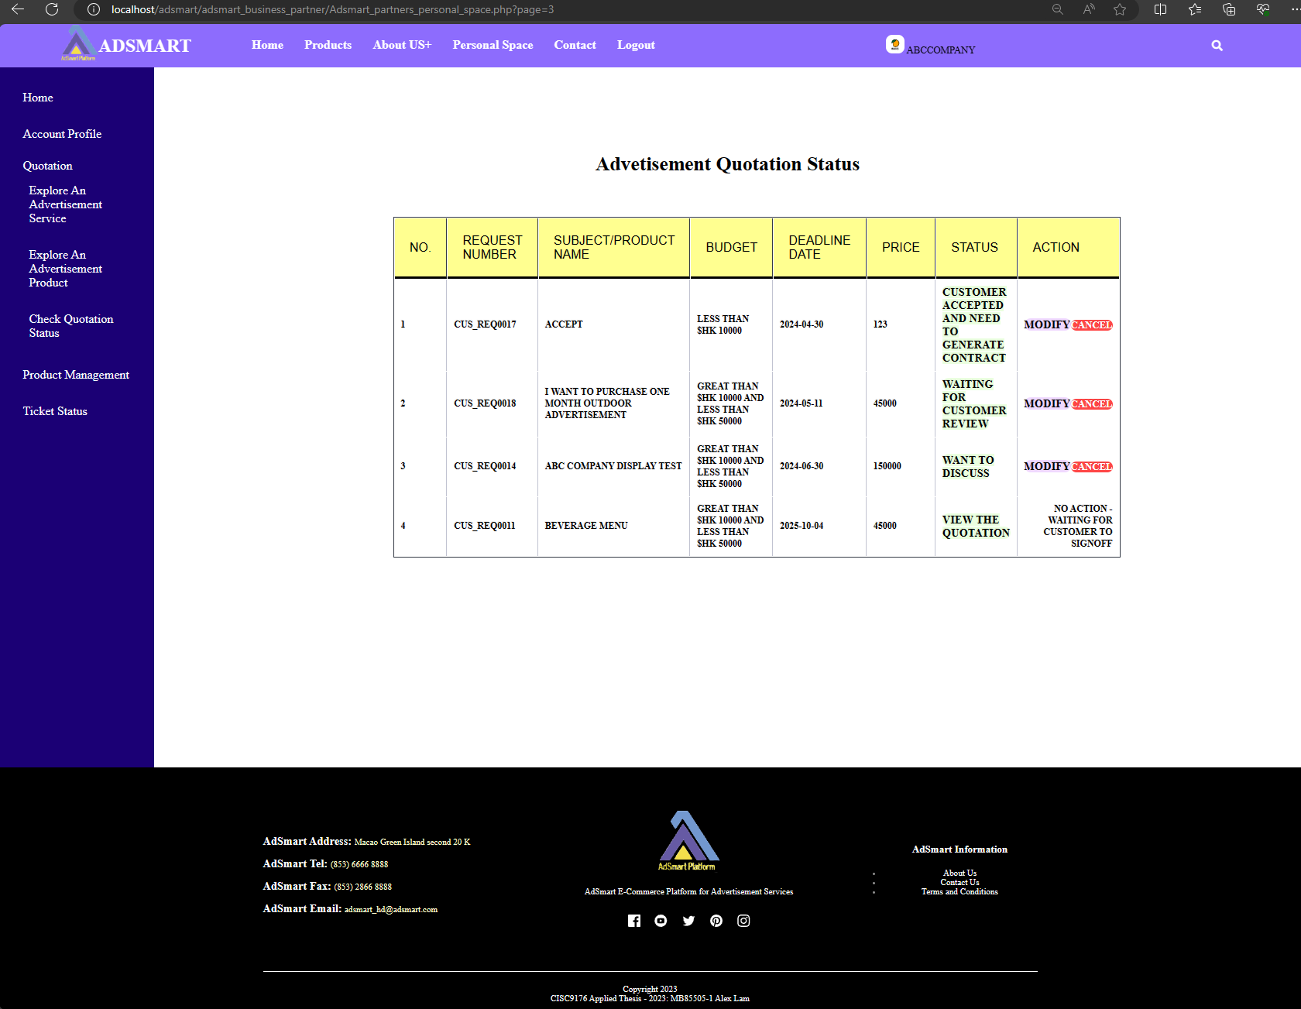

Figure 1.61 Business partner’s advertisement quotation status page

After the business partner sends the first quotation, the customer can see the status of the ticket (CUS_REQ0018) change to "Received the quotation". (figure 1.62).

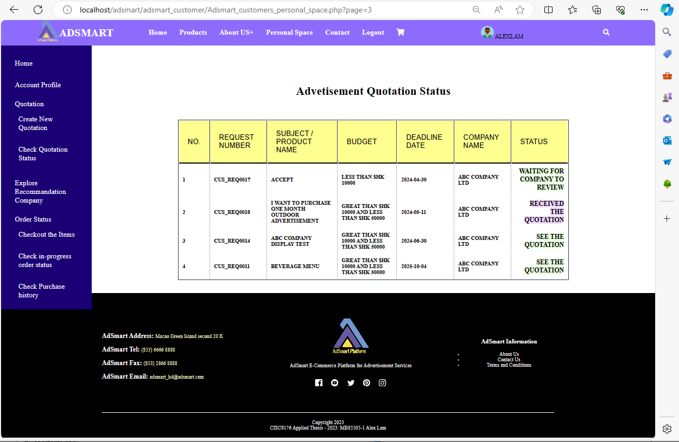

Figure 1.62 Customer’s advertisement quotation status page

As figure 1.63, this is the detail of the first quotation. If the customer decides to accept this offer, he/she can leave a comment and select the customer action as "accept".

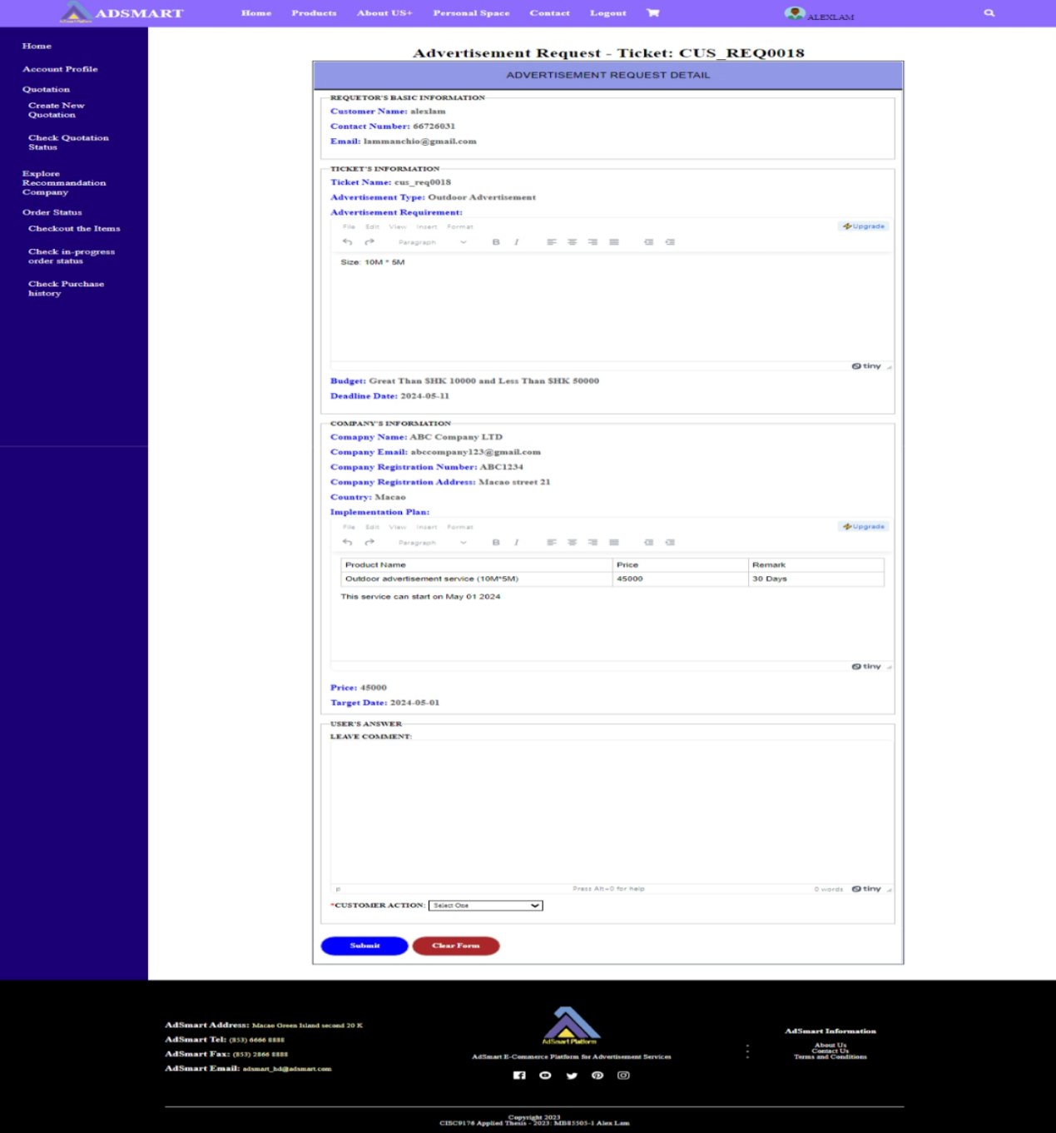

Figure 1.63 The detail of first quotation

As figure 1.64, this is an example where the customer accepts the offer. They can leave a comment, select the customer action as "accept," and then click the "Submit" button.

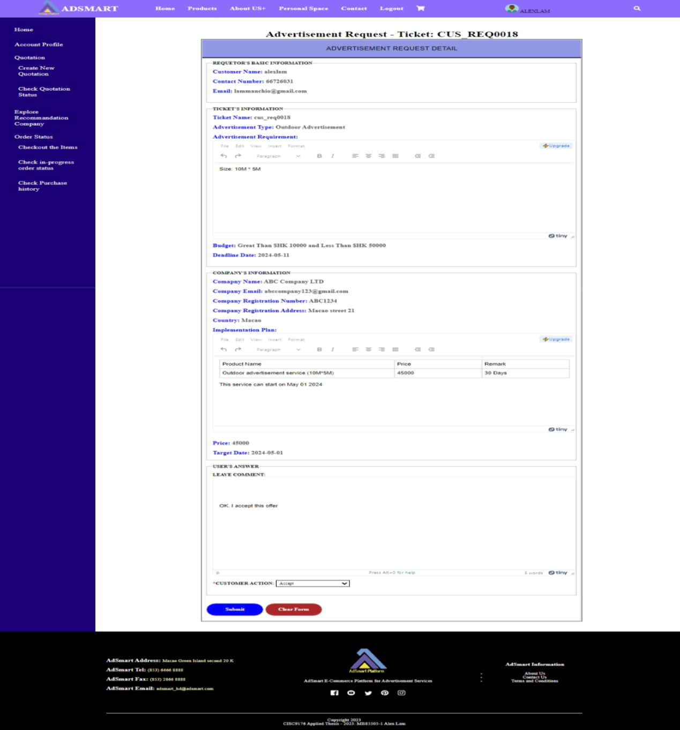

Figure 1.64 The example of customer accepts this offer

As figure 1.65, it shows when the customer accepts the offer and displays a successful message stating that the ticket has been replied to the business partner.

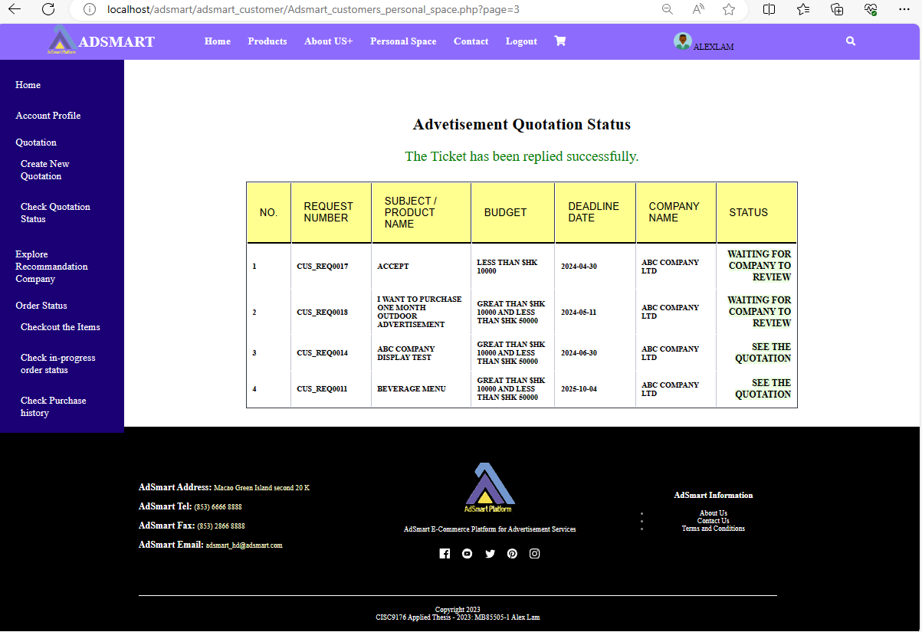

Figure 1.65 Display the successful message about the ticket has been replied

As figure 1.66, it shows when the customer has accepted the offer. The business partner can see the status of the ticket change to "Customer Accepted and Needs to Generate a Contract", and then business partner needs to click the button that it will take them to the “Generate a Contract” page.

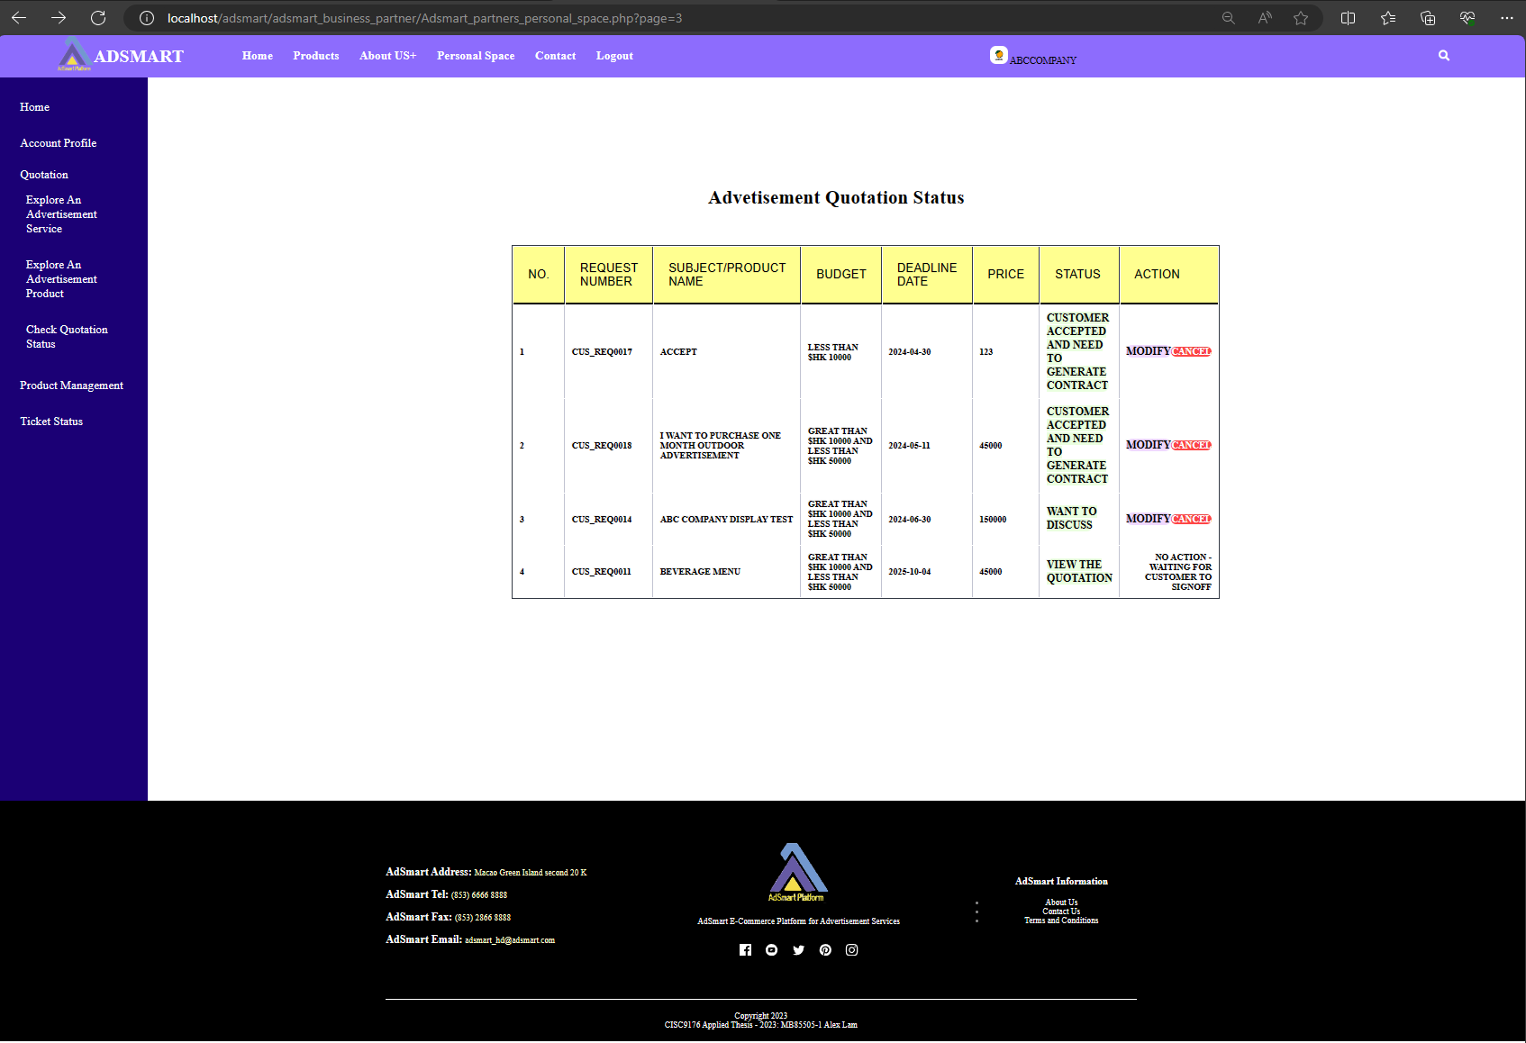

Figure 1.66 Customer accepted and need to generate contract

As figure 1.67, this is the "Generate a Contract" page. The business partner can create a contract on this page, where he/she needs to input subject for this quotation, quotation date, quotation valid for, service/product items summary, total price, delivery terms and delivery time.

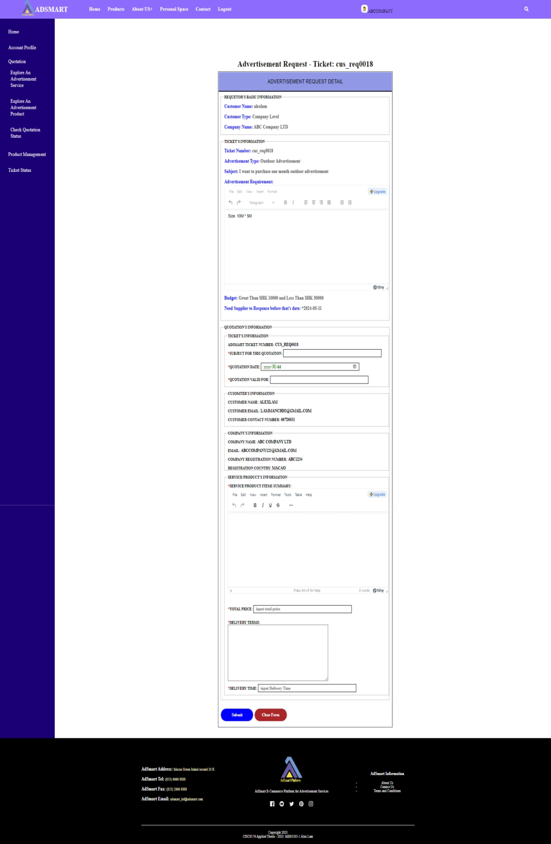

Figure 1.67 Generate a contract page

As figure 1.68, this is an example of a business partner generating a contract.



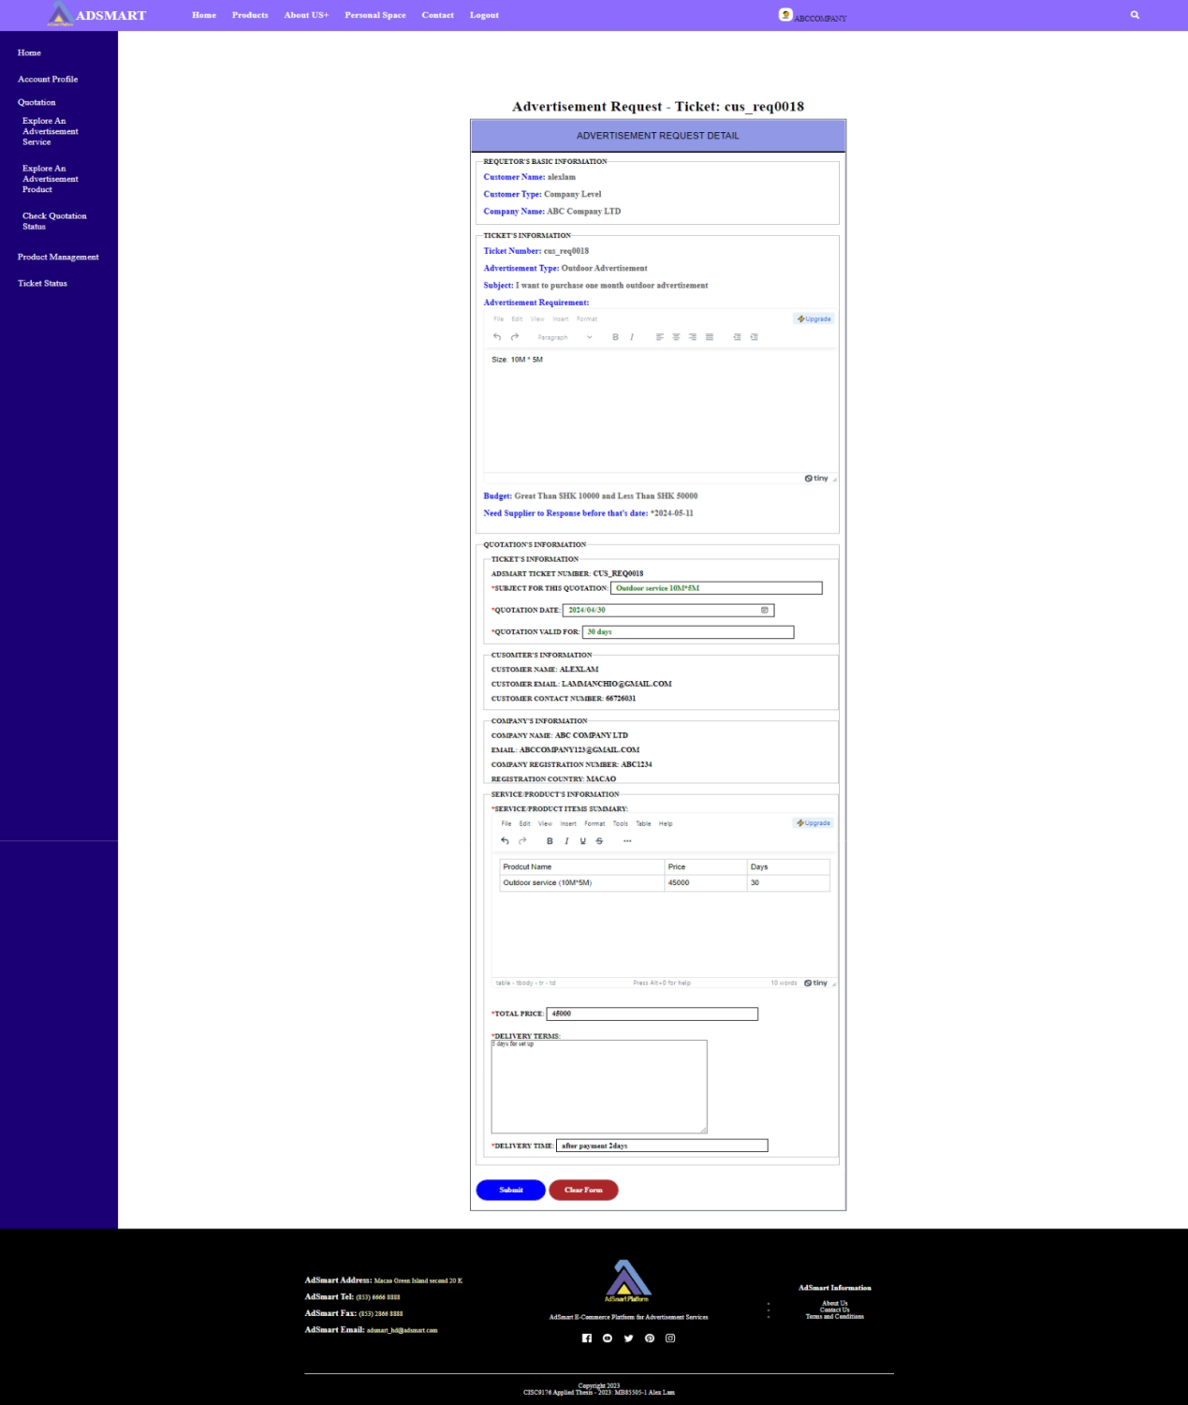

Figure 1.68 The example for business partner to generate a contract

After generating a contract, the business partner can see the status (figure 1.69) change to "View the Quotations."

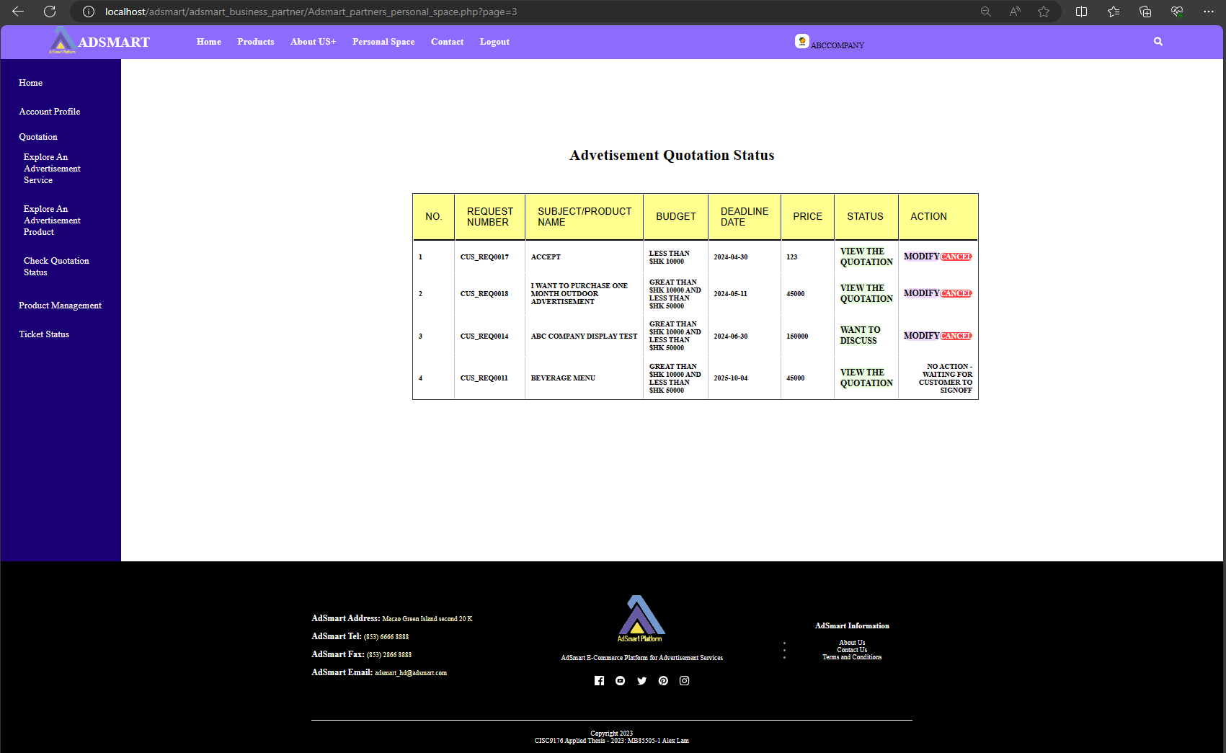

Figure 1.69 View the quotations

As Figure 1.70, concurrently, the customer can see the status change to "See the quotations".

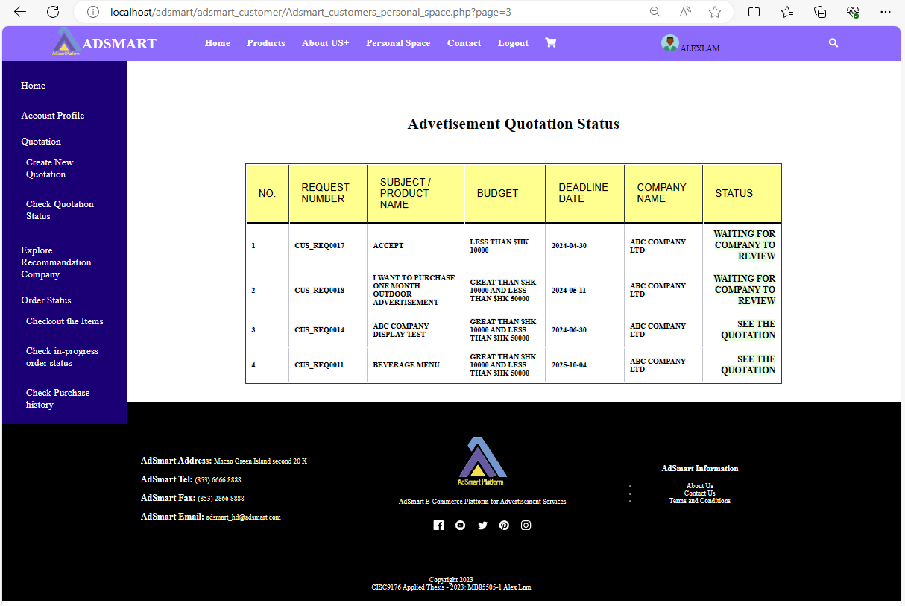

Figure 1.70 See the quotations

As figure 1.71, the business partner needs to download the contract from AdSmart, sign it off, and then upload it back to AdSmart.

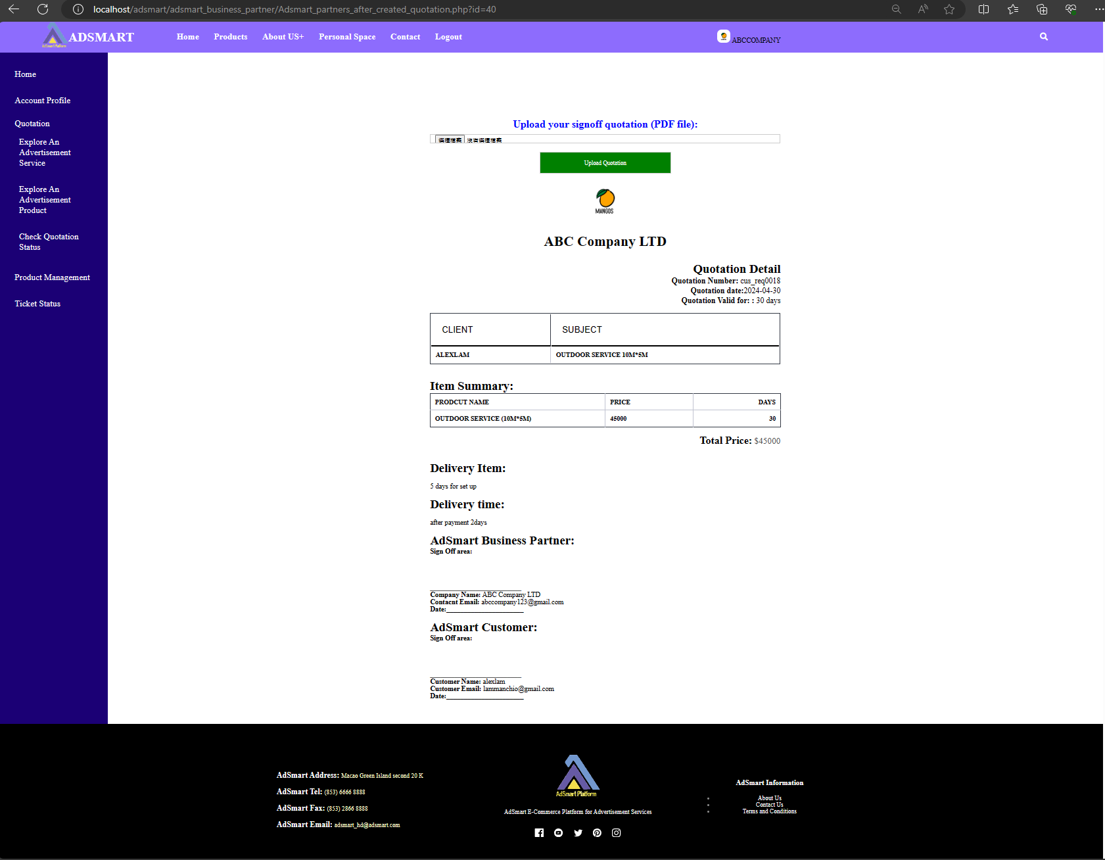

Figure 1.71 Upload business partner signoff contract

As figure 1.72, after the business partner uploads the PDF file, AdSmart will display a successful message to the business partner.

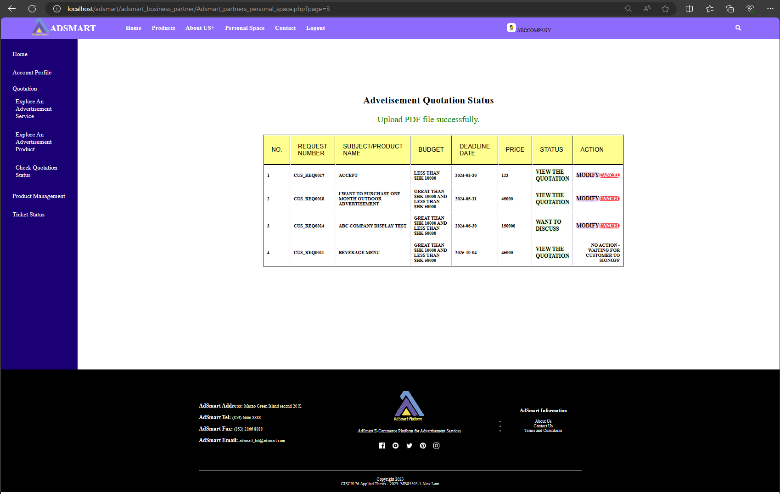

Figure 1.72 Upload PDF file successfully

As figure 1.73, after the business partner uploads the PDF file, the customer can see the status change to "See the quotation".

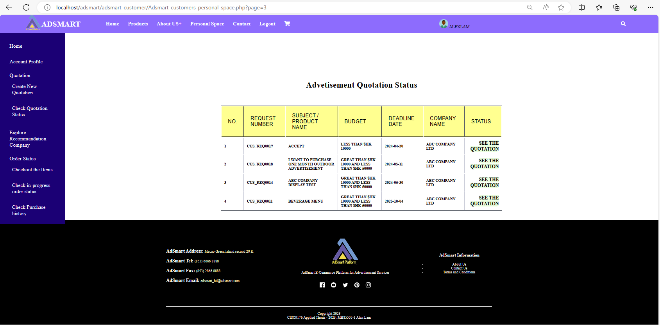

Figure 1.73 See the quotation in customer side

As figure 1.74, after the business partner uploads the PDF file, the customer can download the contract that has been signed off by the business partner. After downloading, the customer needs to sign off on the contract and upload it back to AdSmart.

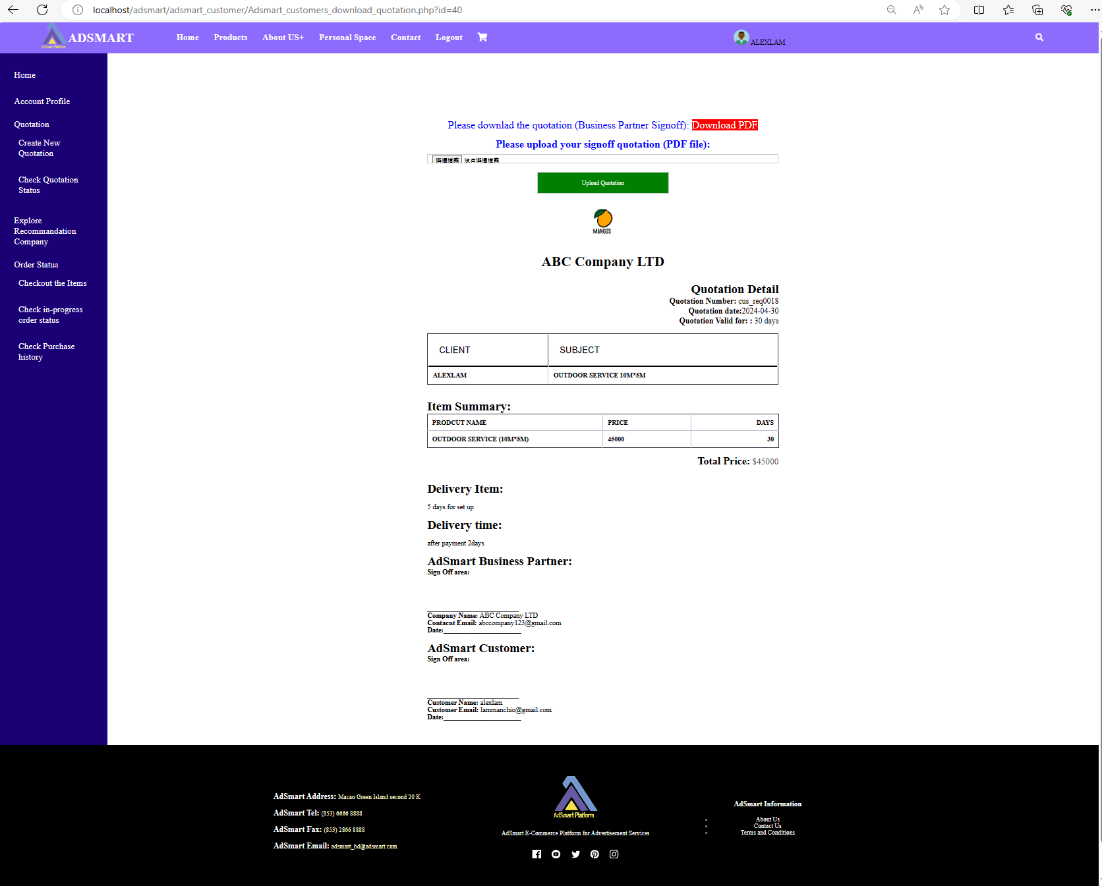

Figure 1.74 Download the contract in customer side

As figure 1.75, after the customer uploads the PDF file, both the partner and the customer can download the fully signed-off version of the contract, but they cannot upload it again.

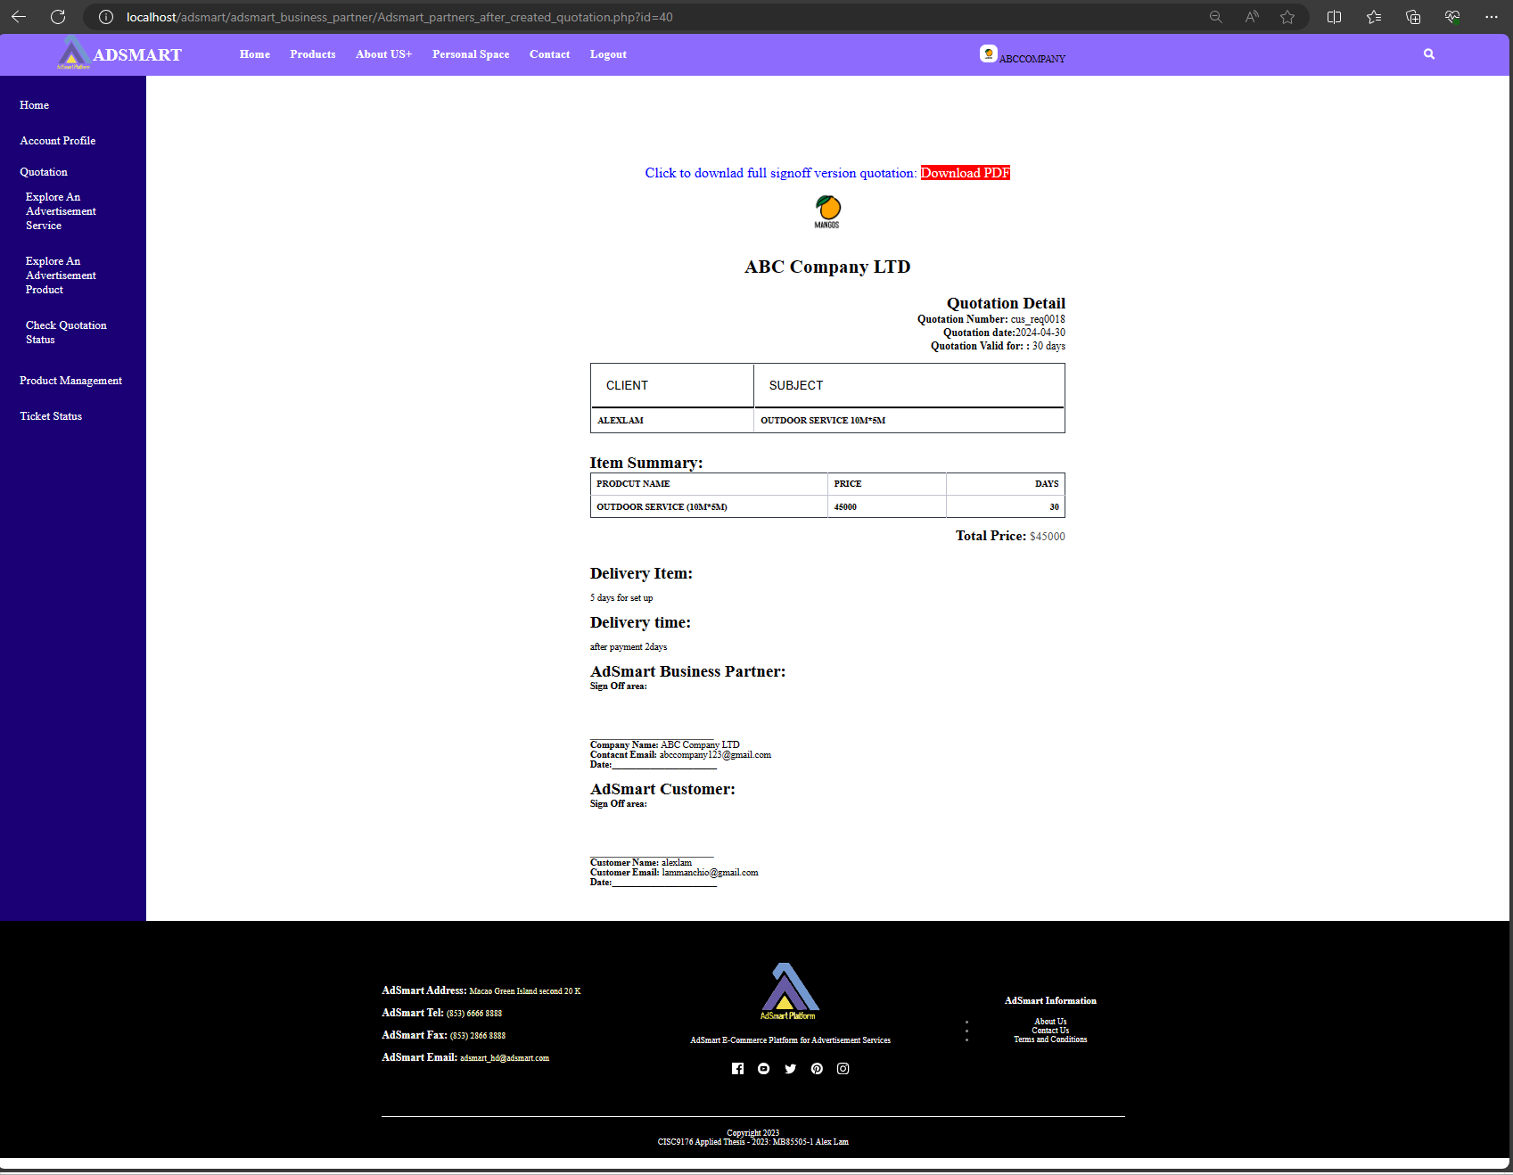

Figure 1.75 Download the full signoff version contract in business side

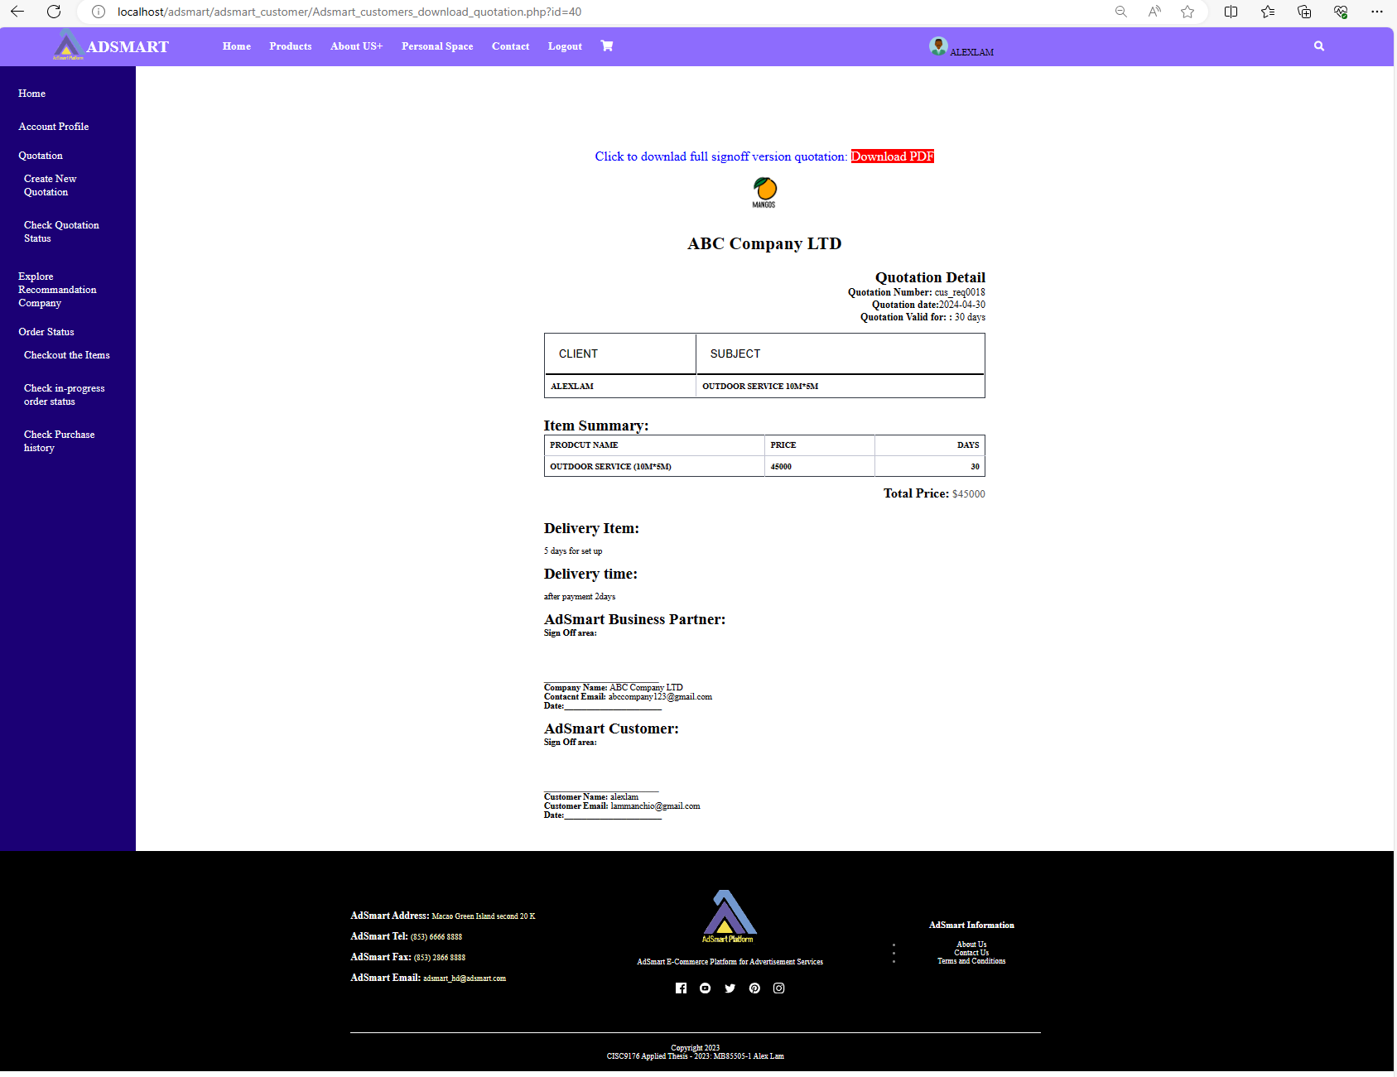

Figure 1.76 Download the full signoff version contract in customer side

## Use case 11: Discuss to Business Partners and Make a Deal

This section provides walk through of the following user interfaces:

1. Create an advertisement request page (Figure 1.77)
2. The example of customer creates an advertisement request (Figure 1.78)
3. Explore new advertisement request page (Figure 1.79)
4. Ticket’s detail page (Figure 1.80)
5. The example of business partner to send first quotation to customer (Figure 1.81)
6. Business partner’s advertisement quotation status page (Figure 1.82)
7. Customer’s advertisement quotation status page (Figure 1.83)
8. The detail of first quotation (Figure 1.84)
9. The example of customer discusses with supplier (Figure 1.85)
10. The status change to “discuss with supplier” (Figure 1.86)
11. The status changes to “customer wants to discuss” (Figure 1.87)
12. Business partner entries to negotiation space (Figure 1.88)
13. Customer entries to negotiation space (Figure 1.89)
14. The example of customer to discuss with business partner (Figure 1.90)
15. Customer can see the reply’s content (Figure 1.91)
16. Business partner can see the reply’s content (Figure 1.92)
17. The example of business partner to discuss with customer (Figure 1.93)
18. After business partner replied (Figure 1.94)
19. Update the status of ticket to “Complete and need a quotation” (Figure 1.95)
20. After customer updated the status (Figure 1.96)
21. After customer updated the status (Figure 1.97)
22. Generate a contract page (Figure 1.98)
23. The example for business partner to generate a contract (Figure 1.99)
24. View the quotations (Figure 1.100)
25. See the quotations (Figure 1.101)
26. Upload business partner signoff contract (Figure 1.102)
27. Download the contract in customer side (Figure 1.103)
28. Download the full signoff version contract in business side (Figure 1.104)
29. Download the full signoff version contract in customer side (Figure 1.105)

In this demonstration, we will show AdSmart customer how to discuss with a business partner and make a deal.

As figure 1.77, this is the "Create an Advertisement Request" page. On this page, the customer can create a new advertisement request to business partner.

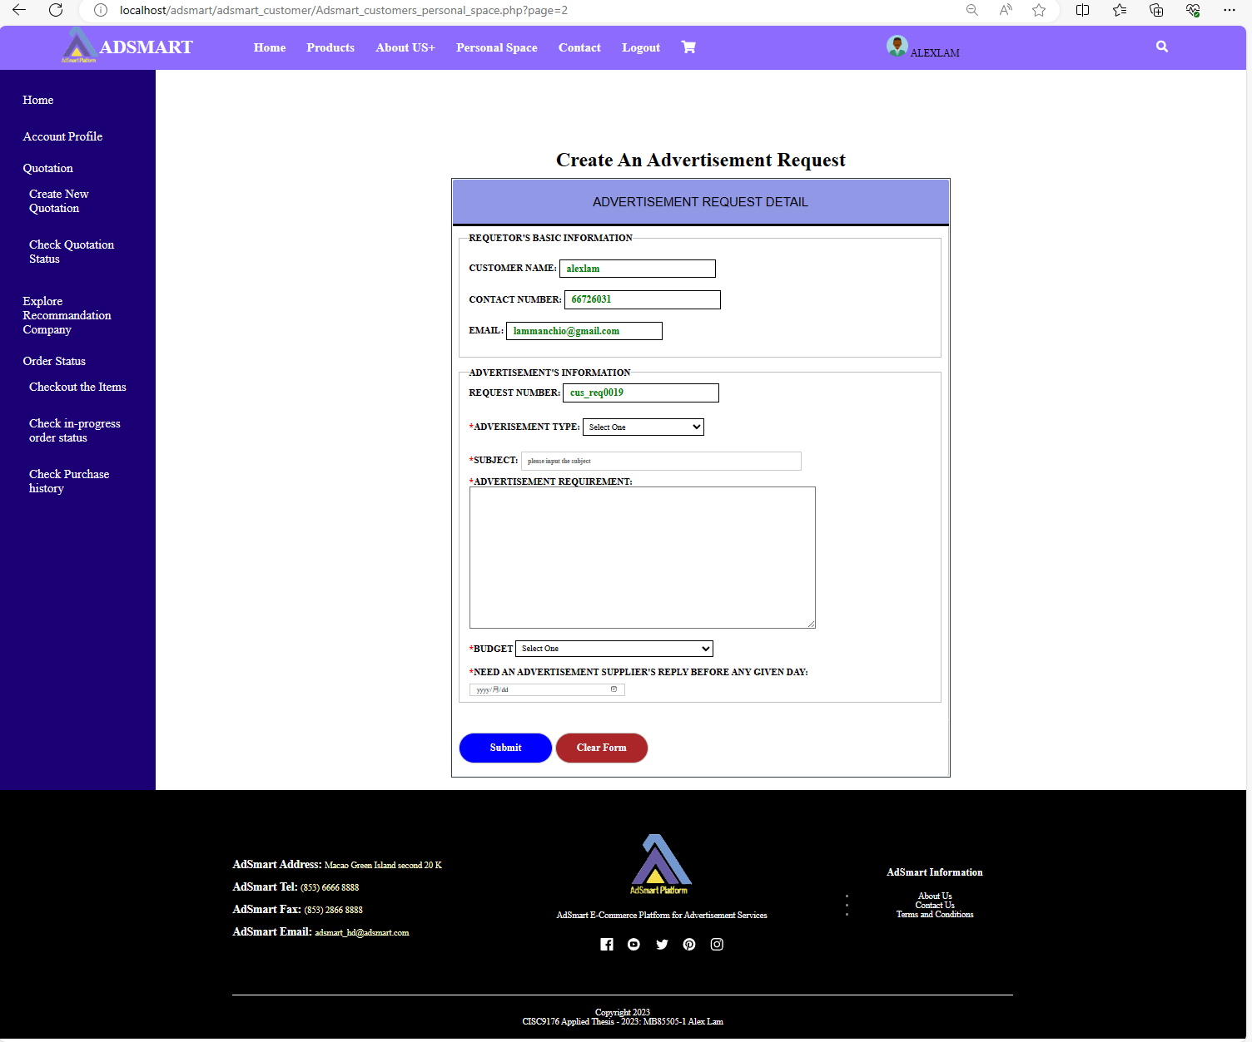

Figure 1.77 Create an advertisement request page

As figure 1.78, this is an example of a customer creating an advertisement request.

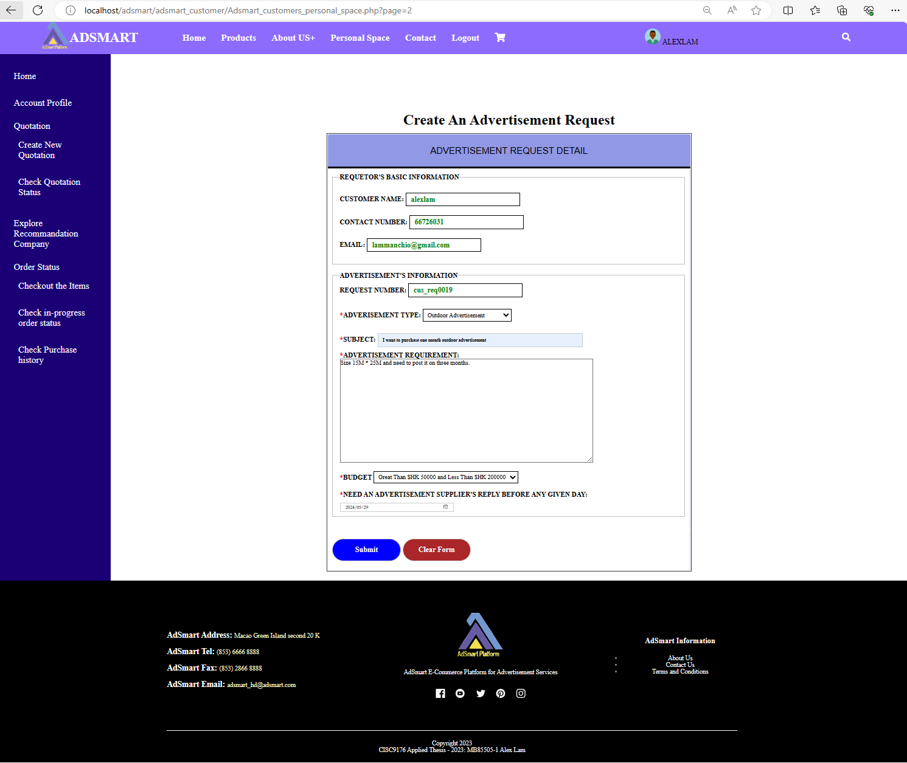

Figure 1.78 The example of customer creates an advertisement request

As Figure 1.79, the business partner can view the request in the "Explore an Advertisement Quotation" page.

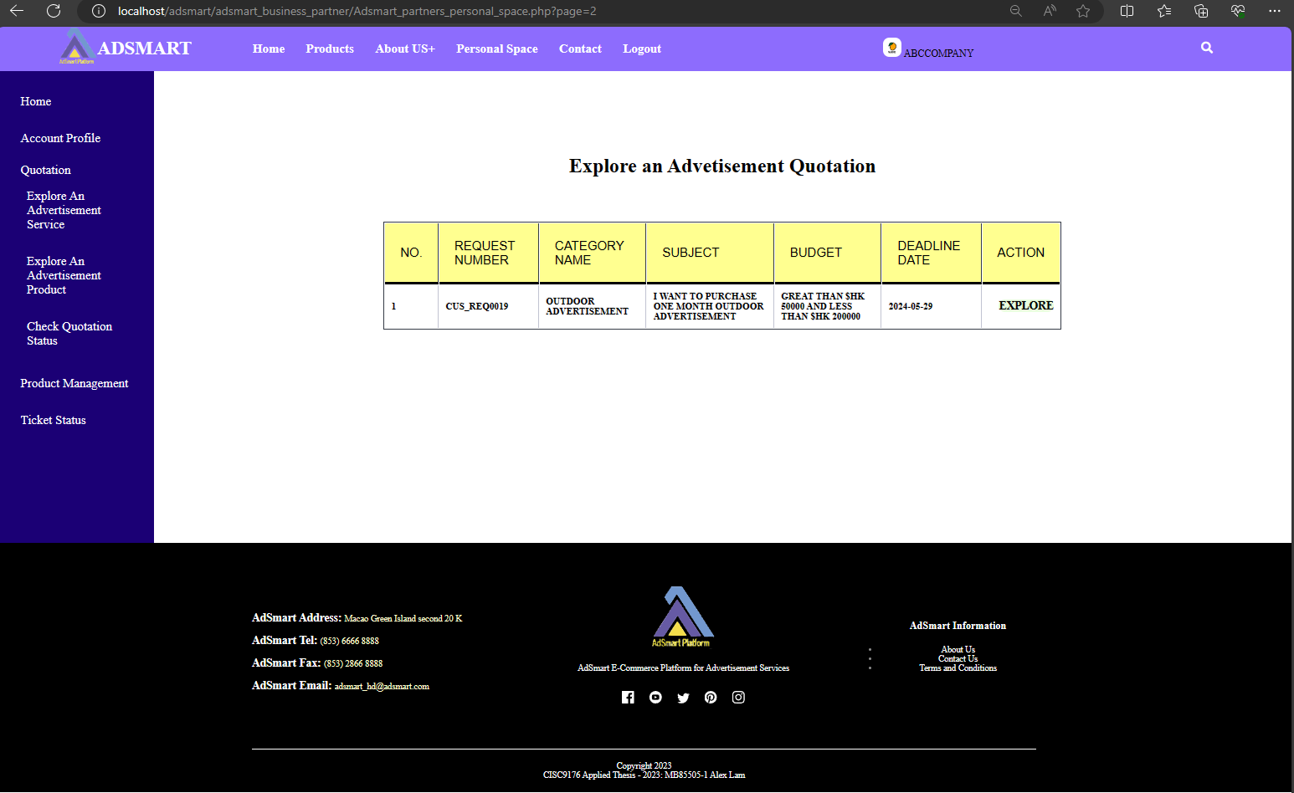

Figure 1.79 Explore new advertisement request page

As figure 1.80, this is the ticket detail page. On this page, the business partner can view the ticket number, customer name, customer type, advertisement type, subject, advertisement requirement, budget and need supplier to response before that’s date. If business partner can fulfill the requirement, he/she can send the implementation plan, price and target date to the customer.

 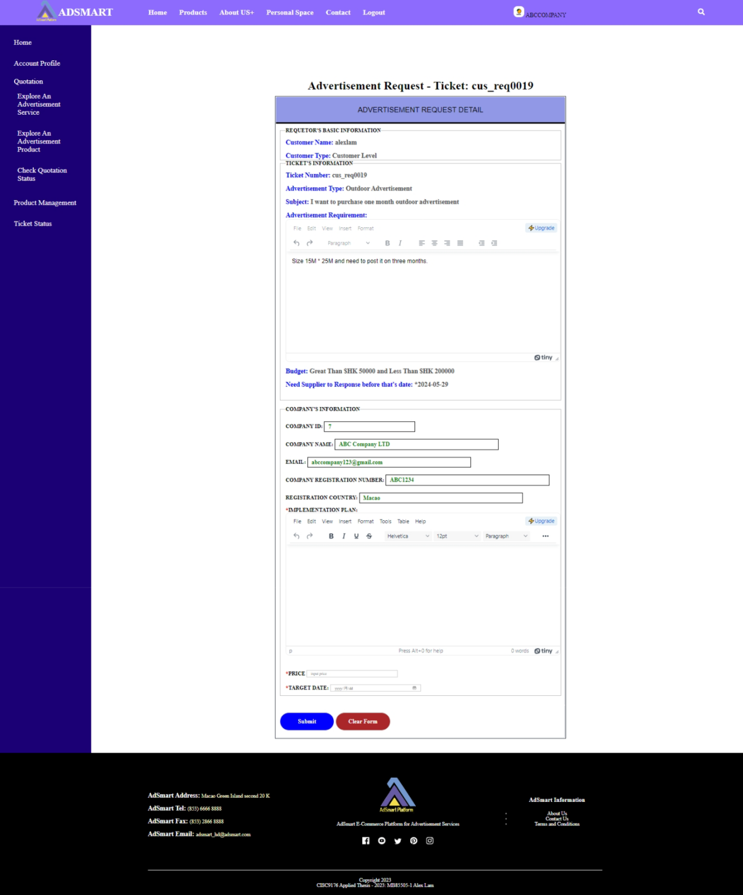

Figure 1.80 Ticket’s detail page

As figure 1.81, this is an example of the business partner sending the quotation to the customer for review. The business partner needs to input the implementation plan, price, and target date.



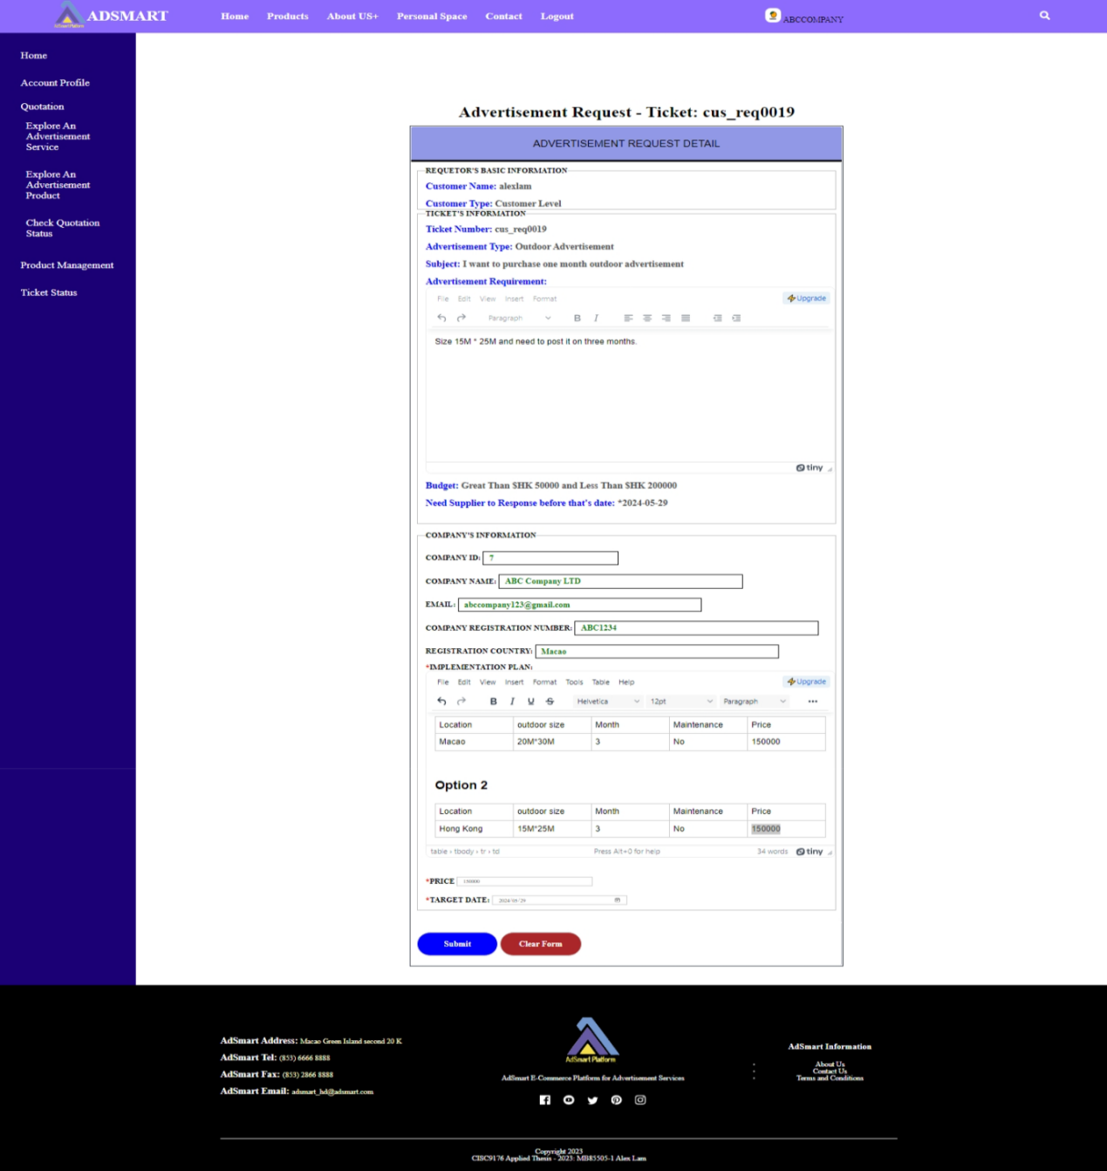

Figure 1.81 The example of business partner to send first quotation to customer

As figure 1.82, the business partner can check the ticket status when he/she sends the quotation to the customer. The status shows as "Waiting for customer review," indicating that the ticket is under review by the customer.

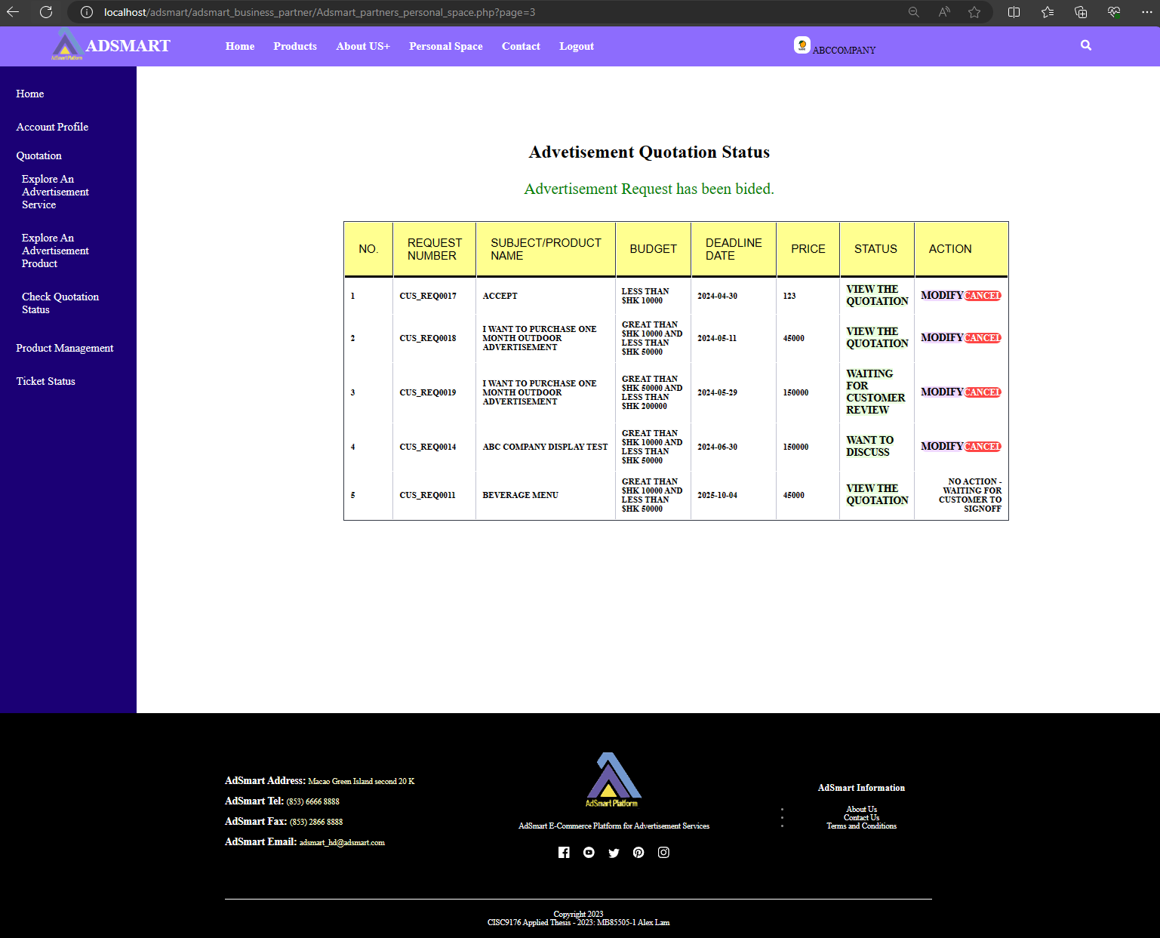

Figure 1.82 Business partner’s advertisement quotation status page

After the business partner sends the quotation, the customer can see the status of the ticket (CUS_REQ0019) change to "Received the quotation" (figure 1.83).

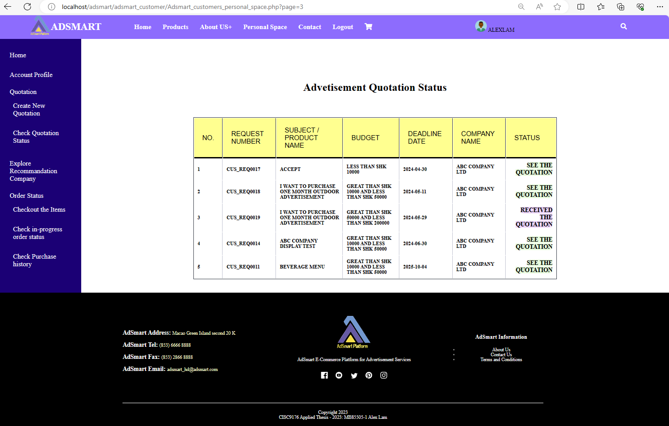

Figure 1.83 Customer’s advertisement quotation status page

As figure 1.84, this is the detail of the quotation. If the customer wishes to discuss with the business partner, they can leave a comment and select the action as "Need to Discuss with Supplier".

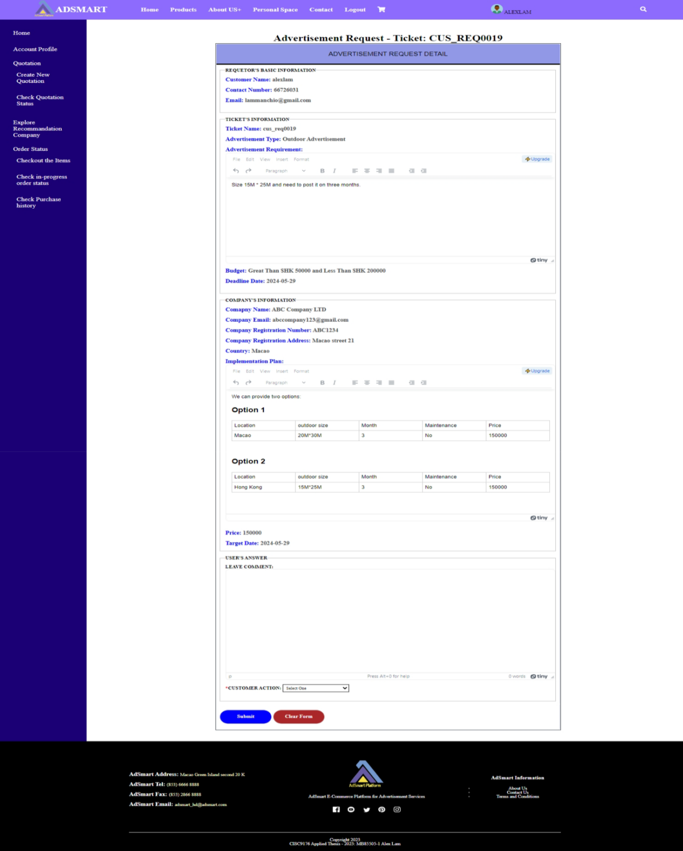

Figure 1.84 The detail of first quotation

As figure 1.85, this is an example where the customer discusses with the supplier. The customer is required to leave a comment, select the action as "Need to Discuss with Supplier", and then click the "Submit" button.

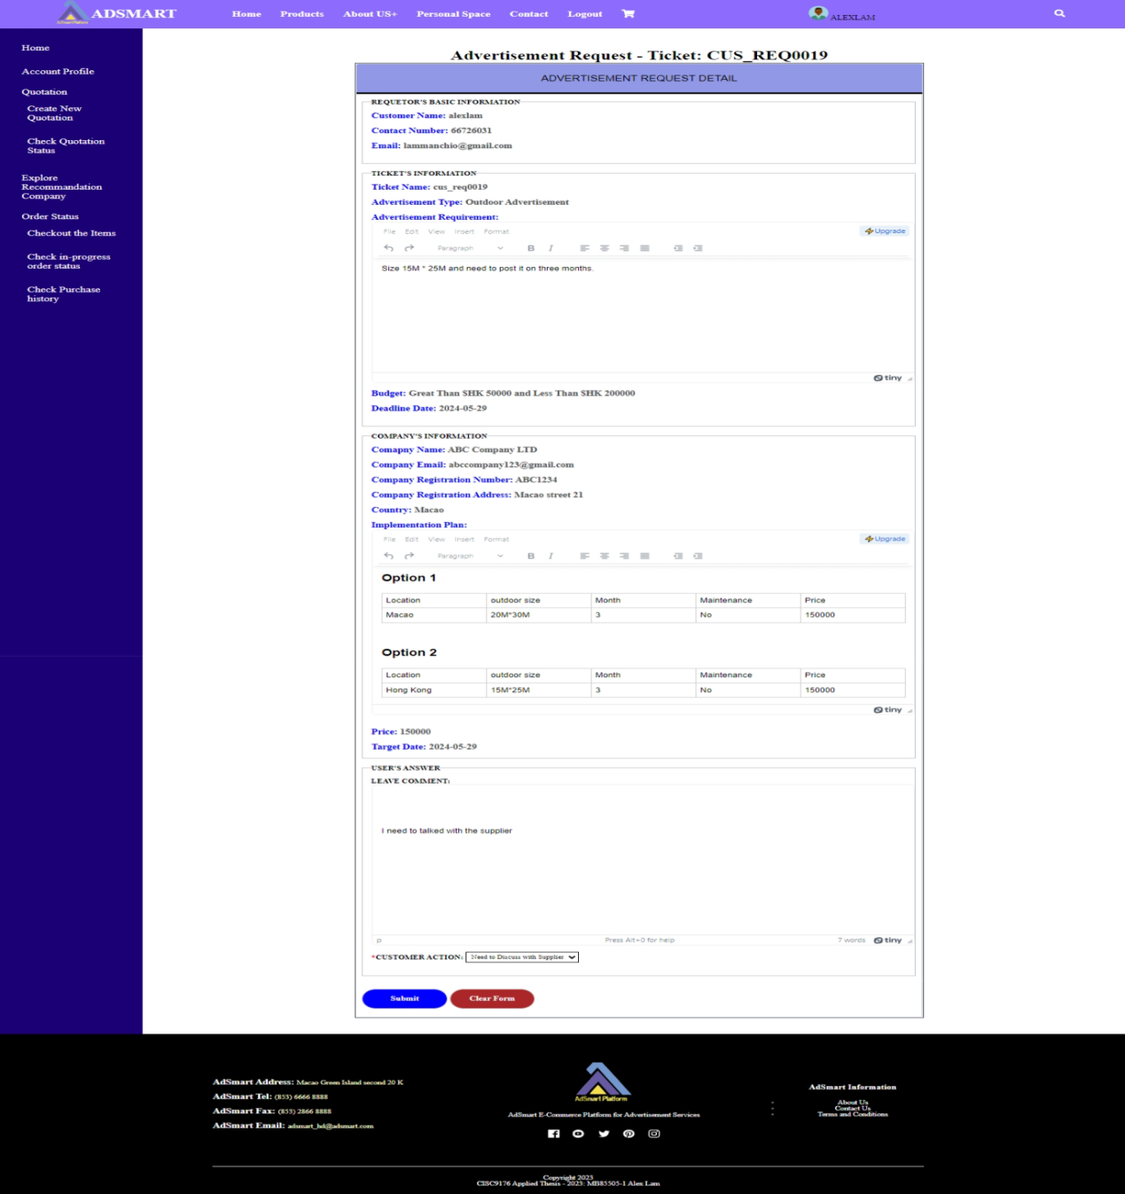

Figure 1.85 The example of customer discusses with supplier

As figure 1.86, the customer can see the status change to "Discuss with Supplier," allowing them to engage in discussions with the business partner within the AdSmart negotiation environment. Concurrently, the business partner can see the status of the ticket change to "Customer wants to discuss" (figure 1.87).

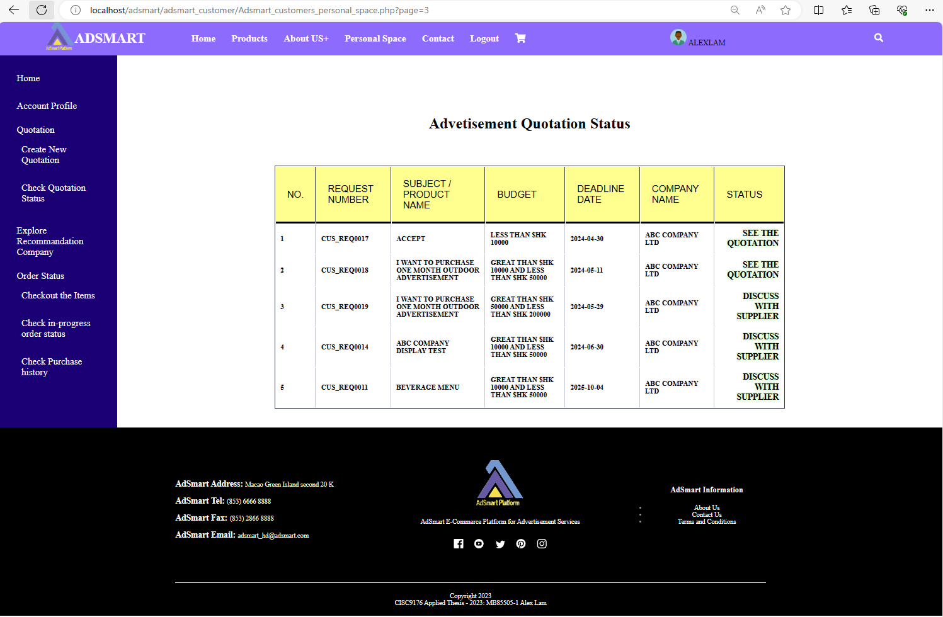

Figure 1.86 The status change to “discuss with supplier”

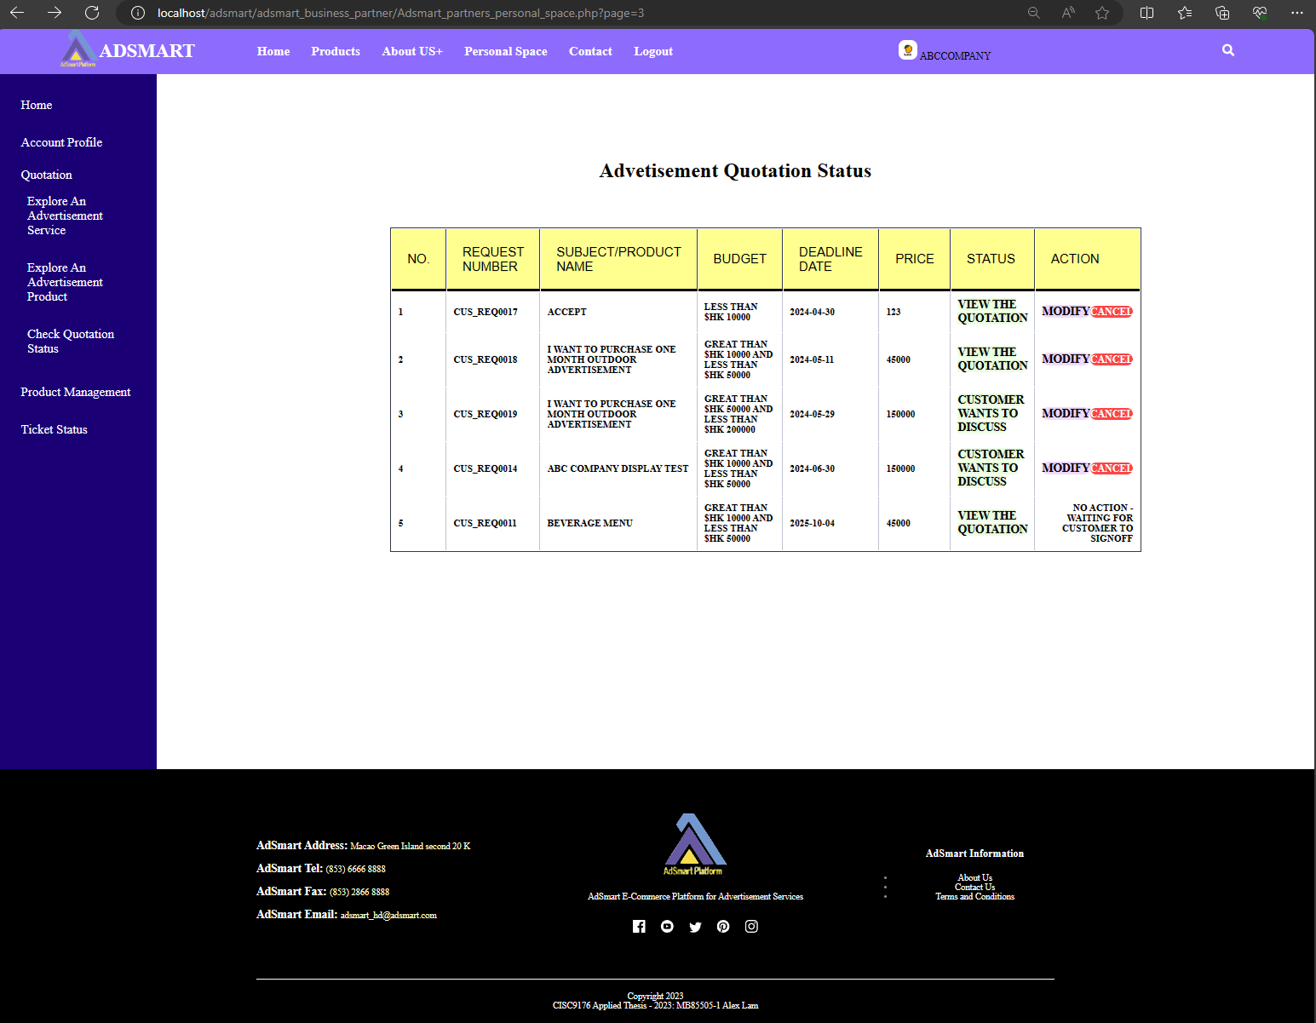

Figure 1.87 The status change to “customer wants to discuss”

As figure 1.88, after ABC Company clicks the "Customer wants to discuss" button, he/she will entry the AdSmart negotiation space where the business partner can discuss the requirements with the customer. In the same time, when the customer clicks the "Discuss with Supplier" button, he/she will entry the AdSmart negotiation space (figure 1.89).



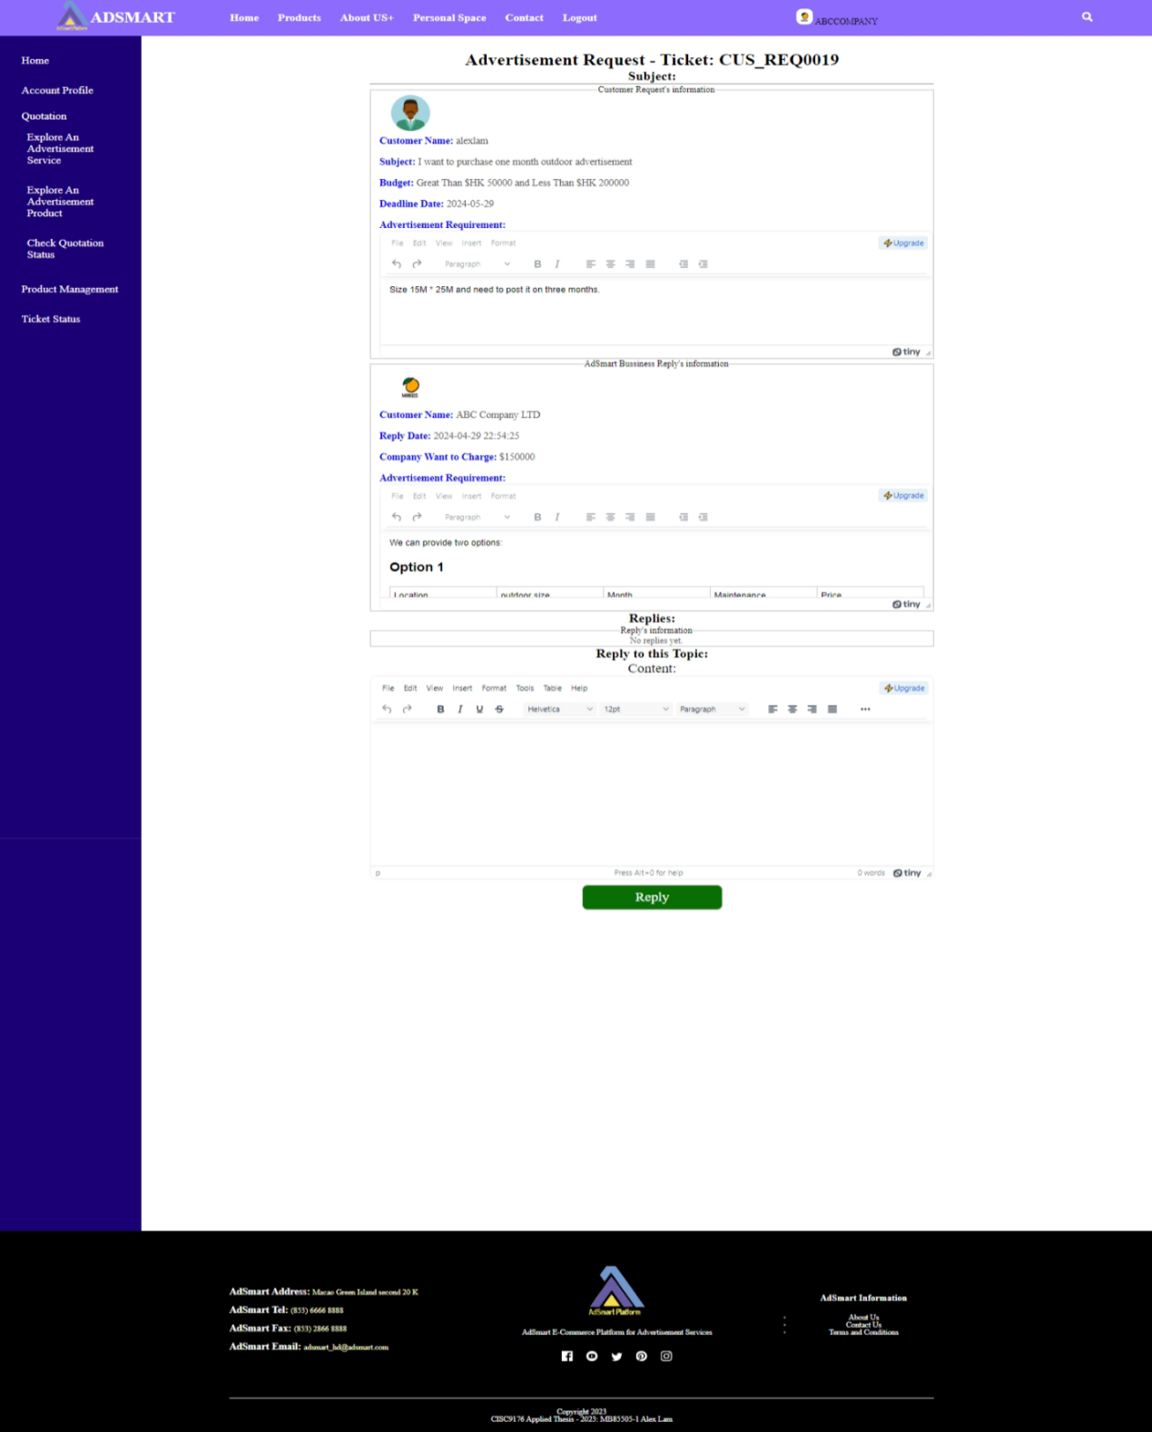

Figure 1.88 Business partner entries to negotiation space



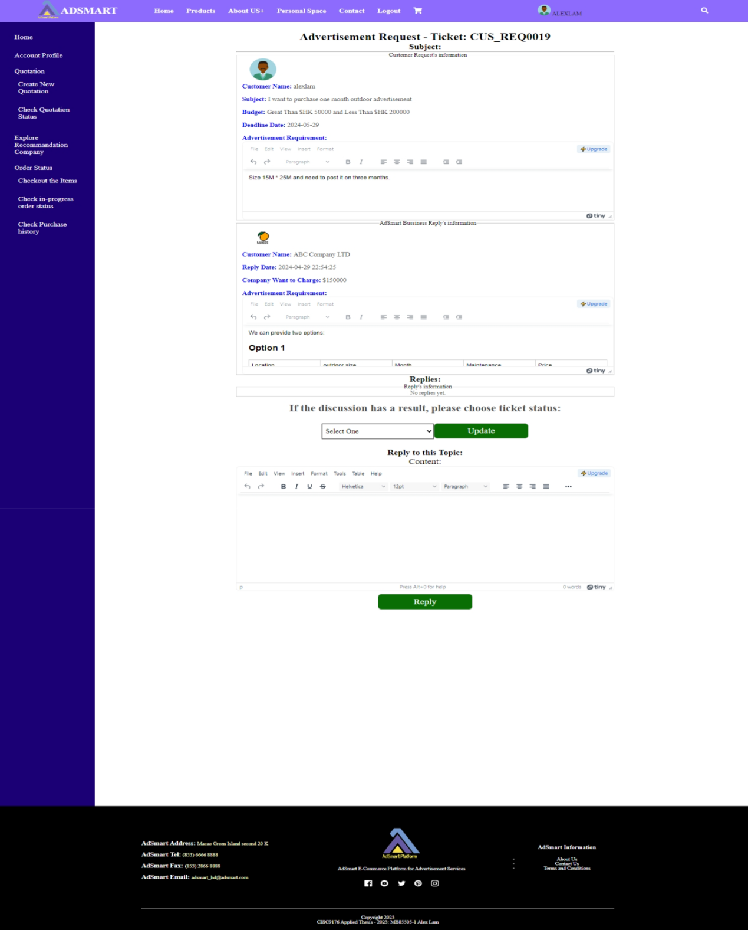

Figure 1.99 Customer entries to negotiation space

As figure 1.100, this is an example of the customer discussing with the business partner.



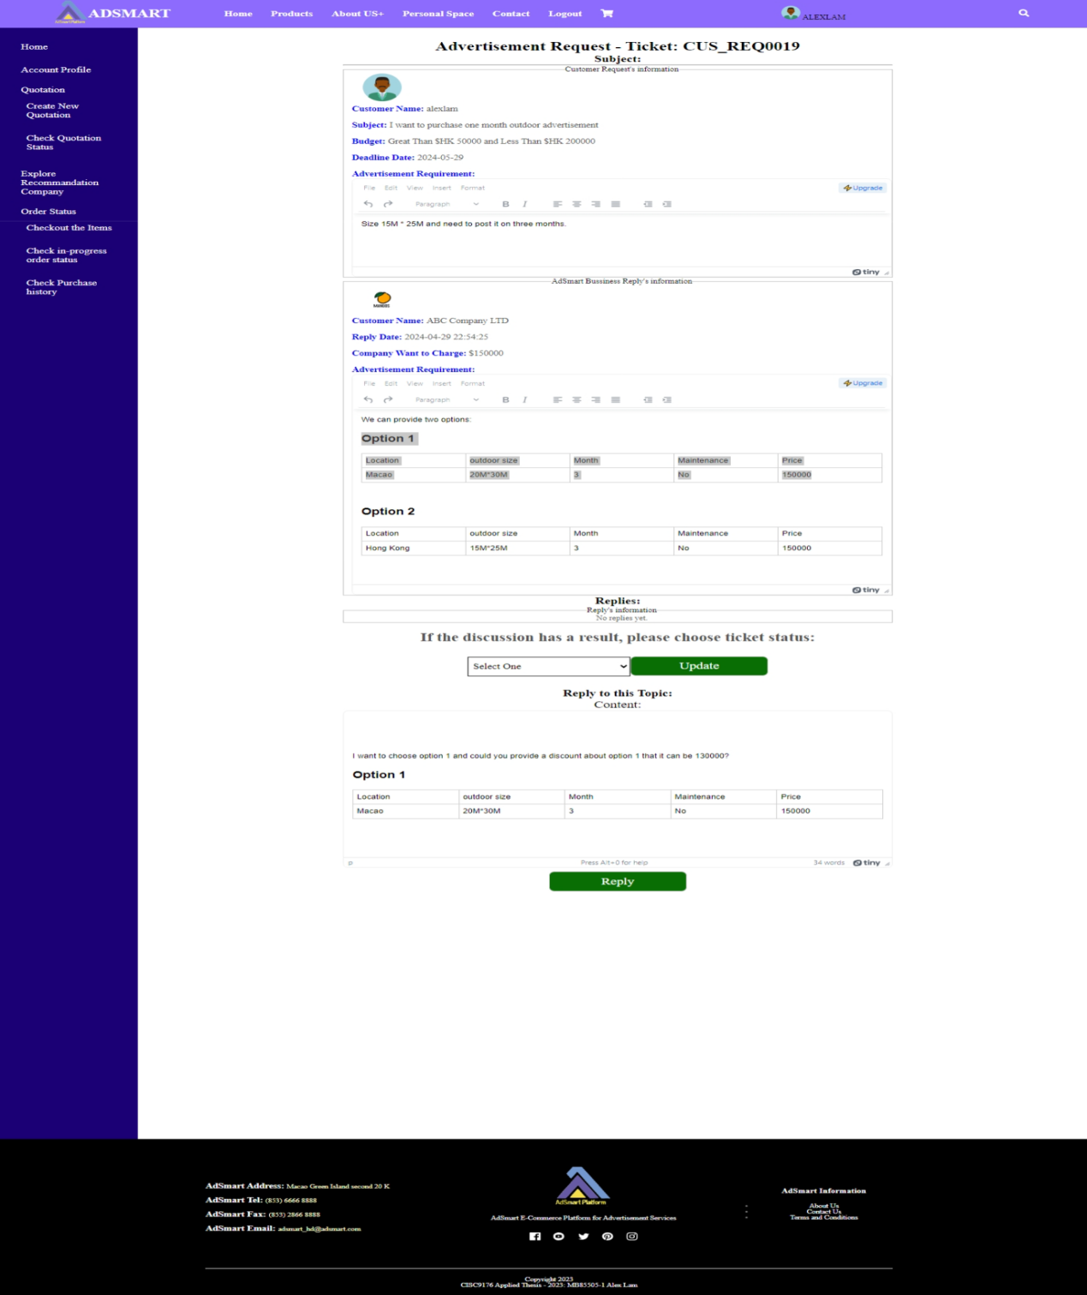

Figure 1.100 The example of customer to discuss with business partner

As figure 1.101, after the customer clicks the "Reply" button, he/she will see the content of the reply in the negotiation space. In the same time, the business partner can also view the reply’s content in the negotiation space (figure 1.102).

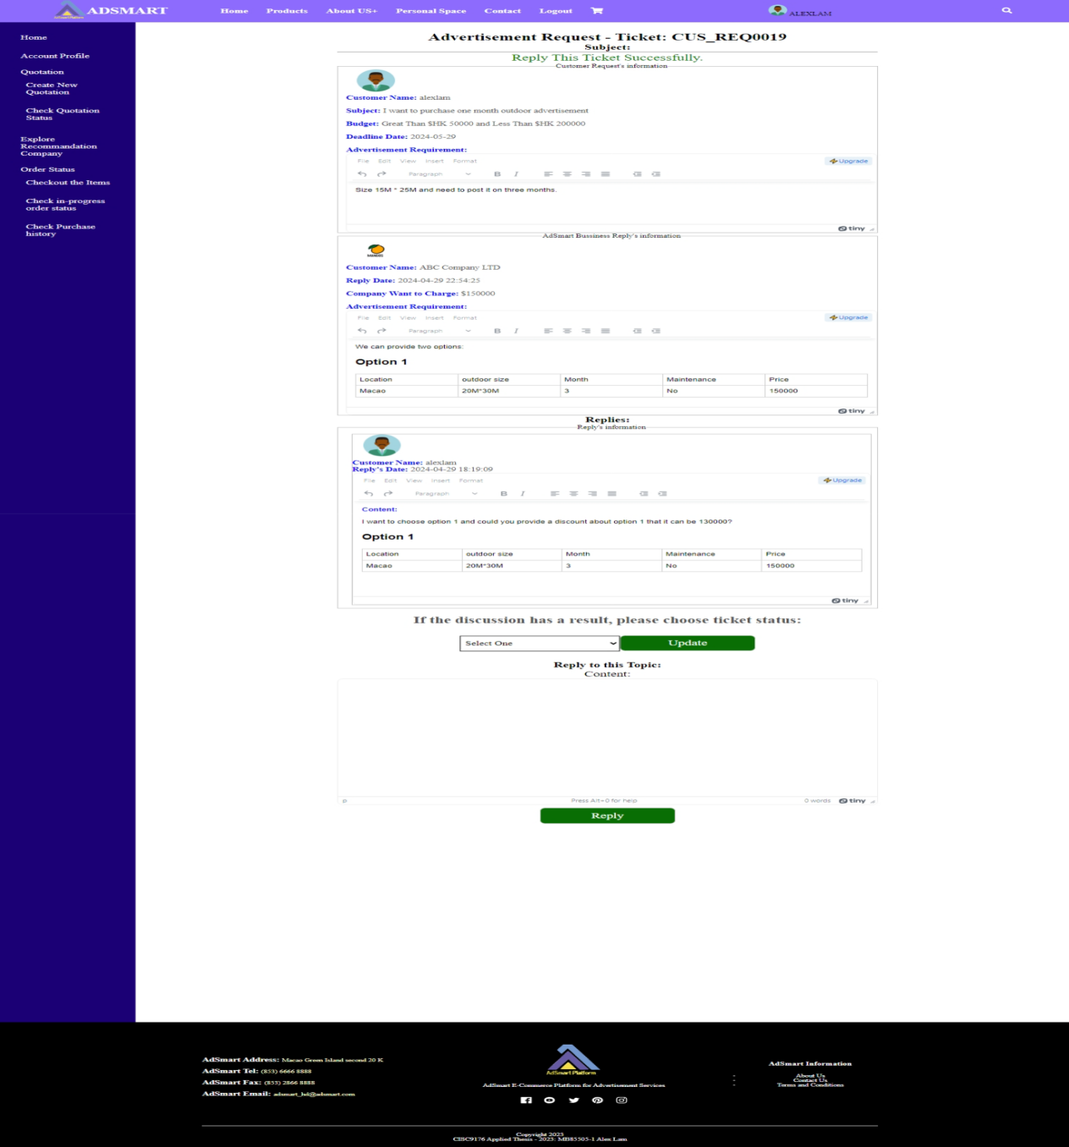

Figure 1.101 Customer can see the reply’s content

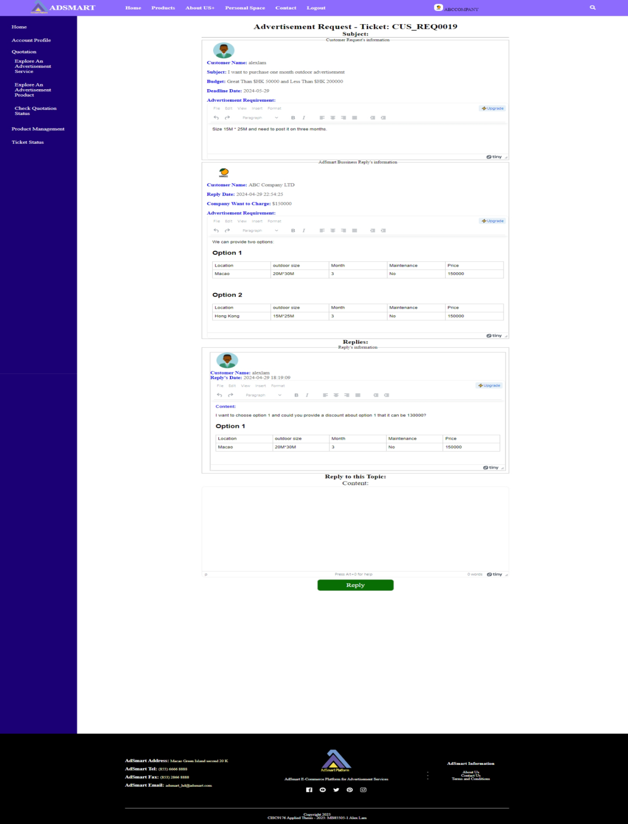

Figure 1.102 Business partner can see the reply’s content

As figure 1.103, this is an example of the business partner discussing with the customer.



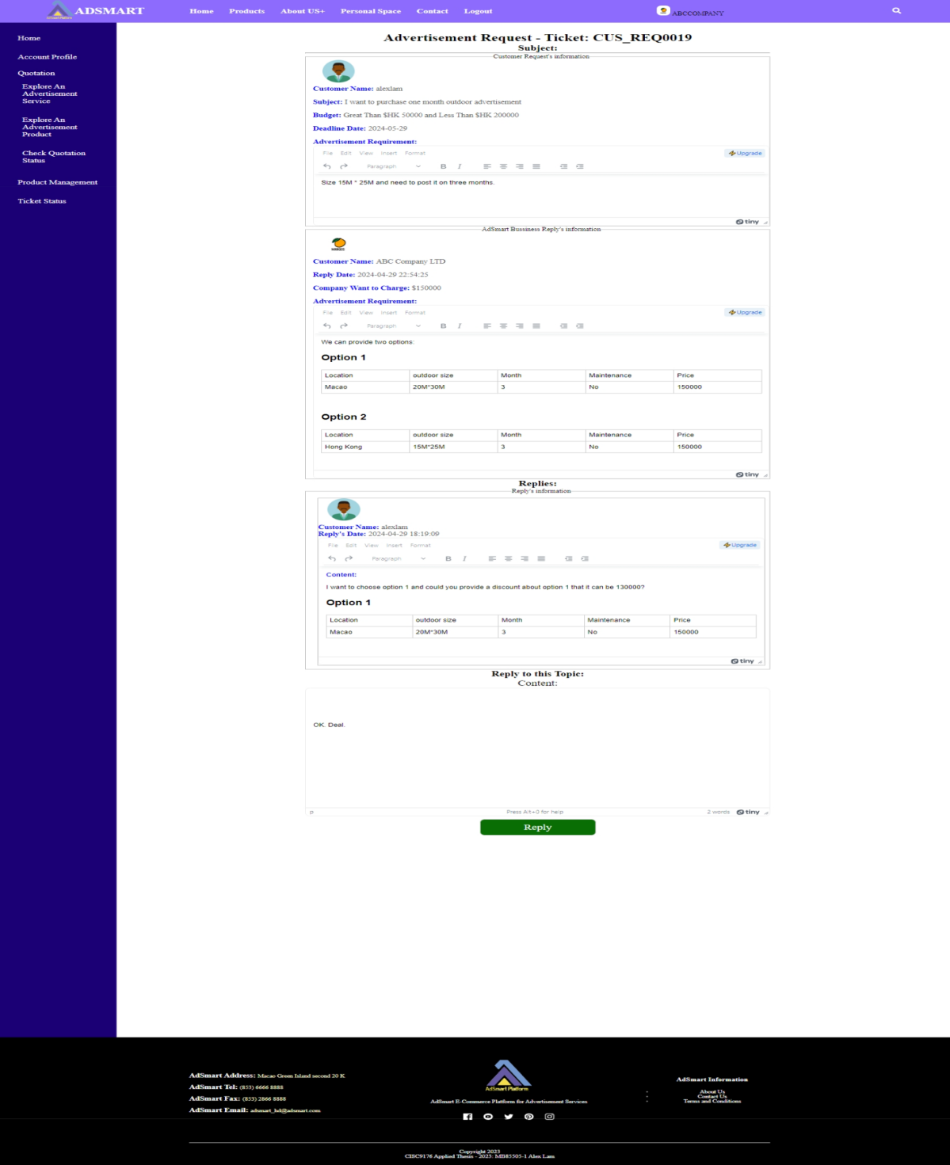

Figure 1.103 The example of business partner to discuss with customer

As figure 1.104, after the business partner replies, the customer can see the content of the business partner's reply. If the customer accepts the business partner's reply, then they need to update the status of the ticket to "Complete and need a quotation".



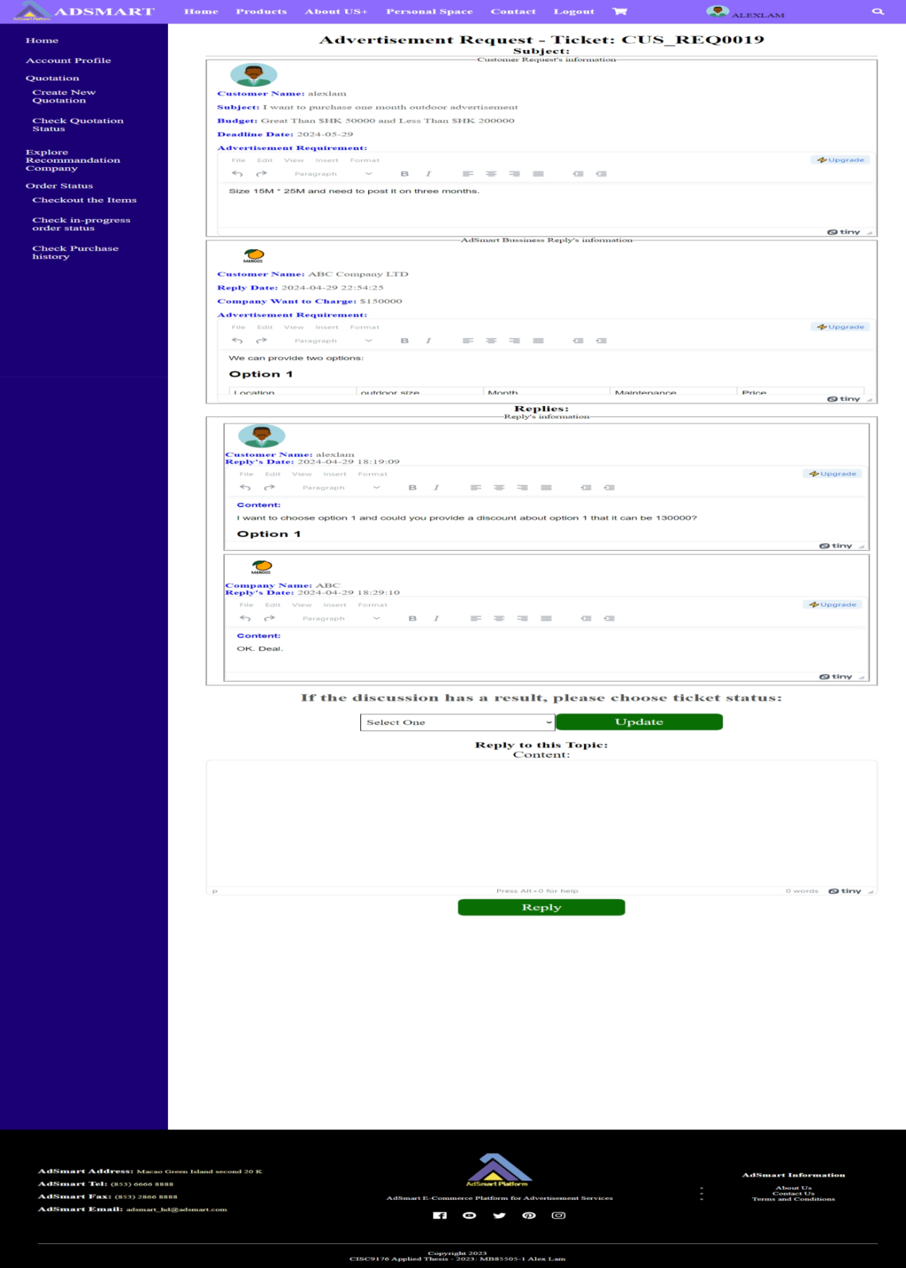

Figure 1.104 After business partner replied

As figure 1.105, this is an example of updating the status of the ticket to "Complete and need a quotation".

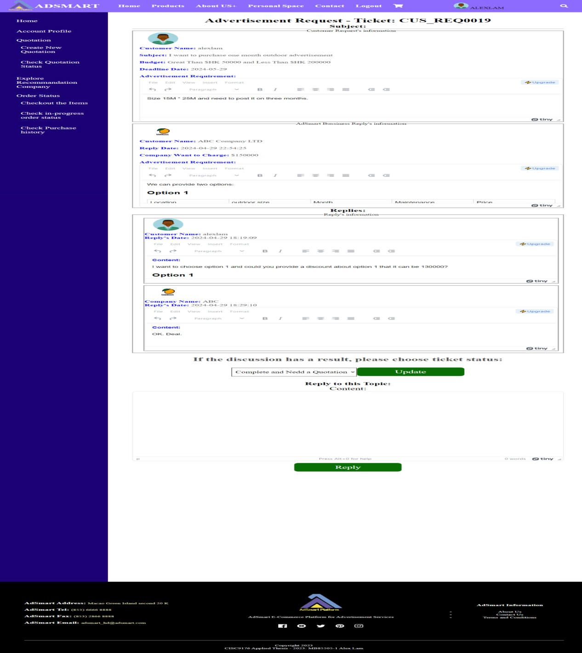

Figure 1.105 Update the status of ticket to “Complete and need a quotation”

As figure 1.106, after the customer updates the status, he/she can see the successful message and the status message “Waiting for business partner to send quotation” at the bottom. In the same time, business partner will see the status message “The request has been accepted! Please Click here to generate a contract!” at the bottom. When he/she clicks the url, AdSmart will bring the business partner to the "Generate a Contract" page.



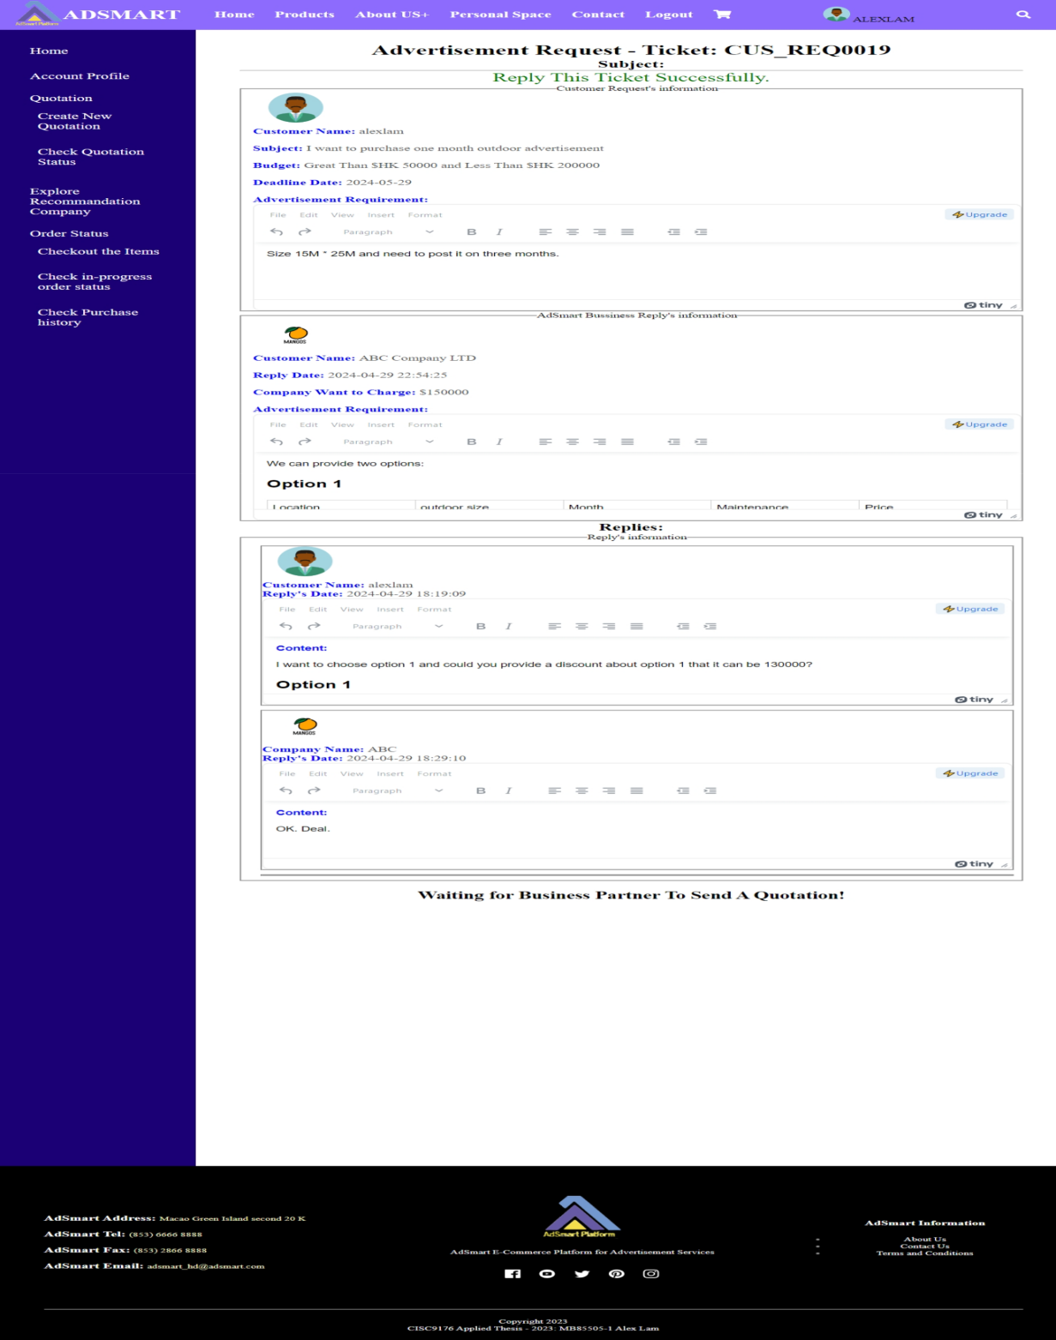

Figure 1.106 After customer updated the status



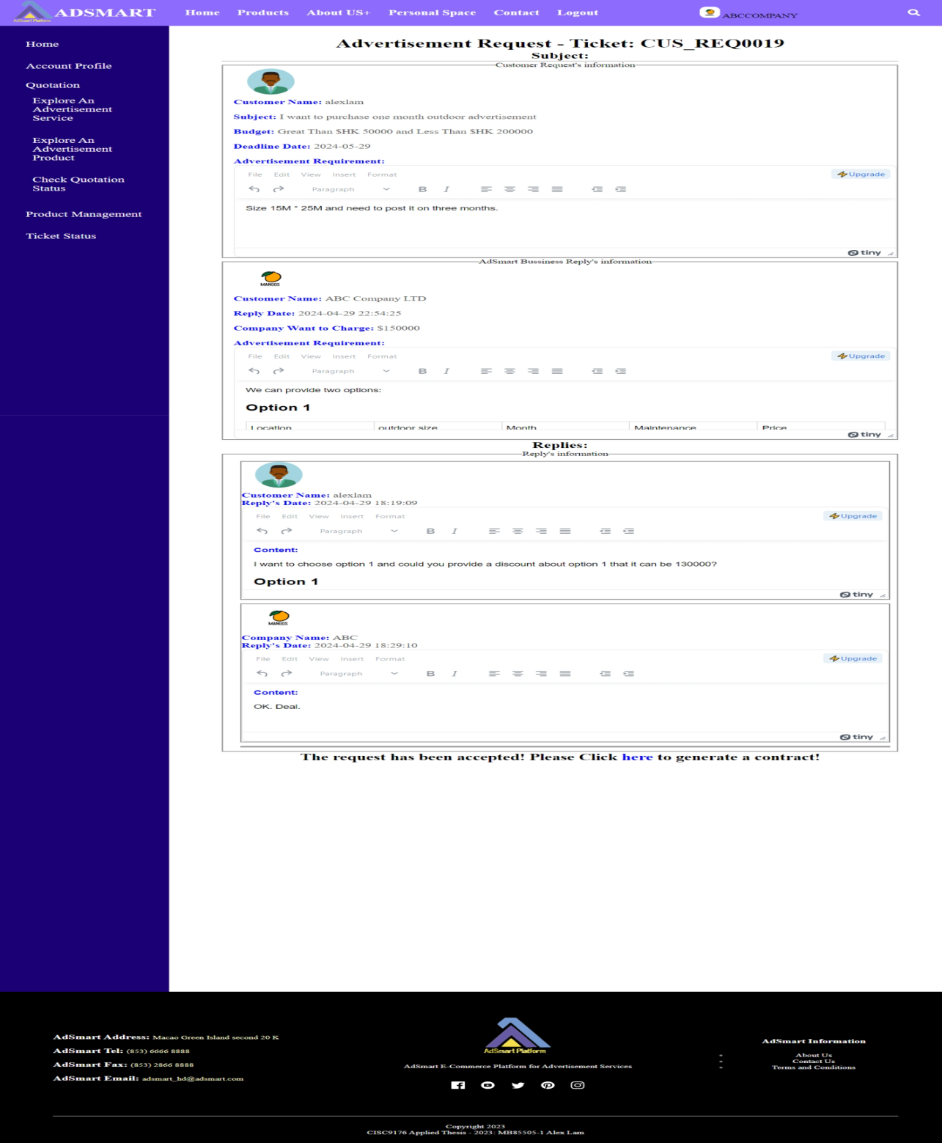

Figure 1.107 After customer updated the status

As figure 1.108, after the business partner clicks the URL, they will be directed to the "Generate a Contract" page.



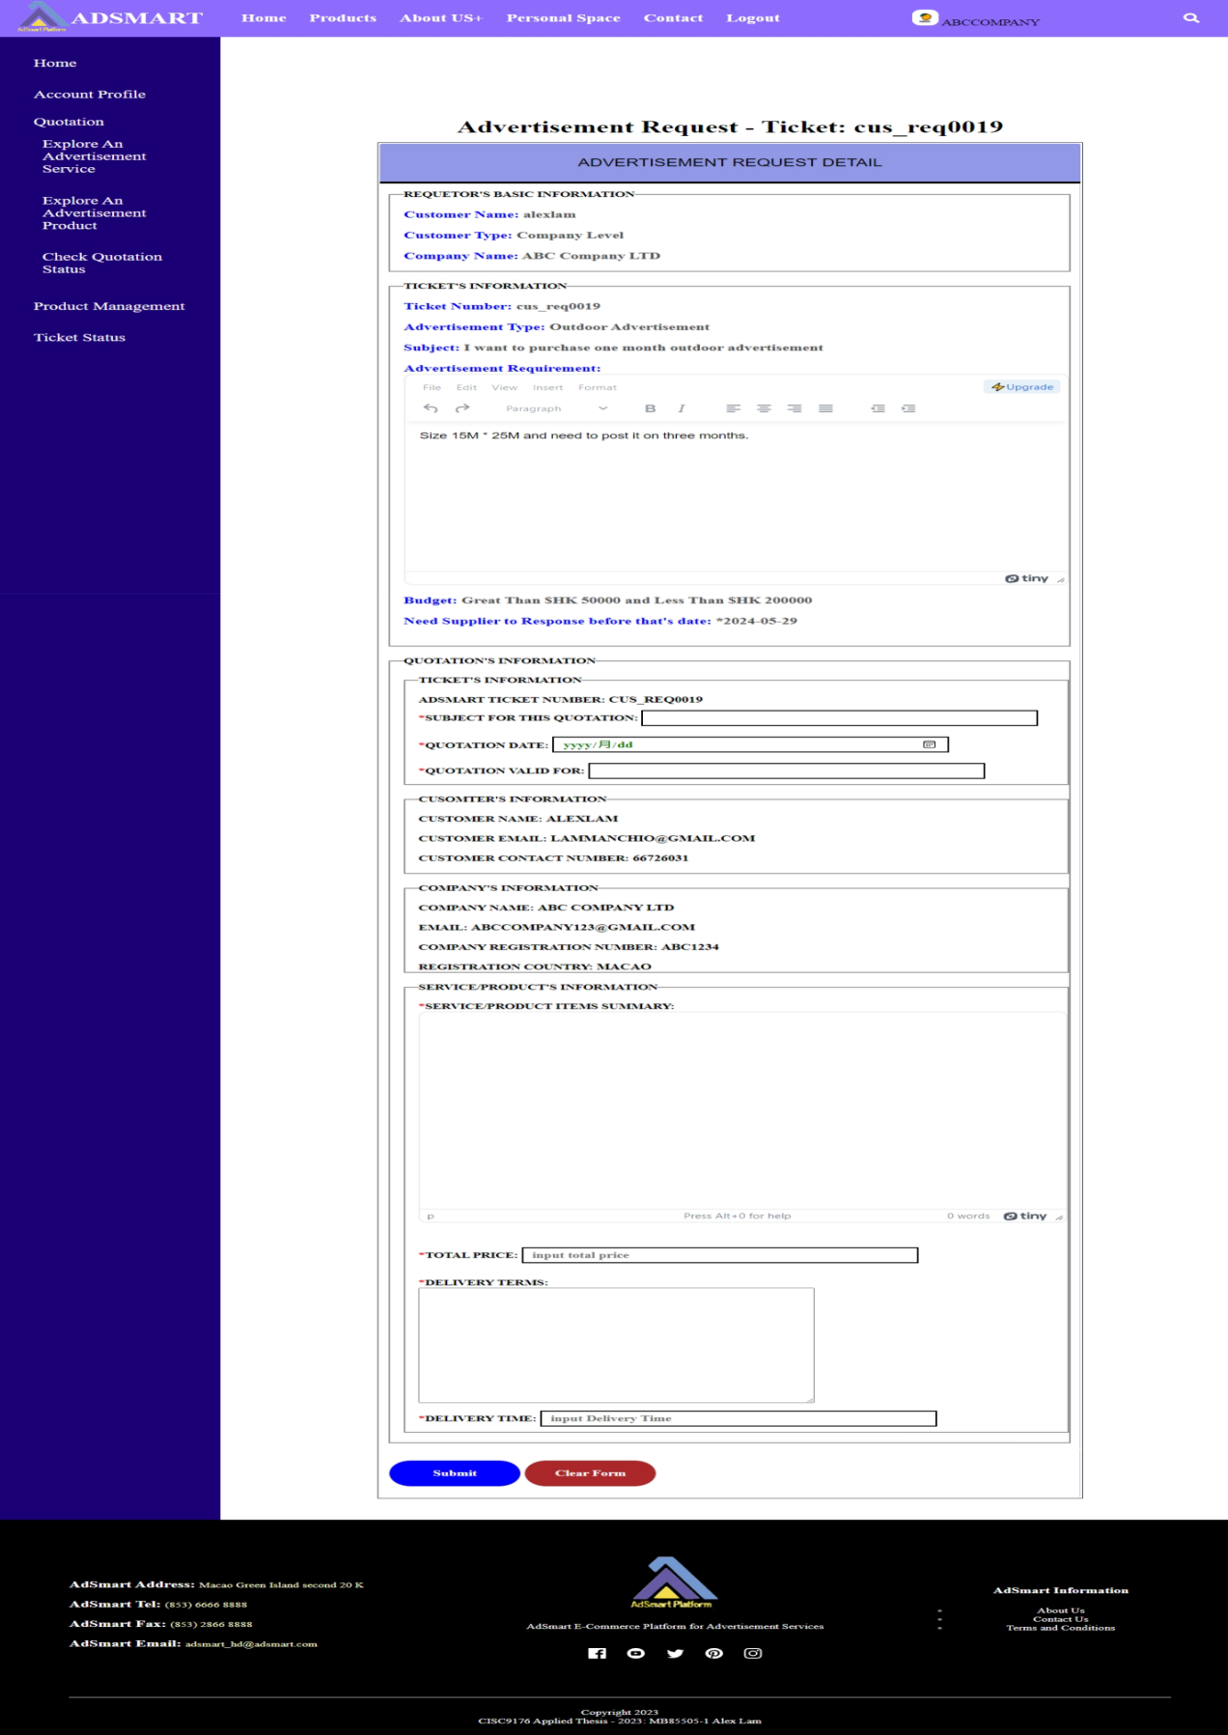

Figure 1.108 Generate a contract page

As figure 1.109, this is an example of the business partner generating a contract.

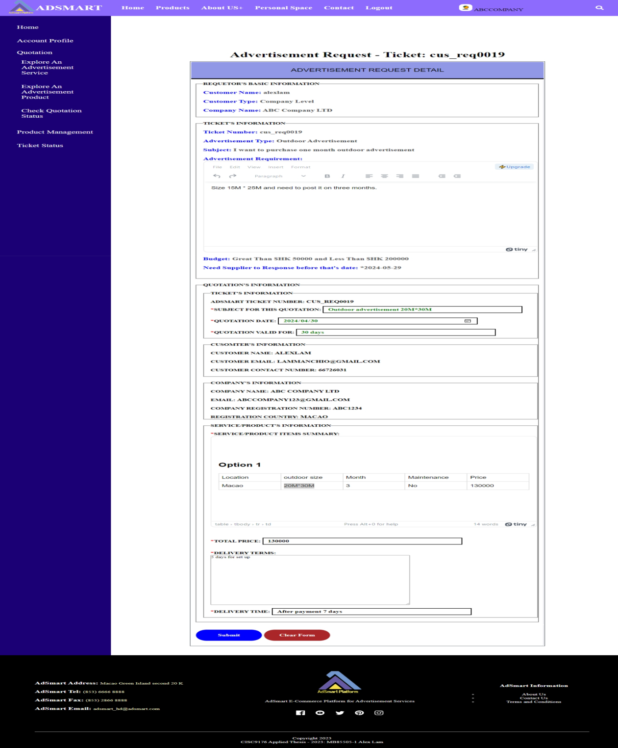

Figure 1.109 The example for business partner to generate a contract

After generating a contract, the business partner can see the status (figure 1.110) change to "View the Quotations".

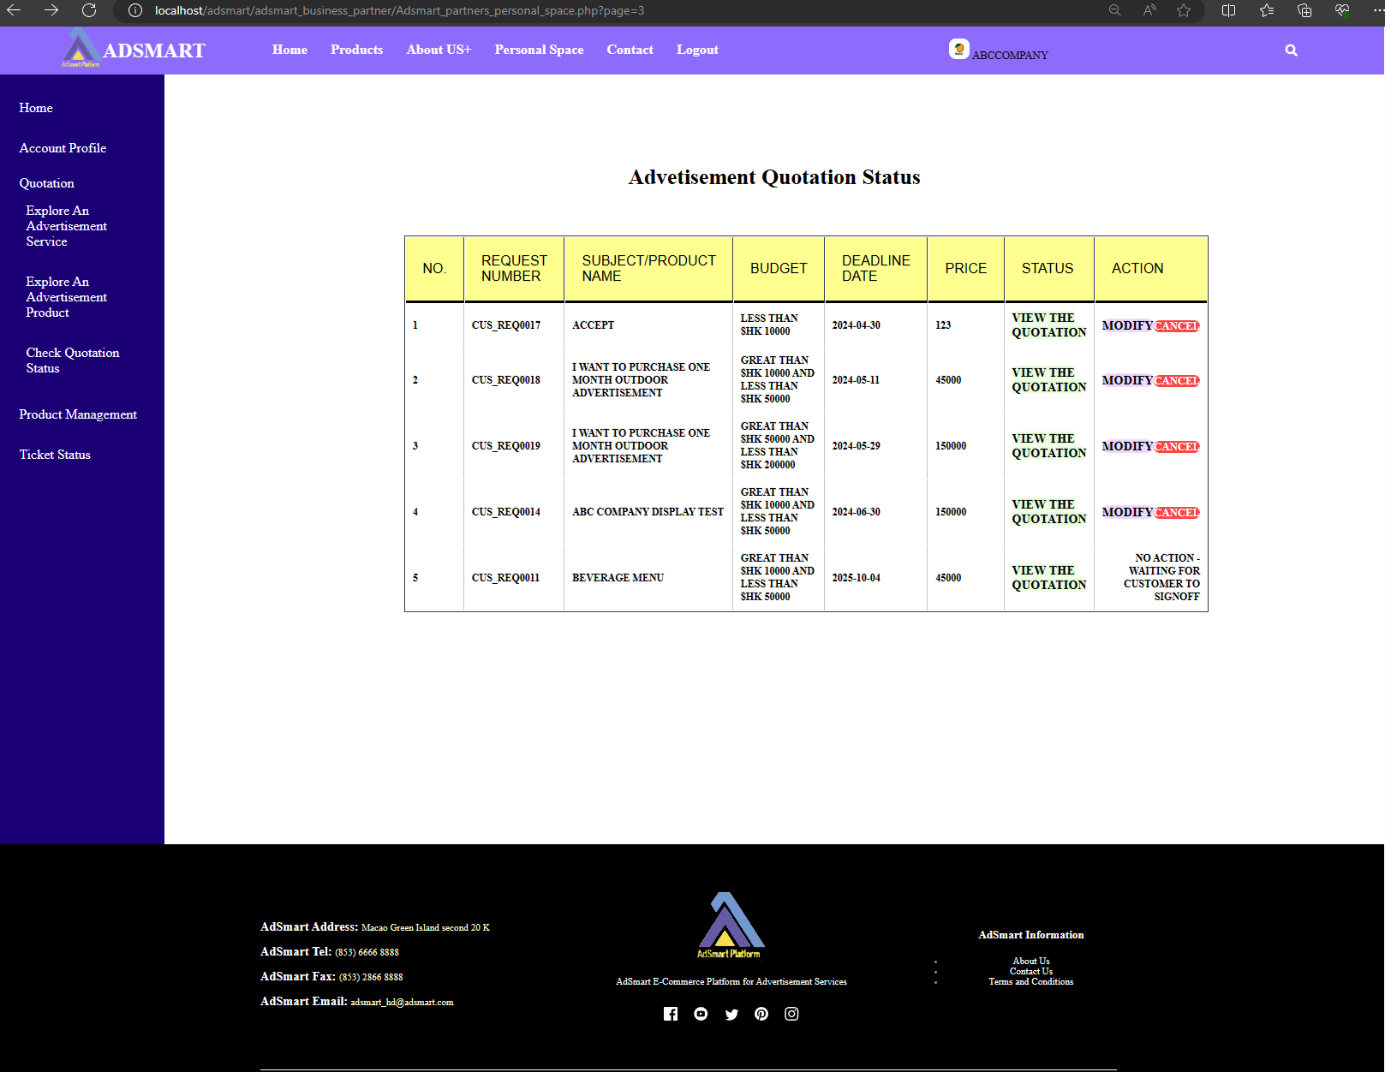

Figure 1.110 View the quotations

As figure 1.111, concurrently, the customer can see the status change to "See the Quotations".

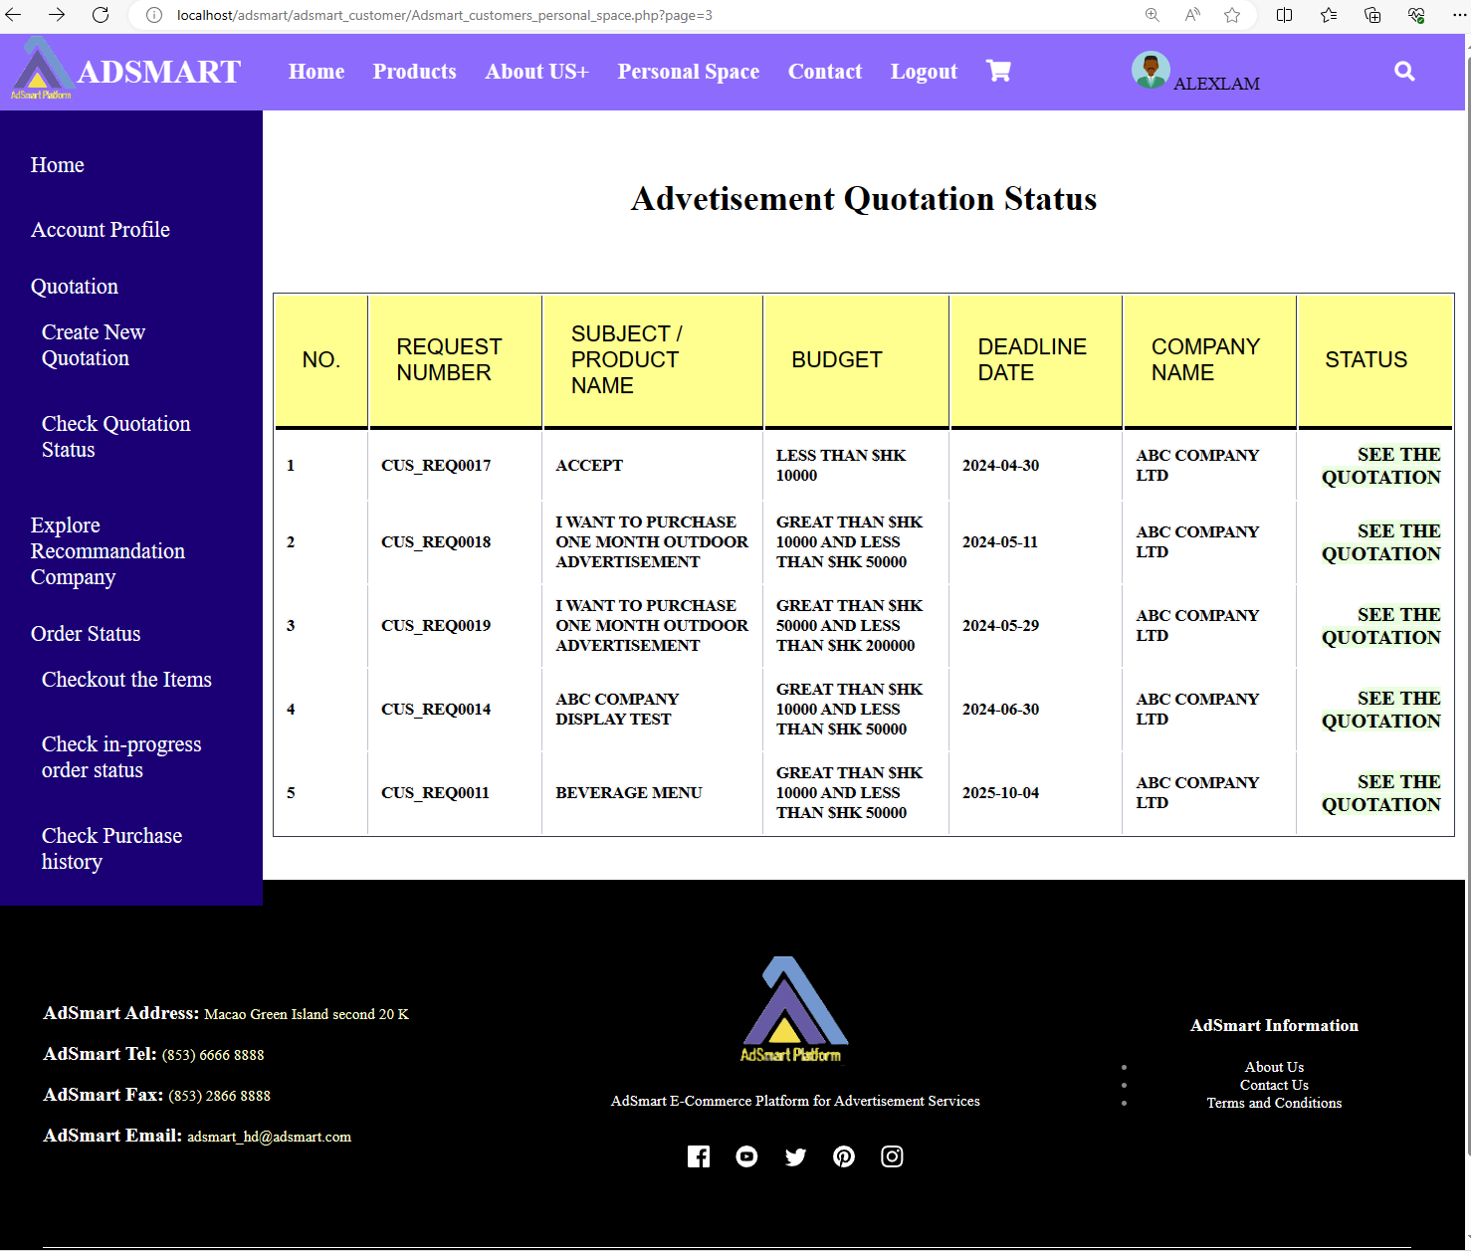

Figure 1.111 See the quotations

As figure 1.112, the business partner needs to download the contract from AdSmart, signs it off, and uploads it back to AdSmart.

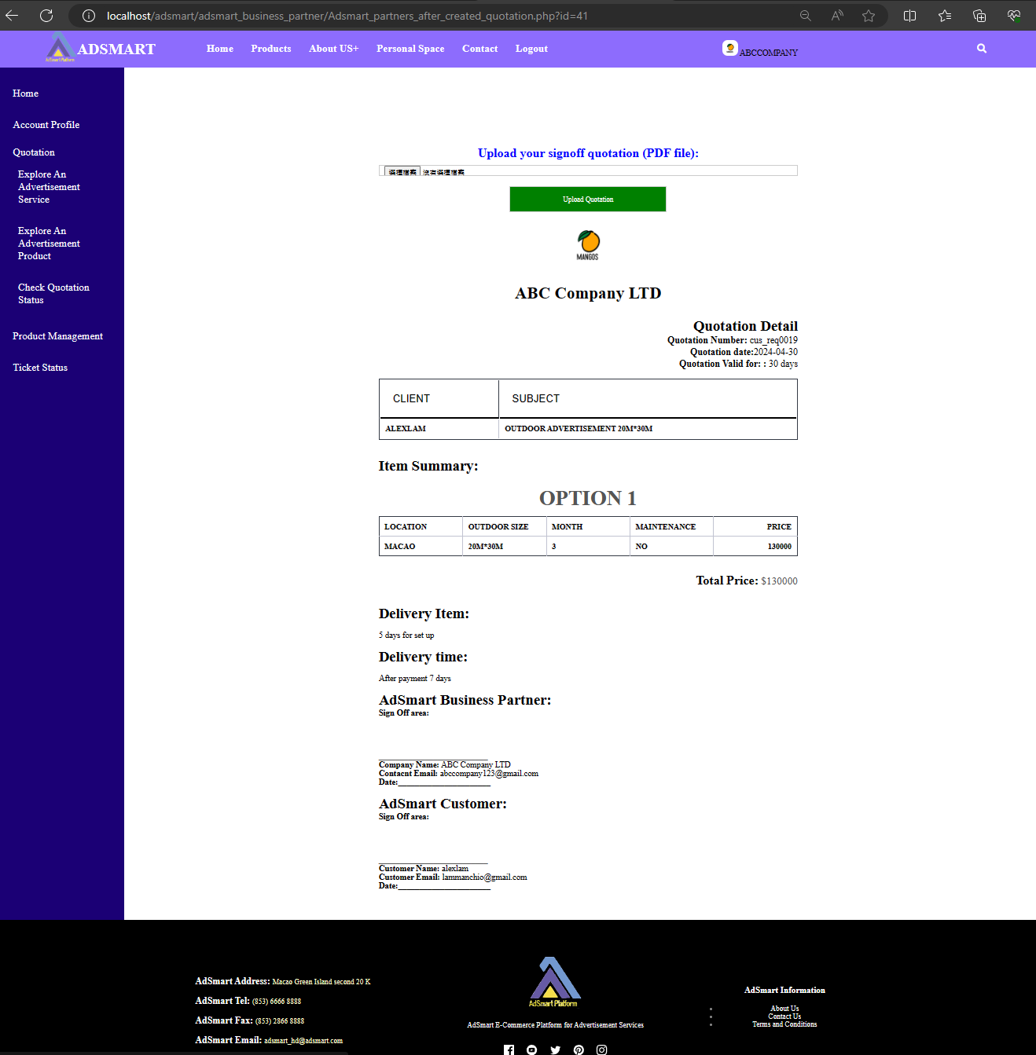

Figure 1.112 Upload business partner signoff contract

As figure 1.113, after the business partner uploads a PDF file, the customer can download the contract that has been signed off by the business partner. After downloading, the customer needs to sign off on the contract and upload it to AdSmart.

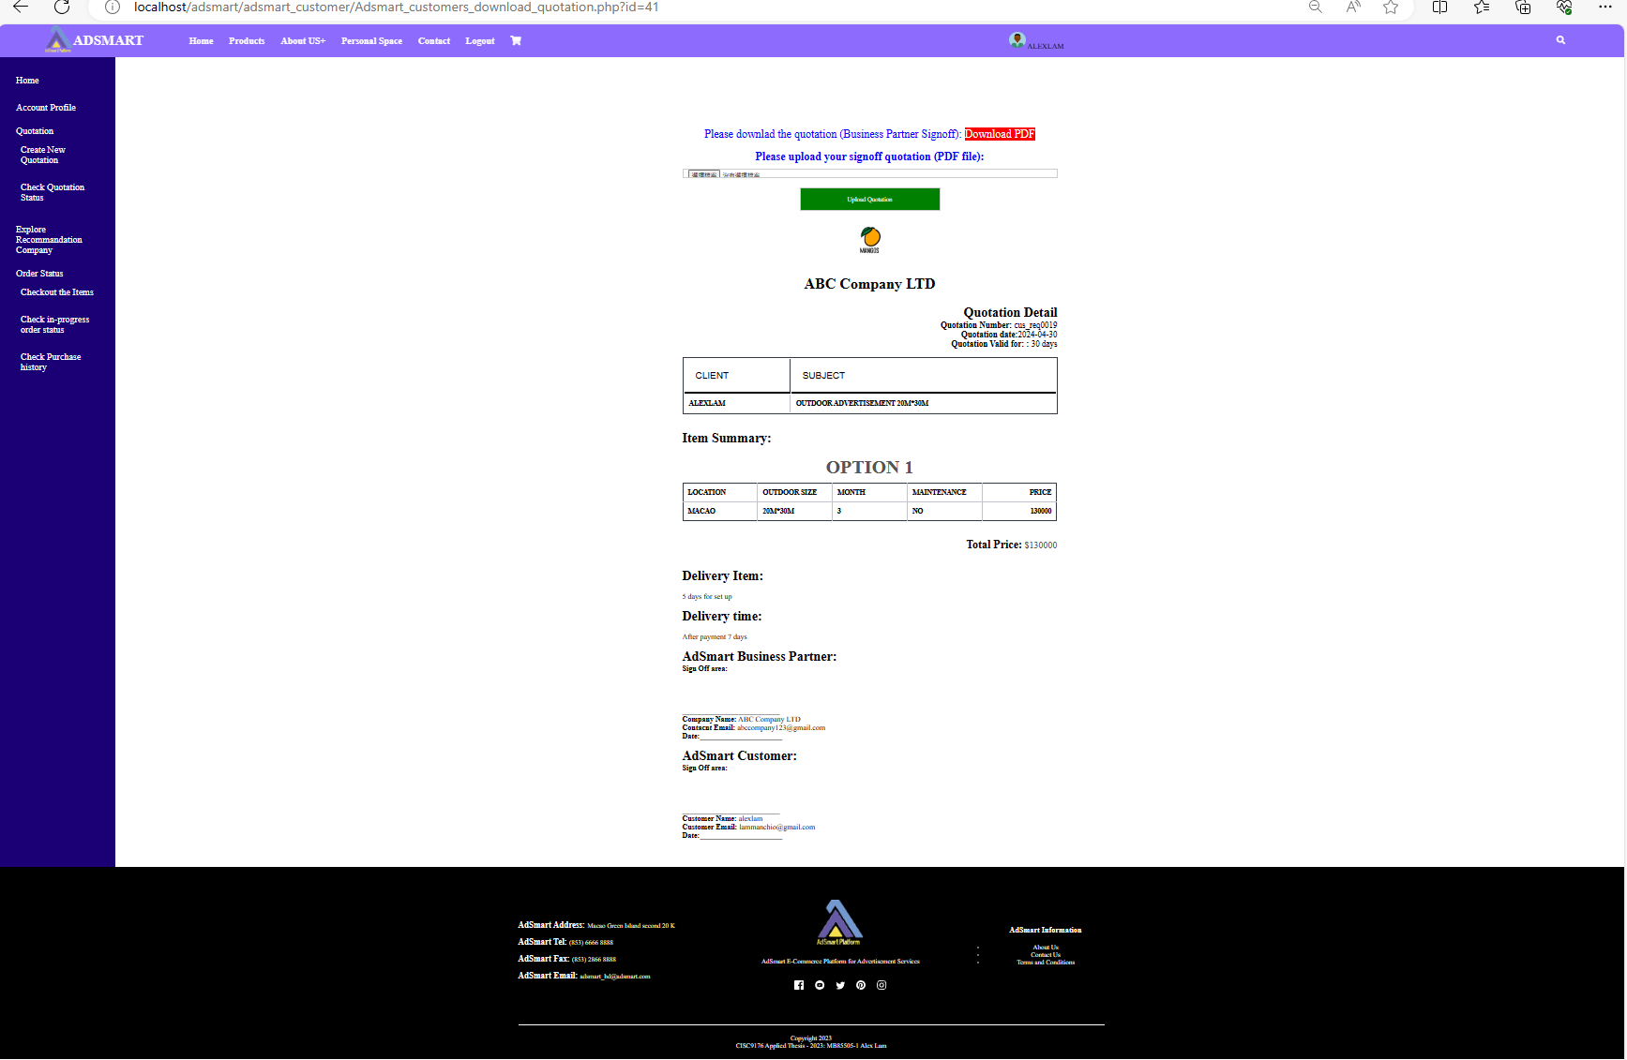

Figure 1.113 Download the contract in customer side

As figure 1.114, after the customer uploads a PDF file, both the partner and the customer can download the fully signed-off version of the contract, but they cannot upload it again.

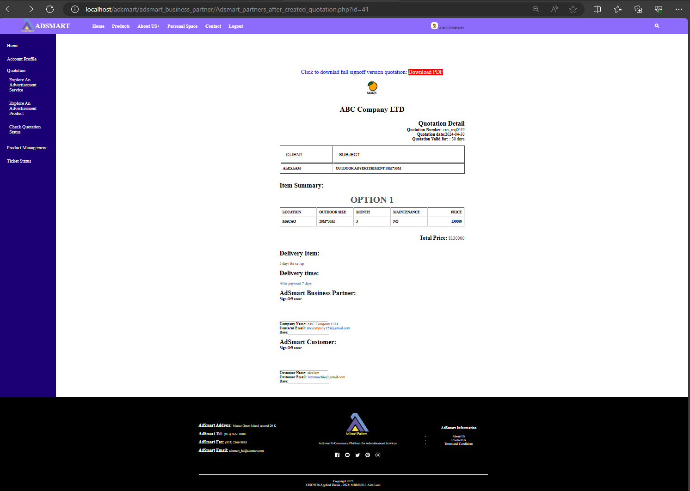

Figure 1.114 Download the full signoff version contract in business side

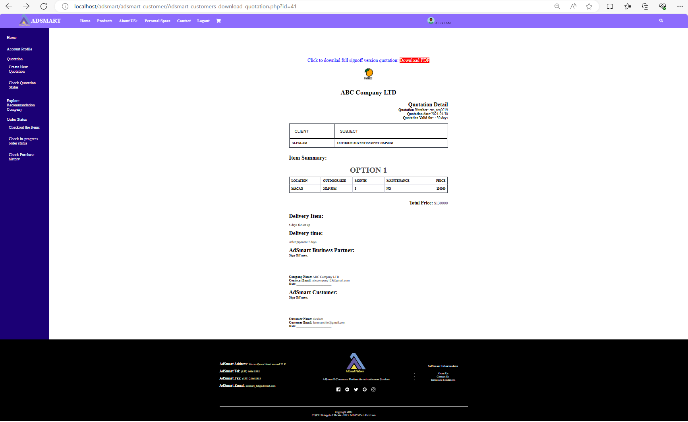

Figure 1.115 Download the full signoff version contract in customer side

## Use case 12: Create Product

This section provides walk through of the following user interfaces:

1. AdSmart business partner Personal space page (Figure 1.116)
2. Product management page (Figure 1.117)
3. Create new products page (Figure 1.118)
4. The example of business partner to Create new products (Figure 1.119)
5. After business partner created product (Figure 1.120)

In this demonstration, we will show AdSmart business partner how to create a new product in AdSmart. In this case, we assume ABC Company needs to release a new product in AdSmart.

As figure 6.66, the business partner needs to click the "Product Management" button on the left sidebar, which will bring the business partner to the “Product Management” page.



Figure 1.116 AdSmart business partner Personal space page

As figure 1.117, Business partner see the product information in Product Management page. if business partner need to create a new product, then he/she needs to click the “create new products” button.

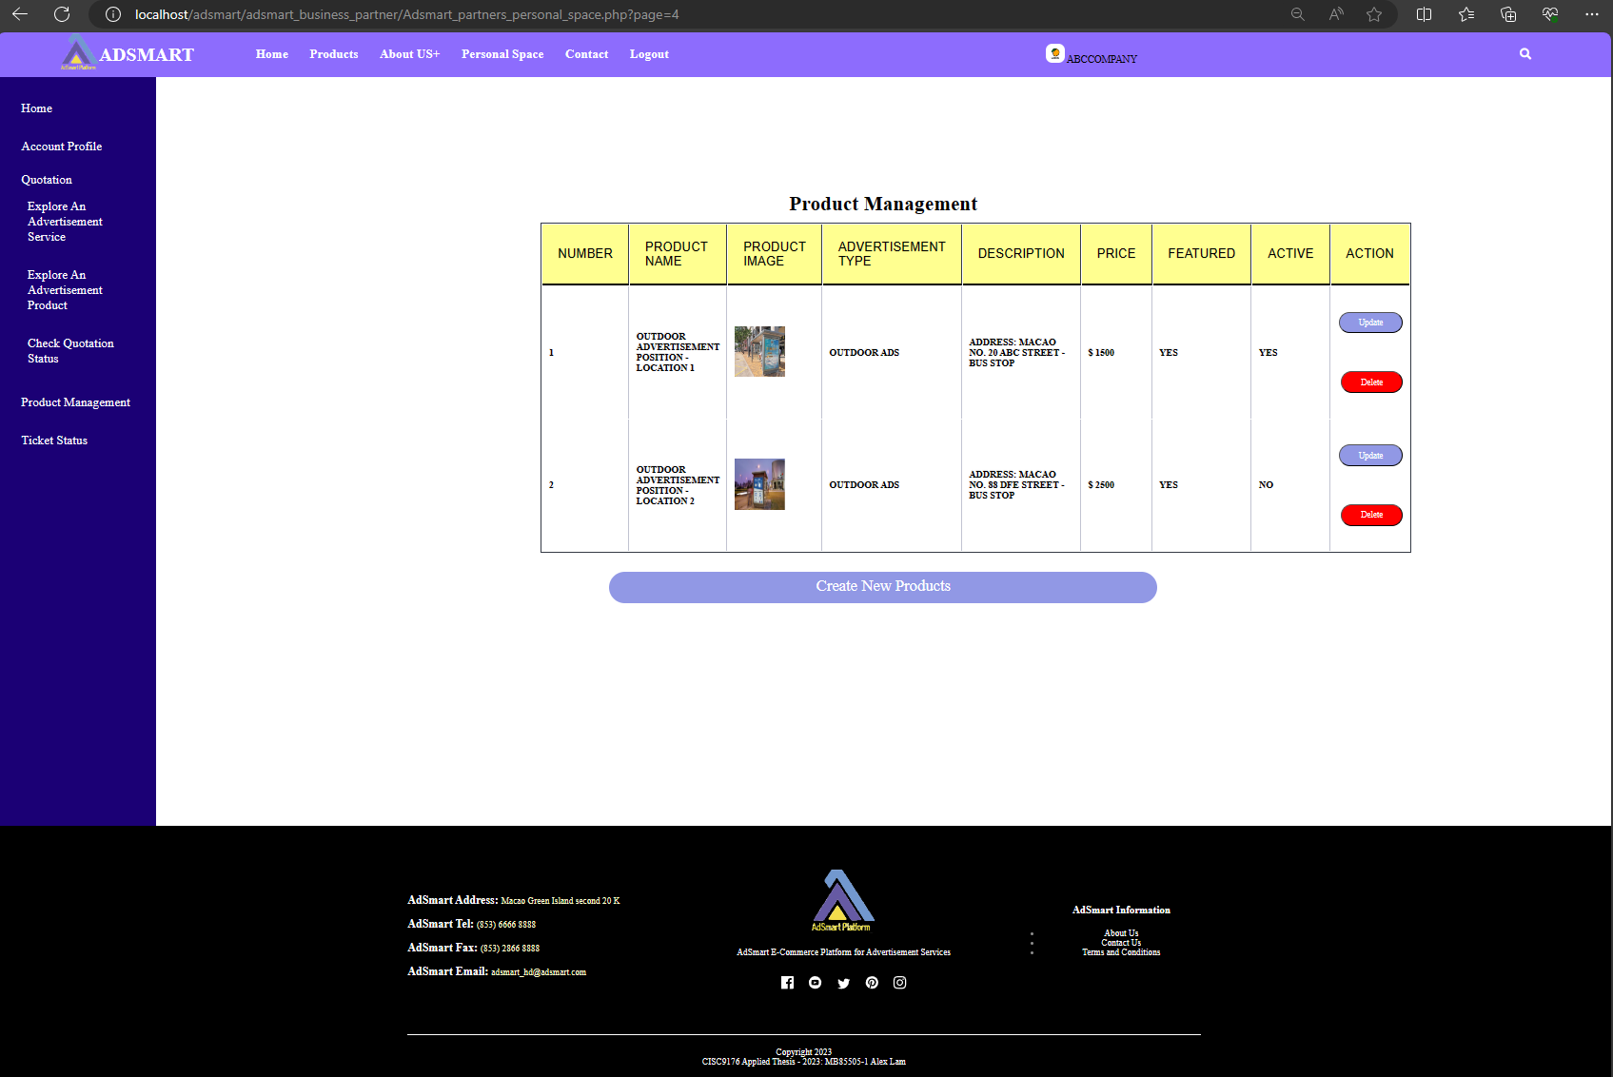

Figure 1.117 Product management page

after the business partner clicks the “create new products” button (figure 1.118), AdSmart will bring the business partner to the “Create New Products” page. He/She needs to input product name, description, price, quantity. select image, choose product category and item category and select the active status.

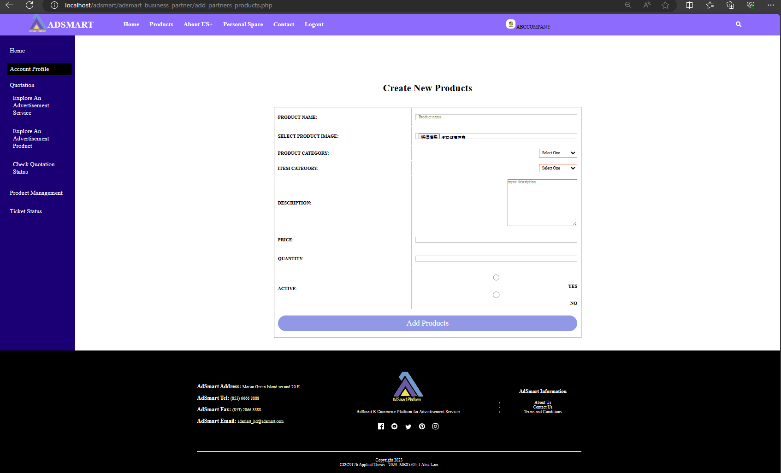

Figure 1.118 Create New Products page

As Figure 1.119, this is an example of creating new products. The customer needs to input the product name, description, price, quantity, select an image, choose a product category and item category, and select the active status.

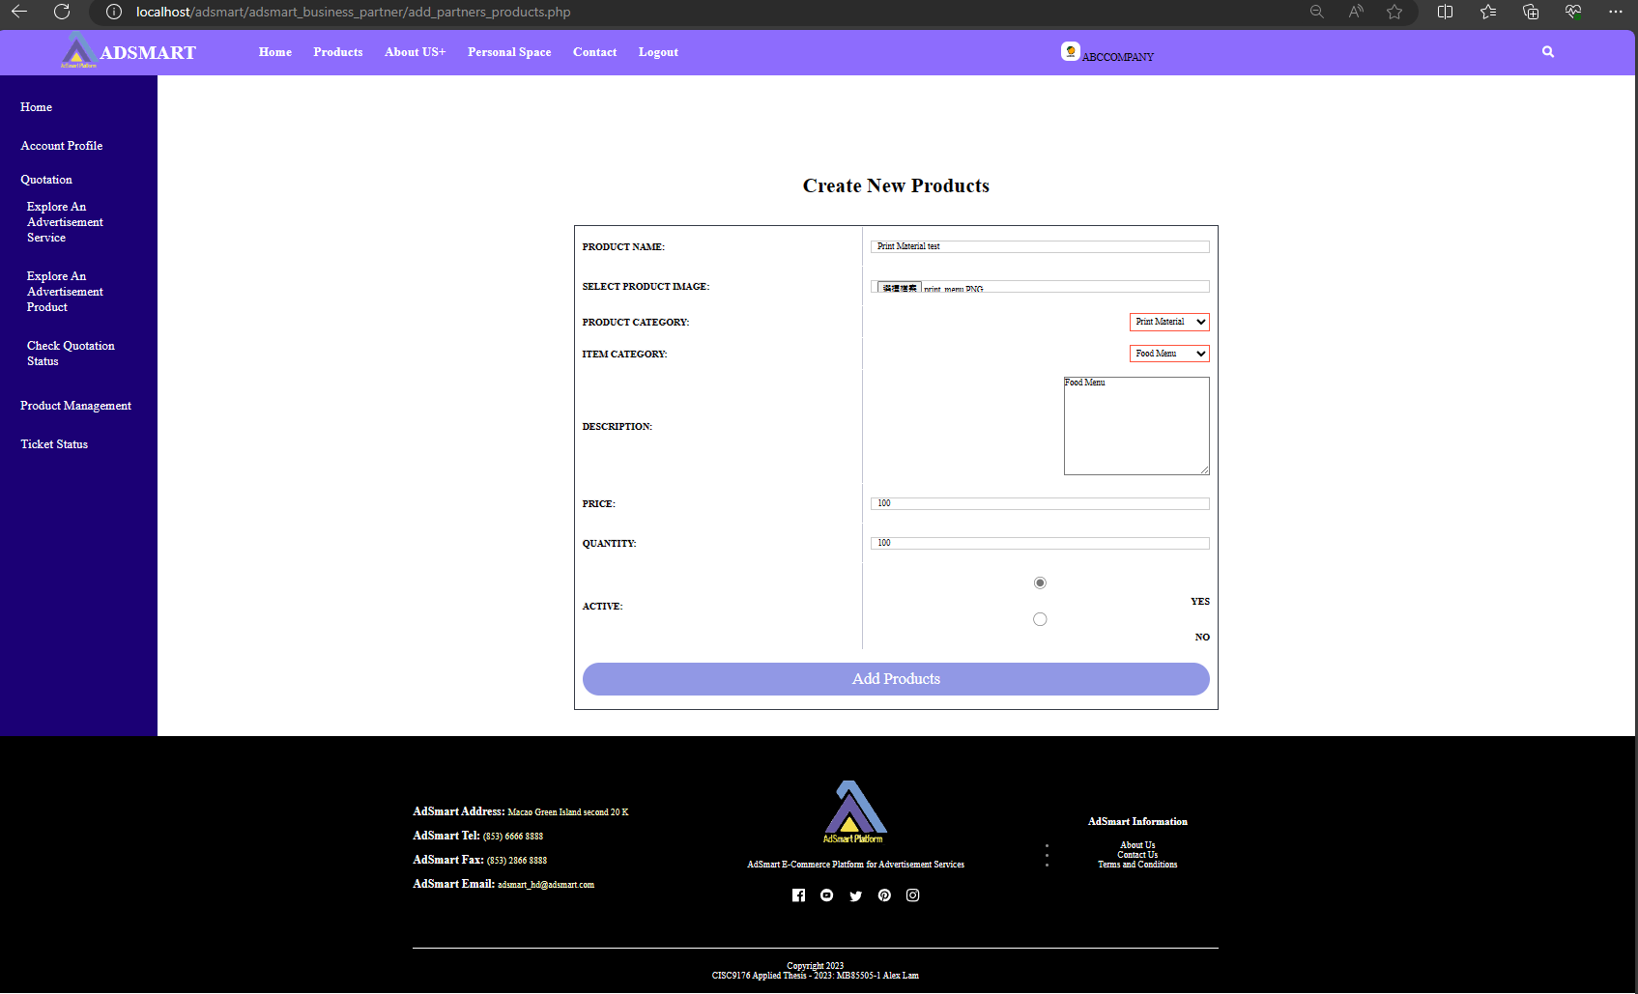

Figure 1.119 The example of create new products

After the business partner has created a product, he/she can view the product in the “Product Management” page (figure 1.120).

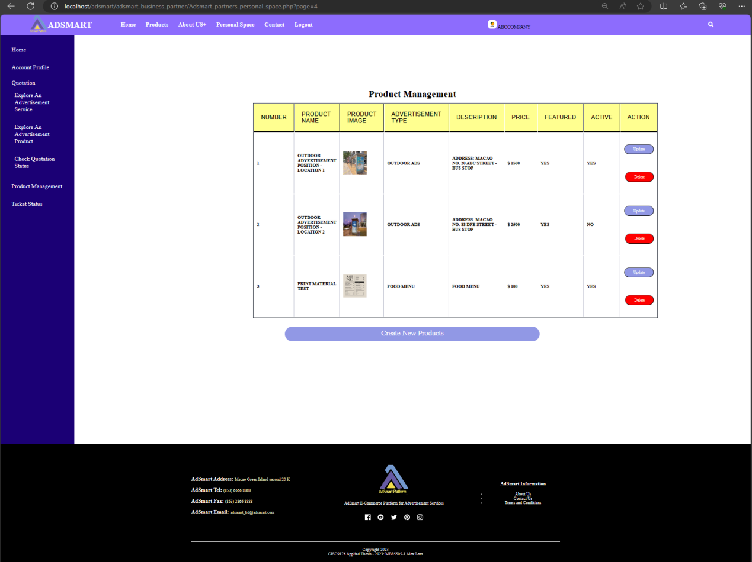

Figure 1.120 After business partner created product